# LBL INVENTORY

28/09/2010

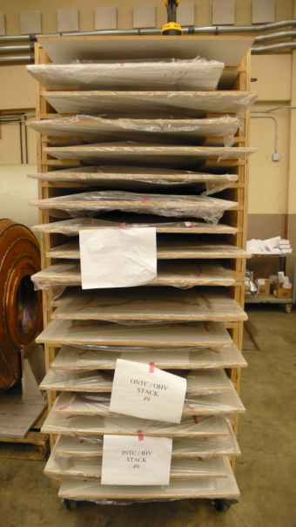

**BOX 1**

19 Harnesses;

OSP 1 thru 6 a full set.  
ISP 1 and 2 a full set  
  
ONTC 2 and 3 missing ONTC 1  
INTC 1 missing INTC 2  
There is a damaged NTC on the top of the rack. Need to see what it is and if it can be used for a missing assembly.  
  
OHV 1 thru 3 a full set  
IHV 1 and 2 a full set

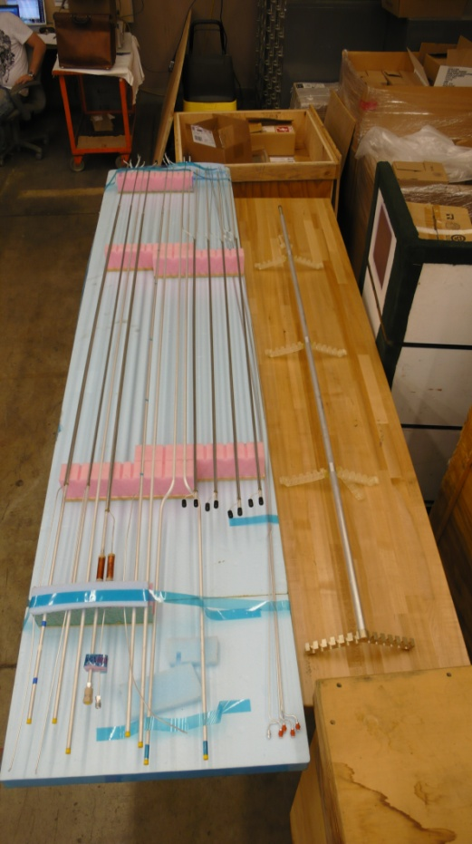**BOX 2**

1 dummy longeron

5 cooling inlet lines with fittings

4 HEX for optos with PP0 fittings

2 Exhaust with fittings, bend

1 Exhaust with fitting, strait  
1 HEX, straight

1 HEX with ballows and PP0 fittings

1 Exhaust

2 HEX straight

2 SLA blocks

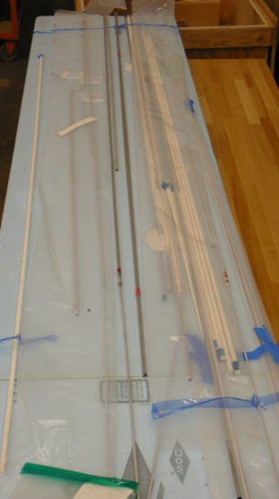n. cooling loops bare pipe

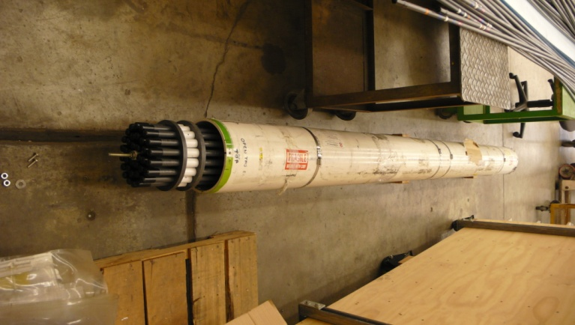1 Exhaust pipe shipping tube, white tube

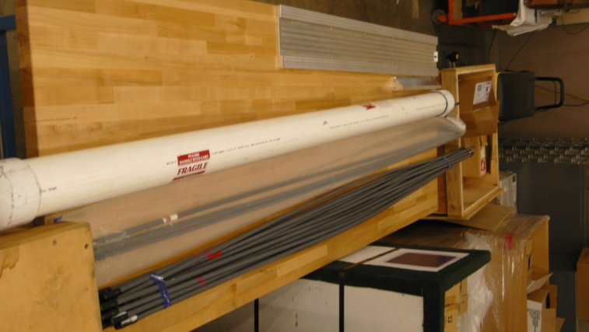

1 Piping storage

1 trimming tool

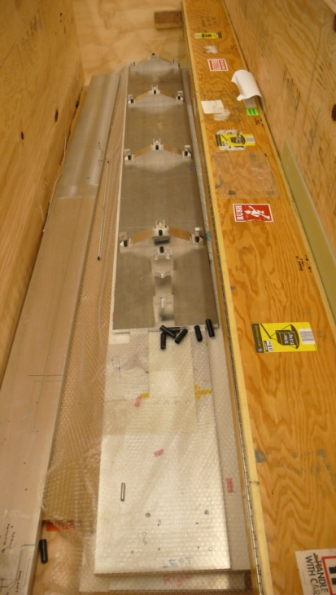

1 tool ???

1 Pipes Bending tool

**BOX 3**

HV covers,

Plexiglas angled supports,

PP0 bonding tool,

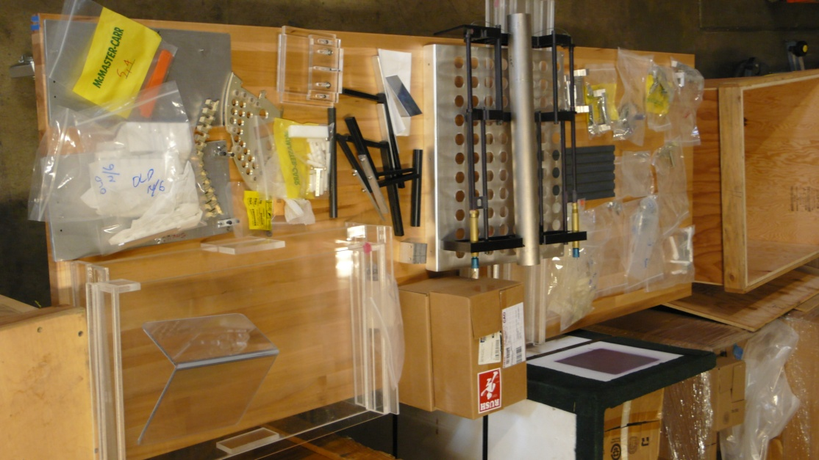Heat Spreaders,

PP1 quarter end plate,

PP0 tube supports Plexiglas Wire bend jig,

steel piping clamps,

Longeron end blocs,

pins for the pin table,

tube caps,

section of the longeron,

angled panel lifters,

angle SS block,

Tube clamp,

fittings,

HEX retainer clips,

Bellows bonding jig,

PP0 flex lamination tool,

SLA parts,

penetration tape bonding tool,

PP0 soldering shipping container,

BPSS mockup,

PP1 connector plate,