4 The Magnetic Channel and the MICE Magnets

Layout and Optics
The MICE magnetic channel consists of seven magnet assemblies composed of eighteen superconducting solenoid coils spread over a length of over 12 meters. The solenoid channel is physically symmetric about its centre, which is defined locally as z = 0. For the baseline channel (Case 1), the current densities of the coils exhibit a symmetry such that J(-z) = - J(z). The centre of the channel is the centre of a pair of focusing solenoid coils around an absorber. As one moves away from the centre, there is a coupling coil around an RF cavity, a pair of focusing coils around an absorber, a pair of matching coils, and three coils that produce a 4 T uniform field region (∆B/B < 0.01) that is at least 300 mm in diameter and 1000 mm long for the detectors. Table 4.1-1 shows the physical parameters of the solenoid coils in half of the channel starting at the centre (z = 0).

Table 4.1-1. The physical locations of the MICE coils with respect to the channel centre. Note that the coils at z < 0 are symmetric with respect to those at z > 0.
MICE Coil | z₁ (m) | z₂-z₁ (m) | r₁ (m) | r₂-r₁ (m)
Focus Coil #1 | 0.100 | 0.210 | 0.263 | 0.084
Coupling Coil | 1.250 | 0.250 | 0.725 | 0.116
Focus Coil #2 | 2.440 | 0.210 | 0.263 | 0.084
Focus Coil #3 | 2.850 | 0.210 | 0.263 | 0.084
Match Coil #1 | 3.512 | 0.198 | 0.258 | 0.0462
Match Coil #2 | 3.953 | 0.197 | 0.258 | 0.0308
Spectrometer End Coil #1 | 4.396 | 0.110 | 0.258 | 0.0616
Spectrometer Centre Coil | 4.554 | 1.294 | 0.258 | 0.0220
Spectrometer End Coil #2 | 5.896 | 0.110 | 0.258 | 0.0682
Note: z₁ is the location of the coil end closest to the centre (z = 0); z₂-z₁ is the coil length;
r₁ is the coil inner radius; and r₂-r₁ is the coil thickness.

The coils listed in table 4.4-1 are for the full MICE configuration. In addition, MICE will be operated in various stages as described in Chapter 2. The baseline MICE channel operates with muons at an average momentum p = 200 MeV/c and β = 42 cm at the absorber centre. Other operating cases for the full MICE channel are being studied, and are also listed in Table 4.1-2.The factors limiting the momentum for these other cases in the full flip channel are the peak field and temperature margin at the focusing coil superconductor.
Table 4.1-2 shows the absolute value of the current density across the coil cross-section for all of the cases above. Table 4.1-3 shows the absolute value of the current density across the coil cross-section for the same cases (i.e. <p> and β) as in Table 4.1-2 except the field does not flip (change polarity) as one goes through the focusing magnets. The current density was calculated for Table 4.1-2 and Table 4.1-3 based on the warm dimensions and positions of the coils. The current density change is small when cold dimensions are used. The average momentum for all of the non-flip cases can be 200 MeV/c or above because less current is needed in the focus coil pair than for the cases where the magnet field flips as one goes down the channel. There are two symmetrical semi-flip cases (a case where the field flips in the centre focus magnet and a case where the field flips in both side focus magnets). The semi-flip fields and forces are similar to the fields and forces for the flip and non-flip cases.
The baseline magnetic field configuration in practice is modified by the presence of magnetic materials. In particular, at each end of the experiment, photo-multiplier tubes are used to detect light from scintillation and Cherenkov detectors. These devices are sensitive to the magnetic fields and so must be protected by magnetic shielding. Specifically, thick iron plates are placed at the ends of the spectrometer solenoid (see chapter 8) to terminate the fields. These fields affect the matching of the beam into MICE and the size of the detectors needed as the beam emerges. Additionally, between the focus coils and the tracker solenoid, there is a radiation shield to protect the tracker during conditioning. This places constraints on the separation of the absorber and tracker coils.

Table 4.1-2. Various Operating Cases for MICE Channel Operating in the Flip Mode. The average muon momentum p, beta at the absorber β, the spectrometer field B and the absolute value of the current density J in the coils in the full MICE channel under various operating conditions.

Parameter | Case 1 | Case 2 | Case 3 | Case 4 | Case 5
Average p (MeV/c) | 200 | 240 | 200 | 170 | 140
Absorber β (cm) | 42 | 42 | 25 | 15 | 7
Spectrometer B (T) | 4.0 | 4.0 | 4.0 | 3.4 | 2.8
Focus J (A mm⁻²) | 113.95 | 136.74 | 140.14 | 134.44 | 130.95
Coupling J (A mm⁻²) | 96.21 | 115.45 | 87.41 | 61.91 | 27.52
Match #1 J (A mm⁻²) | 118.04 | 140.10 | 114.71 | 88.16 | 45.18
Match #2 J (A mm⁻²) | 138.28 | 149.79 | 119.90 | 80.54 | 62.82
End Coil #1 J (A mm⁻²) | 136.80 | 134.16 | 136.80 | 118.52 | 99.48
Centre J (A mm⁻²) | 146.90 | 146.90 | 146.90 | 124.86 | 102.83
End Coil #2 J (A mm⁻²) | 142.49 | 142.49 | 142.49 | 121.11 | 97.75

Table 4.1-3. Various Operating Cases for MICE Channel Operating in the Non-flip Mode. The average muon momentum p, beta at the absorber β, the spectrometer field B and the absolute value of the current density J in the coils in the full MICE channel under various operating conditions.

Parameter | Case 1 | Case 2 | Case 3 | Case 4 | Case 5
Average p (MeV/c) | 200 | 240 | 200 | 200 | 200
Absorber β (cm) | 42 | 42 | 25 | 15 | 7
Spectrometer B (T) | 4.0 | 4.0 | 4.0 | 4.0 | 4.0
Focus J (A mm⁻²) | 59.52 | 71.42 | 79.59 | 97.62 | 112.76
Coupling J (A mm⁻²) | 87.41 | 104.89 | 79.14 | 68.90 | 44.48
Match #1 J (A mm⁻²) | 129.57 | 149.51 | 131.29 | 116.40 | 92.80
Match #2 J (A mm⁻²) | 113.42 | 137.77 | 71.72 | 61.99 | 33.77
End Coil #1 J (A mm⁻²) | 136.80 | 131.55 | 139.44 | 142.05 | 147.32
Centre J (A mm⁻²) | 144.73 | 144.73 | 144.73 | 144.73 | 144.73
End Coil #2 J (A mm⁻²) | 144.87 | 144.87 | 144.87 | 144.87 | 144.87

Figure 4.1-1 shows the magnetic field B(z) on axis for the MICE channel versus distance along the channel for –7 < z < +7 m for the full field flip case. shows the same for the full non-flip field case.

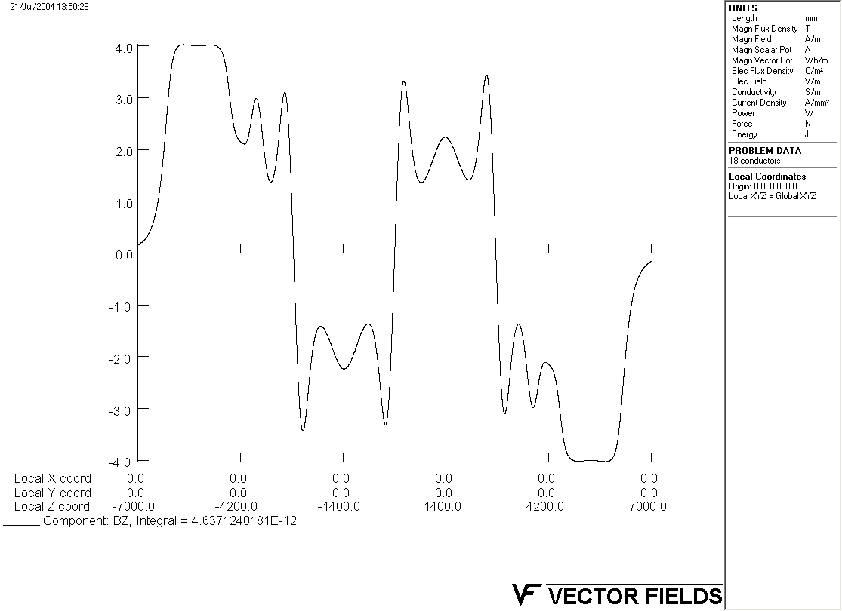
Figure 4.1-1. The magnetic field on axis in MICE for the baseline case
with field flips at z = 0 and z = ± 2.75 m.
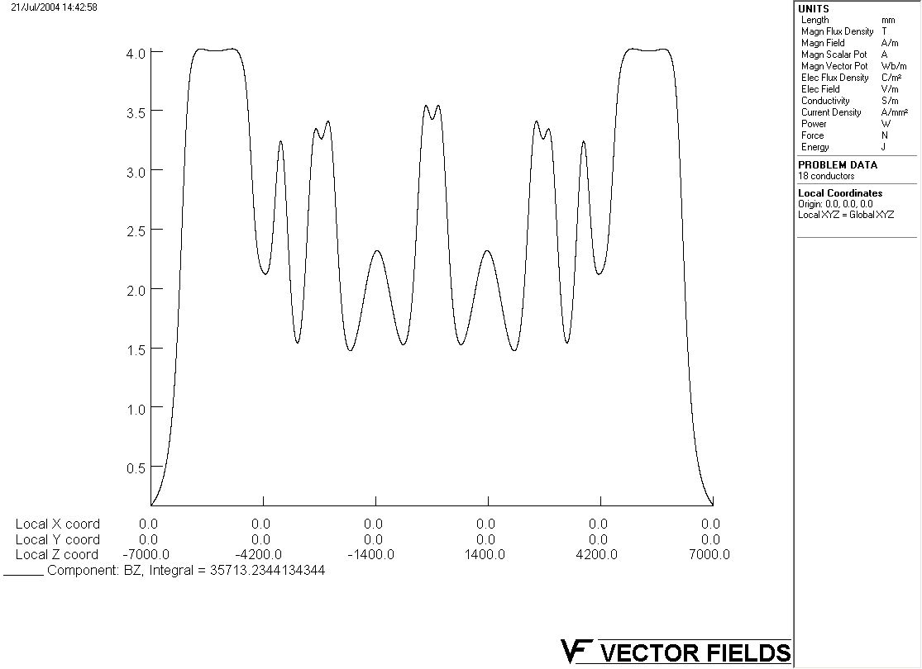

Figure 4.1-2: The magnetic field on axis in MICE for the baseline case
without field flips in the focus magnets

Design of Coils

The eighteen superconducting coils in MICE are grouped in three distinct cold mass and cryostat assemblies: a focus coil assembly, a coupling coil assembly and a tracker solenoid assembly. The final configuration of MICE has three focus coil assemblies, two coupling coil assemblies and two tracker solenoid assemblies. Other configurations of MICE will consist for fewer focus coil assemblies and coupling coil assemblies. The MICE channel assembly is shown in figure 4.2-1.

Figure 4.2-1 The MICE Channel Assembly for the Experiment is its Final Configuration. The two tracker solenoid assemblies are shown in grey at the ends of the channel above. The three focus coil assembles are shown in lavender. The vacuum vessels for the RF cavities are shown in blue and the coupling coil assemblies are shown in gold.

The focus coil assembly is described in section 4.3; the coupling coil assembly is discussed in section 4.4; and the tracker (spectrometer) solenoid assembly is discussed in section 4.5.

4.3 Focusing Magnet
Each focusing magnet assembly consists of a pair of superconducting coils (the focus coils) that surround a muon absorber. A three-dimensional view of the coil assembly within its cryostat vacuum is shown in Figure 4.3-1 The two coils are assembled in a single cold mass so that the magnetic forces (up to 3.6 MN) can be carried by the cold support structure that holds the two coils in the correct position within the cryostat. The two coils can be powered with currents of opposite polarity to produce a magnetic field flip at the centre of each coil pair, or with the same polarity, generating forces of up to 1 MN that will push the two coils together and be supported by the surrounding aluminium structure.
The design of these coils is further complicated by the fact that these coils are around the liquid-cryogen or solid absorber. The piping for the liquid (hydrogen or helium) absorber must go around the focusing magnet cryostat (see Figure 4.3-2). The design parameters of the focusing solenoids are given in Table 4.4-1. A cross section of the magnet and its structure is shown in Figure 4.3-3.
Each coil in the focus pair will have its own leads so that each focusing coil can be operated at either polarity. The three focusing sets will be operated in series from a single 300 A, 10 V power supply. The maximum longitudinal forces that are to be carried by the cold mass support system are 0.50 MN during the expected operating and failure modes of the experiment.

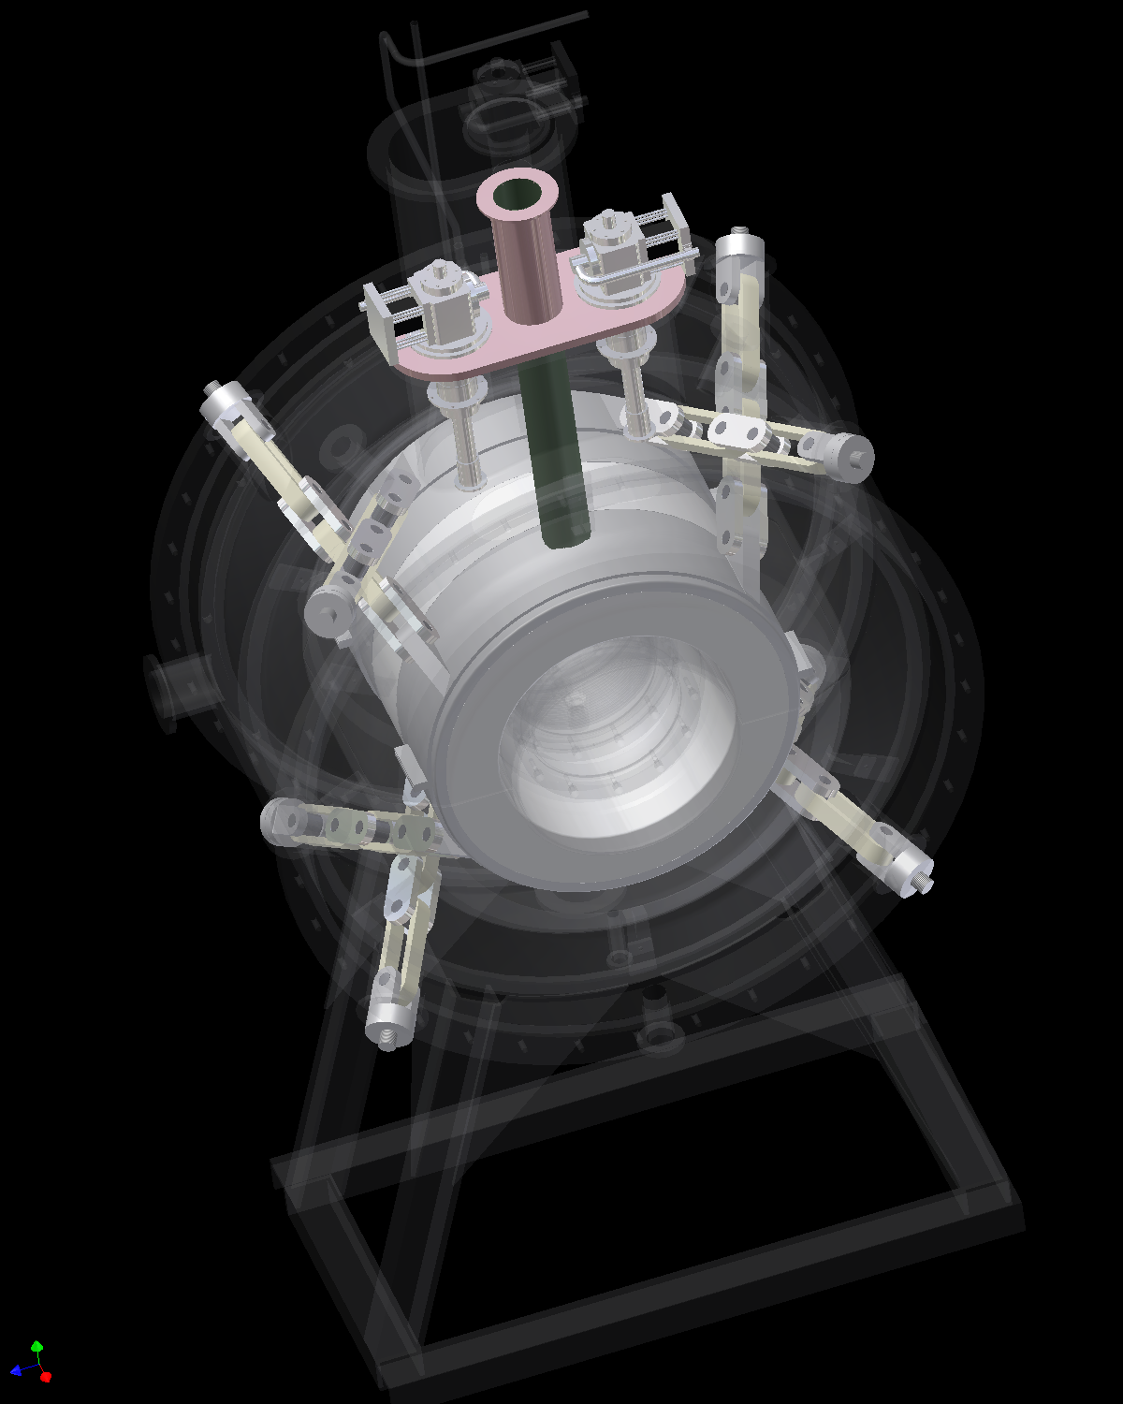
Figure 4.3-1. A Three-dimensional View of the Focusing Magnet Assembly
Magnet Cryostat
Hydrogen Window
S/C Coil 2
Absorber Vacuum

MICE Vacuum
Coil Former
Safety Window
Absorber Body
Hydrogen feed
Liquid Hydrogen Volume
Figure 4.3-1. A Schematic Cross-section of the Absorber Focus Coil Module.
Figure 4.3-3. A Half Cross-section of the MICE Focusing Magnet

4.4 Coupling Magnet
The coupling solenoid is a single superconducting coil around the four RF cavities of the RF- and Coupling Coil Module. The coupling coil confines the beam in the cavity module and, in particular, within the radius of the cavity beam windows. A cross-section of the RF and coupling module is shown in Error: Reference source not found. The coupling magnet design parameters are given in Focusing and coupling magnet parameters, and the coupling coil key dimensions are shown in Error: Reference source not found [6]. The two coupling solenoids will be operated in series using a 300 A, 10 V power supply. The maximum longitudinal force that will be carried by the cold mass support system is 0.5 MN during the expected operating and failure modes of the experiment [5].

Table 4.4-4. Focusing and coupling magnet parameters
Parameter | Focus Magnet | Coupling Magnet
Inner Coil Radius (mm) | 263 | 725
Coil Thickness (mm) | 84 | 116
Coil Length (mm) | 210 | 250
Coil Average J (A mm⁻²)* | 113.95 | 96.16
Number of Coils | 2 | 1
Distance Between Coils (mm) | 200 | -NA-
Number of layers | 76 | 104
Number of turns per Layer | 121 | 151
Design Current (A)* | 208.3 | 175.7
Self Inductance (H) | 98.6 | 563
Stored Energy (MJ)* | 2.14 | 8.69
Peak Field in the Coil (T)* | 6.39 | 6.51
4.2 K Temperature Margin (K)* | ~1.3 | ~1.4
Cold Inter-coil Force (MN)* | 2.36 | -NA-
Warm to Cold Force (MN)* | ~0.09 | ~0.15
* For the standard channel (case 1a) with p = 200 MeV/c and β = 42 cm using 300 K coil dimensions

The superconductor proposed for the focusing and coupling coils has the following parameters: 1) the conductor is a standard MRI magnet conductor with a copper to superconductor ratio of four; 2) the copper in the conductor has a minimum residual resistance ratio RRR of 75; 3) each conductor consists of 55 filaments that are 78 µm in diameter; 4) the conductor twist pitch is 12.7 mm; 5) the dimensions of the insulated conductor are 1.0 by 1.65 mm, and the conductor is rounded to prevent insulation cracking; 6) the design critical current for the conductor is 760 A at 4.2 K and 5.0 T [7].
Figure 4.4-1. A schematic cross-section of the RF and coupling module
Figure 4.4-2. A half cross-section of the MICE coupling magnet

4.5 Tracker Solenoid Magnet
The detector magnet assembly consists of five coils that fit into a cryostat that is about 2750 mm long assembled together to give a single cold mass [9]. There are two matching coils that match the muon beam from between the spectrometer coil set and the focusing coil set. The three spectrometer solenoid coils generate a uniform magnetic field (good to better than 1 percent) in a detector volume, which is 1000 mm long and 300 mm in diameter [1, 8]. The matching coils and the spectrometer magnet coils shown in Figures 4.7 and 4.8 are designed to operate using a three 300 A, 10 V power supplies. The three coils in the spectrometer part of the magnet (the two end coils and the centre coil) are hooked in series and are powered from one of the 300 A power supplies. The two match coils each have their own 300 A power supply. Two 50 A power supplies are across end coil #1 and end coil #2 to permit fine tuning of those coils with respect to the centre coil. The longitudinal forces that are to be carried by the detector magnet cold-mass support system are less than 0.50 MN during the expected operating and failure modes of the experiment.
The superconductor proposed for the matching and spectrometer coils has the following parameters [9]: 1) the conductor is a standard MRI magnet conductor with a copper to superconductor ratio of four; 2) the copper in the conductor has a minimum residual resistance ratio RRR of 100; 3) each conductor consists of 222 filaments that are 78 µm in diameter; 4) the conductor is twisted; 5) the dimensions of the insulated conductor are 1.00 by 1.65 mm, and the conductor corners are rounded; 6) the conductor design critical current is 760 A at 4.2 K and 5.0 T.

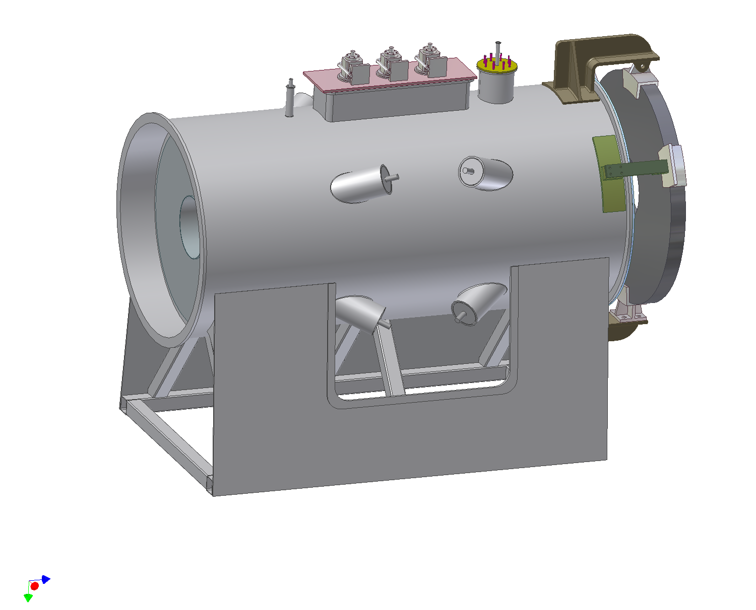

He Fill Neck
Cooler Neck
Lead Neck

Magnet Stand
Cold Mass Support
Space for Radiation Shield
PMT Iron Shield

Figure 4.5-1. A three dimensional view of the tracker module showing the positions of the magnet coil, and the iron shield for the photo multiplier tubes.

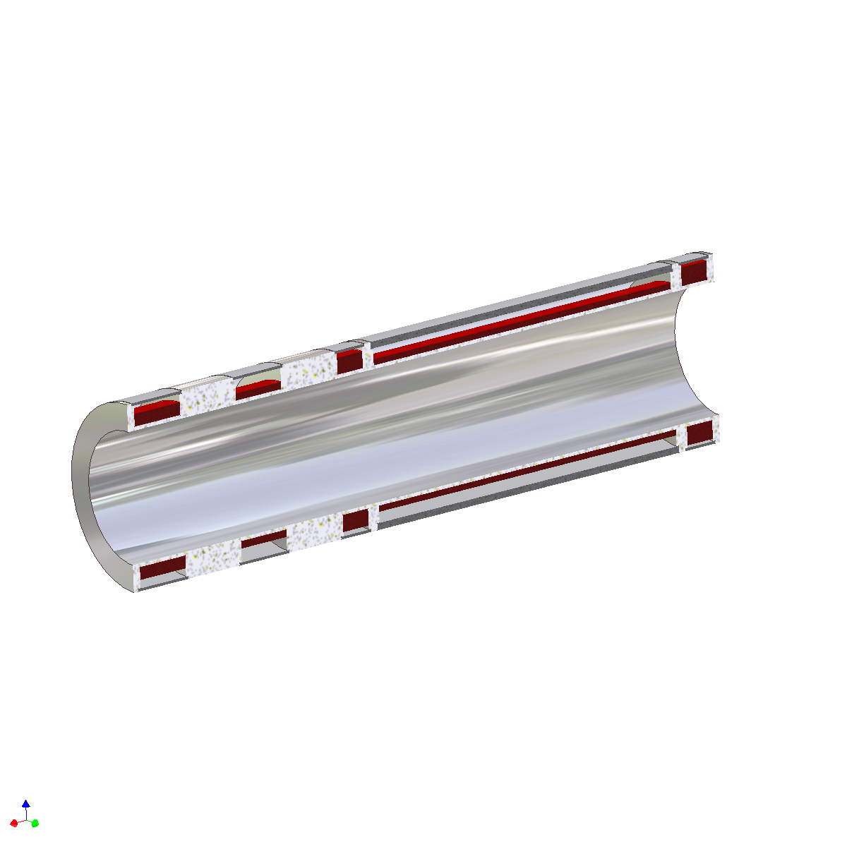
Match Coil # 1
Match Coil # 2
End Coil # 1
Center Coil
End Coil # 2
Al Mandrel
Cover Plate

Figure 4.5.2. A 3D cross-section of the tracker solenoid showing the positions of the five coils.

Table 4.5-1. Matching and spectrometer magnet design parameters
Parameter | Match 1 | Match 2 | End 1 | Centre | End 2
Inner Coil Radius (mm) | 258 | 258 | 258 | 258 | 258
Coil Thickness (mm) | 46.2 | 30.8 | 61.6 | 22.0 | 68.2
Coil Length (mm) | 198 | 197 | 110 | 1294 | 110
Current Centre Axial Position* (mm) | 3611.0 | 4051.0 | 4451.0 | 5201.0 | 5952.0
Current Centre Radial Position* (mm) | 281.1 | 273.4 | 288.8 | 269.0 | 292.1
Coil Average J (A mm⁻²) | 118.04 | 138.28 | 136.80 | 146.90 | 142.49
Number of layers per Coil | 42 | 28 | 56 | 20 | 62
Number of Turns per Layer | 120 | 119 | 66 | 784 | 66
Design Current (A)** | 214.2 | 251.8 | 249.5 | 265.9 | 265.2
Coil Self Inductance (H)^ | 13.1 | 5.8 | 9.6 | 41.6 | 11.4
Coil Stored Energy (MJ)** | 0.47 | 0.20 | 0.30 | 1.49 | 0.40
Peak Field in Coil (T)** | 4.7 | 2.42 | 5.61 | 4.02 | 5.62
Temperature Margin at 4.2 K (K)** | ~2.0 | ~2.5 | ~1.9 | ~2.3 | ~1.7
Conductor Length (m) | 8910 | 5730 | 7220 | 25720 | 7910
Coil Mass (kg) | 116 | 72 | 89 | 347 | 98
Total Conductor Length for Magnet (m) | 55490
Cold Mass Inner Diameter (mm) | 490
Cold Mass Outer Diameter (mm) | 690
Cold Mass Length (mm) | 2554
Vacuum Vessel Outer Diameter (mm) | 1404
Magnet Warm Bore (mm) | 400
Magnet Cryostat Length (mm) | 2780
Total Tracker Magnet Cold Mass (kg) | ~1390
Copper Shield and Intercepts Mass (kg) | ~290
Vacuum Vessel and Cooler Mass (kg) | ~1990
PMT Iron Shield Mass (kg) | ~1240
Total Tracker Solenoid Mass (kg) | ~4910 (with iron shield)
Peak Cold Inter Coil Force (MN)** | ~1.47
Peak Cold to Warm Force (MN)** | ~0.23 (with iron shield)
* R and Z are with respect to the centre of MICE (the centre of the central AFC magnet). R = 0 is the MICE axis.
** For the standard (Case 1) with p = 200 MeV/c and β = 42 cm based on the 300 K dimensions of the coils.
^ The self-inductance of the two end coils and the centre coil in series = 78 H.

The quench protection of the MICE magnets is designed to be passive. Where applicable, there are diodes and resistors across the coils to shunt current out of the coil, as it becomes conducting. Quench back is an important part of the quench protection of the coupling and focusing coils. Since the magnets are tied together inductively, a quench in one MICE magnet coil will likely trigger a quench in the other magnets of the string.
Figure 4.5-3 shows the load lines of the five coils compared with the I_{c}(B) curve. The case shown refers to a configuration, which is the worst case when the momentum is 240 MeV/c in either the flip or non-flip mode. It is clear that the design has a large enough temperature margin to ensure that the tracker magnet is stable. The added temperature margin means that the coil currents can be changed for tuning MICE.
The coils are wound on a machined aluminum mandrel. Between the coil and the mandrel is a 1-mm thick layer of G-10, which is used as ground plane insulation. The superconducting coil will be potted with fiberglass-epoxy. Outside of the coil there is a volume of liquid helium. The helium cools the coil all around, so that the temperature drop within the coil package is minimized. Each coil slot in the mandrel will have an aluminum cover plate, which forms a closed volume for the liquid helium that is around the coil. The liquid volumes around the coils are inter-connected. Liquid helium from the condenser is fed to the bottom of the magnet helium space. Helium gas is taken from the top of the helium space where it is fed back to the condenser. The liquid volume around the coil is shown in Figure 4.5-2.

Figure 4.5-3. The load lines for each of the spectrometer coils (peak field in the winding) compared with the conductor critical current curve.
The cold mass includes: 1) the coil package shown in Figure 4.5-2, 2) the piping that connects the 4.2 K coolers to the helium volume within the cold mass; and 3) the cold mass supports that are shown in Figure 4.5-4. The cold mass support system is self-centering as the magnet cools down from 300 K to 4 K. The cold mass is supported within the magnet vacuum vessel through 8 oriented fiberglass epoxy tension band assemblies with a length of 685 mm each. Each assembly consists of end brackets, a temperature intercept point (at 50 K) and two identical tension bands, which are about 220 mm long. (See Figure 4.5-4) There are four support strap assemblies at each end connected about 400 mm in from the end of the cold mass assembly. The eight tension straps assemblies hold the cold mass (1380 kg), and they are designed to carry a longitudinal force of 0.50 MN (~50 metric tons) without de-tensioning any of the tension band assemblies.
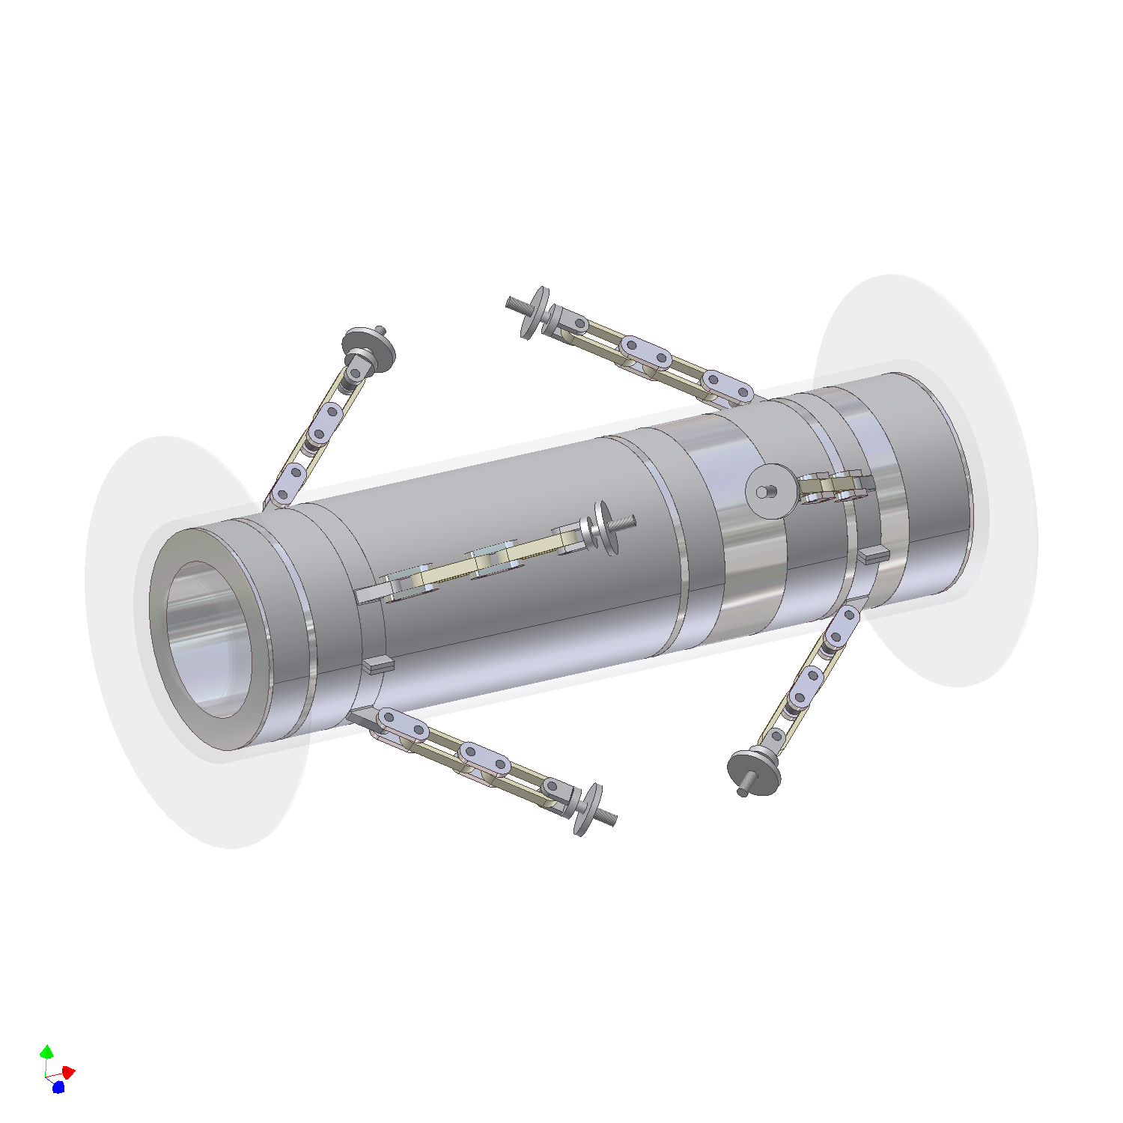
Cold Mass Support Clamp
Magnet Cold Mass
50 K Intercept
Support Band
300 K End
4 K End

Figure 4.5-4. The cold mass with its cold mass support system.
The cryostat has four main components: the thermal shield, the vacuum chamber, a chimney for the coolers, a helium vent line, and a chimney for the six 300 A current leads and the two 50 A current leads. The thermal shield completely surrounds the cold mass. The shield is connected to the first stage of the cooler and the intercept point on the cold mass support. The portion of the shield that is connected to the cold mass support intercept and the first stage of the cooler will be made from pure copper about 6.4 mm thick. The portion of the shield that is around the cold mass will be conduction cooled from the copper section connected to the first stage of the cooler.
The shield around the magnet will consist of cylindrical inner and outer shields, with shield plates across the ends of the magnet. The pure copper shields around the magnet will have a minimum thickness of 1-mm. Because one wants to avoid circulating currents in the shield during a magnet quench, the shield must not form a closed loop that contains magnetic flux lines. The inner and outer shields should have slots in them to kill the eddy current that might form during a magnet quench. Between the shield and the cold mass will be a minimum of 10 layers of MLI. Between the shield and the cryostat vacuum tank will be a minimum of 25 layers of MLI.
Table 4.5-2. Heat loads to the tracker solenoid
Parameter | Heat Load at 4.5K with 50 K Shield (W) | Heat Load at 4.5K with 80 K Shield (W) | Heat Load at 50 K (W)
Six 300 A Current Leads | 0.13 × 6 = 0.78 | 0.26 × 6 =1.56 | 11.85 × 6 = 71.1
Two 50 A Current Leads | 0.05 × 2 = 0.10 | 0.10 × 2 =0.20 | 3.5 × 2 = 7
Cold Mass Support | 0.14 | 0.24 | 3.8
Shield supports | 0.06 | 0.10 | 0.5
Radiation | 1.10 | 1.52 | 12.1
Necks, Pipes and Wires | 0.32 | 0.50 | 3.0
Total | 2.50 | 4.12 | 97.5

Table 4.5-2 shows the projected heat loads for the MICE tracker solenoid. The heat loads in the 4 K range are shown for two temperatures for the shields and intercepts. If the shield and intercepts is at 50 K, the heat load is low enough to cool the tracker magnet with two coolers. If the shield operates at 80 K, three coolers are required at 4.2 K. The estimated heat load into the first stage is low enough so that the first stage temperature for two coolers is between 50 and 60 K (This temperature depends on the type of cooler used.) With three coolers, the first stage temperature will be lower than 50 K. Table 4.5-2 suggests that two coolers can be used to cool the tracker solenoid. Figure 4.5-5 shows the tracker magnet with three coolers.
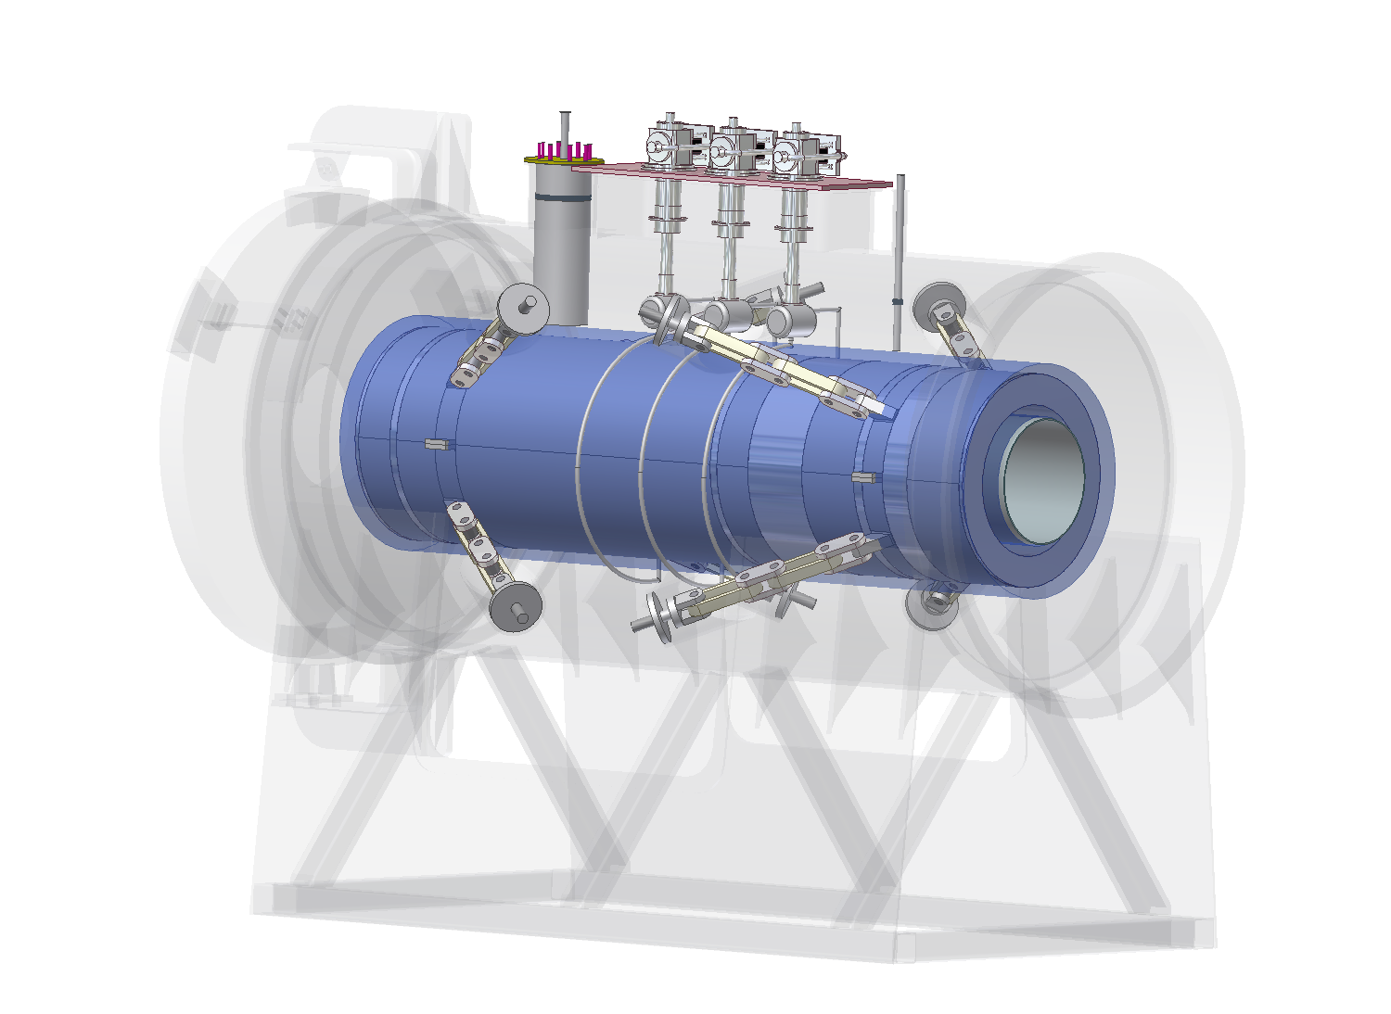
4.2 K Cooler
Condenser Tank
Lead Neck
Liquid Pipe
Gas Pipe
Cold Mass

Figure 4.5-5. The location of the tracker magnet coolers with respect to the cold mass.
The cooling power is provided by three coolers directly to the cold-mass through thermal-siphon heat pipes. There is a separate heat pipe for each cooler. The liquid side of the heat pipe connects to the bottom of the magnet liquid helium volume. The gas (two-phase helium) part of the heat pipe connects to the top of the liquid volume around the magnet. The concept of the thermal siphon heat pipe is described in section 4.6 of this report. The helium space around each of the five coils is connected to the helium space around the coil next to it, so cold helium that is fed into one coil is fed to all of the coils. Cooling the tracker solenoid at one point using the coolers will result in unacceptable temperature gradients inside the cold mass. The liquid coolant will better distribute the cooling power to the whole tracker magnet. Liquid nitrogen and liquid helium flowing through a tube attached to the cold mass will be used to cool down of the tracker solenoid. Care must be taken to see that there is no liquid nitrogen in the cooling tube when liquid helium is put into the system. Once the cold mass has been cooled to the 10 to 20 K-temperature range, the liquid volume around the magnet can be filled with liquid helium. Because, the temperature margins in the tracker magnet are large, the liquid volume should be filled only 85 percent full. The 15 percent gas volume above the liquid allows for the expansion of the helium into the space when the magnet temperature rises above 4.2 K. With the magnet filled to 85 percent of capacity, the magnet operating temperature can be anywhere between 3.5 K and 4.8 K.
The tracker magnet will have three pairs of 300 A leads and one pair of 50 A leads. Each matching coil will be connected in series with the matching coil in the tracker magnet at the opposite end of the MICE cooling channel. The two end coils and the center coil are connected in series. The three coils form the spectrometer section of the tracker magnet. The spectrometer section of the tracker solenoid will be connected in series with the spectrometer section of the tracker at the opposite end of the MICE cooling channel. Each end coil will have a small 50 A power supply across it to tune the tracker magnet and insure that the uniform field region of the tracker is uniform to the requirements of the specification. The power system for the two-tracker solenoid is shown in Figure 4.5-6.

Figure 4.5-6. The tracker solenoid power supply system.

.

4.6 Cooling the magnets and the use of closed cycle coolers
The proposed cryogenic cooling system for MICE uses a number of two-stage cryogenic coolers to cool the superconducting magnets [10] and the liquid hydrogen absorbers [11]. Two stage coolers can develop refrigeration at a 4 K (up to 1.5 W at 4.2 K) on the second stage while simultaneously generating a moderate amount of refrigeration (say 40 W at 60 K) on the first stage. At liquid hydrogen temperature (20 K), a small low temperature cooler will develop between 18 and 20 W at 20 K on the second stage while the first stage produces about 40 W of cooling at 60 K [11]
The superconducting coils for the MICE magnets will be cooled by conduction from liquid helium in a space on the outside of the magnet coils. A simple gravity feed heat pipe supplies cold liquid from the helium condenser to the bottom of the magnet. The boil off gas is re-liquefied on a condenser surface and the dense liquid helium is sent back to the bottom of the magnet helium tank. The amount of liquid helium in contact with the magnet depends on the amount of liquid helium reserve that is needed to keep the magnet cold while it is being discharged during a power failure without quenching. The volume of liquid helium in the solenoids will be quite low (say 10 litres). The advantages of using small coolers for the magnets are: 1) the cost of a number of small coolers is lower than the cost of a central refrigerator and the helium transfer lines needed to carry the cooling to the load; 2) The coolers are closed cycle so no helium purification is needed; and 3) the cooler compressor units are small and are located the experiment hall six meters from the cooler cold head. The compressor, the cooler cold head and the helium gas lines between the compressor and the cold head are purchased as a unit. The MICE cooler compressors must be supplied with about 120 kW of electricity heat removal by either air or water-cooling.
The requirements that must be met in order for the MICE magnets to be cooled with small coolers are: 1) the heat load at 4.2 K must be less than the cooler (or coolers) capacity at that temperature (1 to 1.5 W at 4.2 K per cooler on the second stage); 2) the temperature drop from the highest temperature point in the superconducting magnet coil to the cooler second stage cold head should be less than 0.2 K; and 3) there must be enough liquid helium in contact with the magnet to permit the magnet to be fully discharged in the event of a power failure. The heat leak into the cooler second stage is heat flow from the 50 K through cold mass supports and cryostat neck, radiant heat from the shields (< 0.2 W m⁻²), and the heat-flow down the current leads. The heat flow into the 4 K region is dominated by heat flow down the current leads. In order to limit this heat flow, high temperature superconducting (HTS) current leads are used from 50 K to 4 K. The 4 K lead heat leak is less than 1 W per kA lead pair. As a result, a magnet coils have an operating current of less than 300 A.
In addition to the requirements above, there must be enough refrigeration capacity from the first stage of the cooler (or coolers) at 50 K to cool the current leads, to intercept heat down the cold mass supports and necks, and to cool an intermediate temperature shield. The heat flow at 50 K is usually dominated by the heat leak down the current leads (about 70 W per 1000 A lead pair). This is good reason that the magnet current is less than 300 A.
The magnet cooler requirements for the magnets are as follows: 1) The coupling magnet, which has one pair of 300 A leads, requires a single 4 K cooler to keep it cold. 2) The focusing magnet, which has two pairs of 300 A will require two 4 K coolers to keep the magnet cold. 3) The detector module requires three coolers to keep the magnet cold. There will be three pairs of 300 A leads and two pairs of 60 A leads needed for this magnet. The projected heat budget for each type of magnet is shown in Table 4.6-1. All of the magnets for MICE channel and detectors will require fourteen coolers.
The method for reducing the ΔT between the cooler cold head and the hot spot in the magnet is to have liquid helium on the outside of the magnet coils. The helium gas boiled off from the magnet is re-condensed on an extended surface condenser attached to the cooler second stage cold head [12]. The cold liquid is returned to the magnet at the bottom of the helium tank. As the liquid warms up, it rises around the coil and eventually boils. This method can ensure that the liquid helium in contact with the magnet is less than 0.1 K warmer than the cold head (see Figure 4.9). By putting the liquid helium all around the outside of the coils rather than at one place on the coil, one can shorten the heat transfer path from the magnet hot spot to the helium in the cryostat. With careful design of the liquid helium region, the ΔT between the magnet hot spot and the cold head can be < 0.2 K [13].
Theoretically the superconducting magnets can be cooled down using the small coolers. The time for a magnet cool down using a cooler alone is the better part of one-month, so for practical reasons, liquid cryogens will be used to cool down the MICE magnets from room temperature to 4 K. The liquid cryogens required to cool the MICE magnets is given as follows: 1) The focusing coils, with a cold mass of 650 kg, require 380 L of liquid nitrogen and about 150 L of liquid helium to cool it down. 2) The coupling coils, with a cold mass of 1160 kg, require about 540 L of liquid nitrogen and about 275 L of liquid helium to cool it down. 3) The detector magnet, with a mass of 1390 kg, requires about 800 L of liquid nitrogen and about 320 L of liquid helium to cool it down. Once the magnets are cooled down, they will be kept at 4 K, even during maintenance or an absorber change.

Table 4.6-5. Magnet and Absorber Heat Loads and Cooler Stage Temperatures
Parameter | Coupling  Magnet | Focusing  Magnet | Detector  Magnet | LH₂  Absorber
1st Stage Multilayer Insulation Heat Leak (W) | 5.2 | 4.8 | 12.1 | 1.0
1st Stage Cold Mass Support Heat Leak (W) | 3.0 | 3.0 | 3.8 | ---
1st Stage Piping Heat Leak (W) | 1.0 | 1.0 | 2.7 | 2.4
1st Stage Instrumentation Heat Leak (W) | 0.3 | 0.4 | 0.8 | 0.1
1st Stage Current Lead Heat Leak (W) | 21.0 | 42.0 | 78.1 | ---
Total First Stage Heat Leak (W) | 30.5 | 51.4 | 97.5 | 3.5
First Stage Temperature (K) | 45 | 40 | 46 | 27
2nd Stage Multilayer Insulation Heat Leak (W) | 0.40 | 0.35 | 1.10 | 0.73
2nd Stage Cold Mass Support Heat Leak (W) | 0.10 | 0.10 | 0.14 | 0.20
2nd Stage Piping Heat Leak (W) | 0.20 | 0.20 | 0.34 | 0.1
2nd Stage Instrumentation Heat Leak (W) | 0.01 | 0.01 | 0.04 | 0.01
2nd Stage Current Lead Heat Leak (W) | 0.29 | 0.59 | 0.88 | ---
Total Second Stage Heat Leak (W) | 1.00 | 1.25 | 2.50 | 1.04
Second Stage Temperature (K) | 3.8 | 3.5 | 3.7 | 4.0*
* Because this temperature is 4 K, heat must be added to the second stage to keep the H₂ condenser at 15 K.

The MICE liquid hydrogen absorbers are also cooled using small coolers. For MICE there is no muon beam heating in the liquid hydrogen and the total heat leak into the hydrogen absorber is designed to be less than 10 W. One cooler is needed to cool each of the three liquid absorbers. A full description of the absorber focus coil module is given in Chapter 6.
Small coolers will also be used to cool the VLPC sensors for the scintillating fibre detectors. Through multiplexing the fibres and having a reduced first stage temperature, the refrigeration requirement at 5 K is reduced. The estimate of the required VLPC cooling is about 4 W at 5 K. The first stage of the cooler is more than adequate to handle the lead losses that are in the 30 to 40 W range. The first stage temperature is around 45 K. Two 4.2 K coolers will handle the VLPC heat load.
Figure 4.6-3. A Schematic Representation of the Cooler Cooling Circuit for a MICE Coupling Magnet

Magnetic Measurements
It is essential to know all the magnetic fields in MICE to the level of 10⁻³ and this requires a careful measurement system. This will be based on local meaurements associated with a calculated field reconstruction. The precision of such a measurement system relies on the knowledge of the locations of the sensors and of the positions of the superconducting coils in space. Therefore a precise knowledge of the geometric data of the superconducting coils is needed. Figure 4.7-4 shows schematically how the magnetic field measurement and monitoring system works.
The location of the magnetic sensors depends on what part of the experiment they are connected to: 1) for the cooling part of the experiment the magnetic sensors should be placed outside the vacuum vessel, if possible in high field gradient regions; 2) for the spectrometers the sensors should be placed within the magnet, near the fibre layers. A support structure that holds together all of the detector components and magnetic sensors is needed. The positions of the sensors with respect to all of the coils must be known.
In all the cases the sensors must be placed in planes perpendicular to the beam axis, approximately on the same radius and at 120° azimuthally to each other. Figure 4.7-4 shows a scheme for the positioning of the sensors.

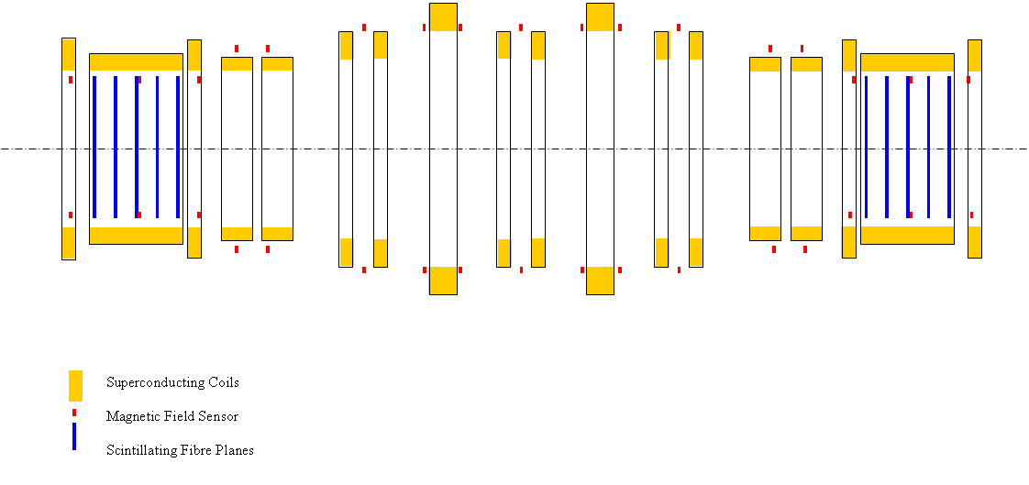
Figure 4.7-4. A schematic of the positions of magnetic sensors with respect to the magnet coils in MICE.

The magnetic measurement scheme proposed for MICE has already been developed for the ATLAS experiment at CERN and most of the components exist. The sensors have been developed by CERN and NIKHEF and are based on 3D hall probes with the associated electronics. Figure 4.7-4 shows a picture of such a sensor. The sensor needs to be calibrated for a range of magnetic fields up to 4.5 T. The field sensors will have to be upgraded for fields up to 4.5 T, following a development already underway for the CMS experiment.
Table 4.7-6 summarizes the characteristics of the probes and gives the level of precision needed in their positioning. In order to reach the maximum precision, the calibration of the sensors has to be performed against NMR probes, for all three space orientations, in a 4 T field having homogeneity of 10⁻⁵ T over 1 dm³. In such a case, if one knows the position of the superconducting coil within 1 mm, the axis of the magnetic system can be determined with an accuracy of around 0.2 mm.
The method for making the magnetic measurement once the magnet system is assembled is as follows: 1) survey the position of each sensor around the experiment with a theodolite; 2) power each coil separately to reconstruct its respective position in space knowing its current and geometrical shape; 3) power the whole experiment and make the field reconstruction in the experiment knowing the currents, the positions of the sensors and magnets, and the relative displacements of the magnets due to their attraction or repulsion.

Table 4.7-6 Characteristics of the Hall Effect sensors
 | MICE requirements
Magnetic field | 4.5 T
Precision | ( 2x10⁻⁴ × B ) T
Spatial precision in positioning | 1 mm
Angular precision in positioning | 2 mrad

Figure 4.7-5. A picture of one ATLAS magnetic sensor with its electronics.

