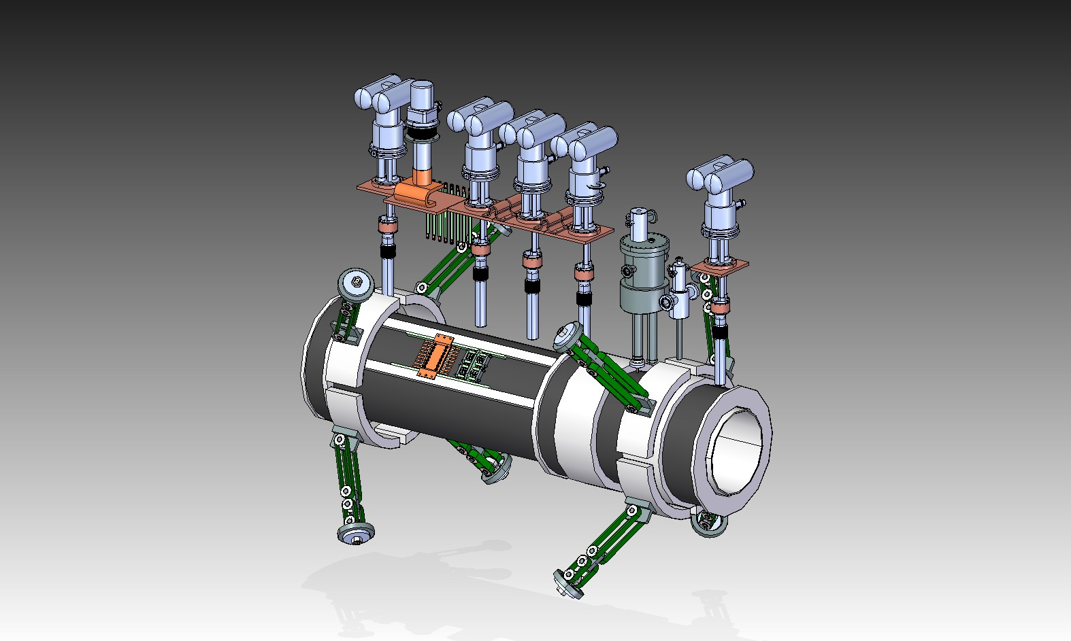

~~SD 18 inside bore~~

3rd Level sensor within Fill / Vent tube. All internal cables exit through the same tube

2 He Level Sensors inside He volume

~~CX 01 inside He volume~~

~~CX 02 inside He volume~~

~~SD 22 Cold Mass bore bottom~~

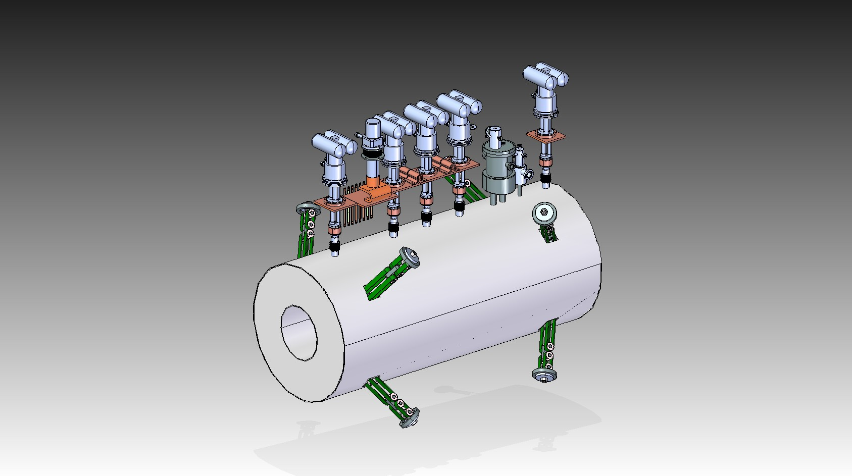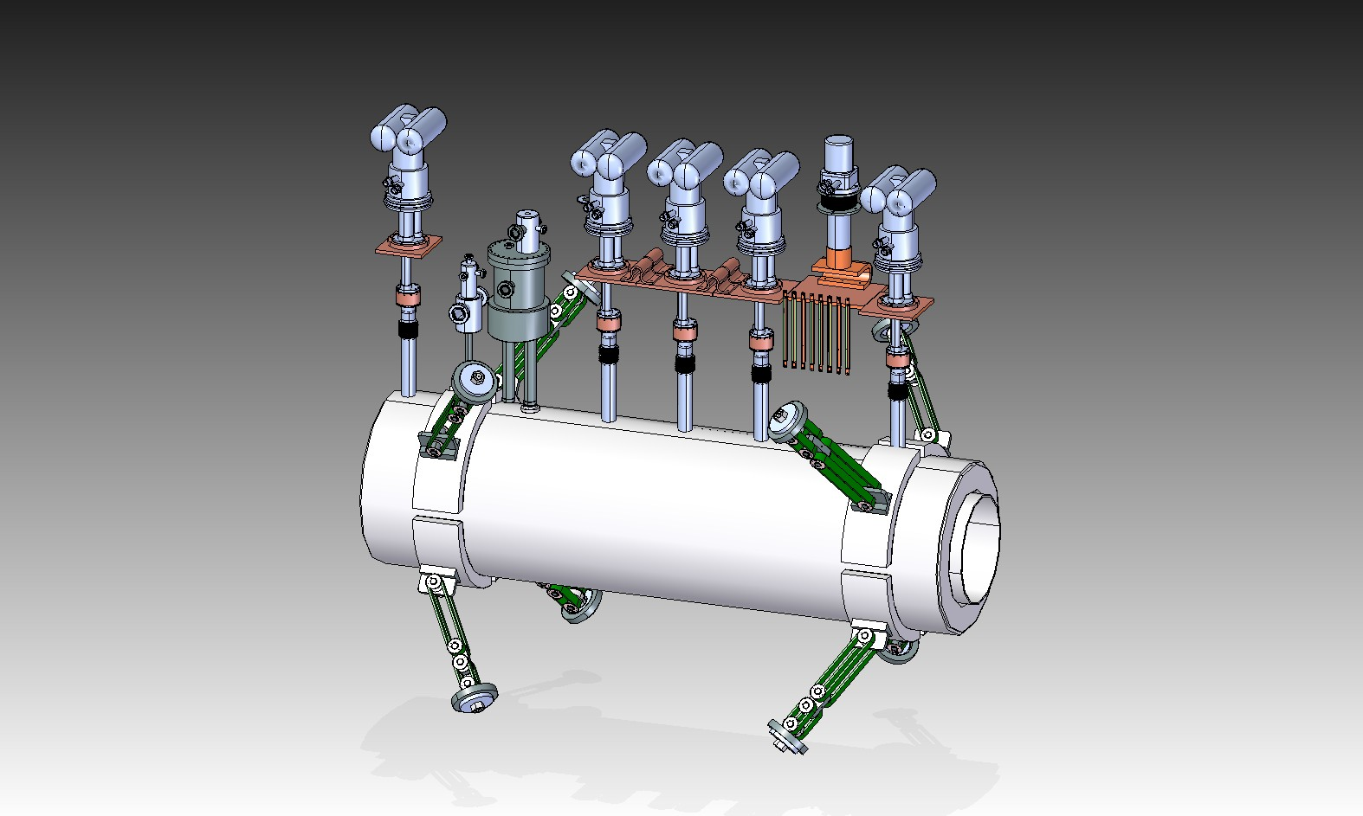

CX 2

CX 1

SD 19

SD 20

SD 26

CX on the bottom of the cold mass cover plate and CX on the He fill line. To ascertain if LN2 still inside the cold mass.

CX 12 On Cold Mass Cover

CX 11 On He fill line

New Strip heater to boil off any residual LN2 during cool down operations. One on fill line and one on He vessel cover. (Fill line not shown)

SD 02 to monitor the gradient between the copper plate and radiation shield

SD 09 to monitor gradient between support and radiation shield

SD 23 (Inside radiation shield bore)

SD 24 (on Matching coil end steel knuckle)

SD 04 to monitor gradient between support and shield

SD 25 centre bottom of the radiation shield to monitor the farthest point from cooling.

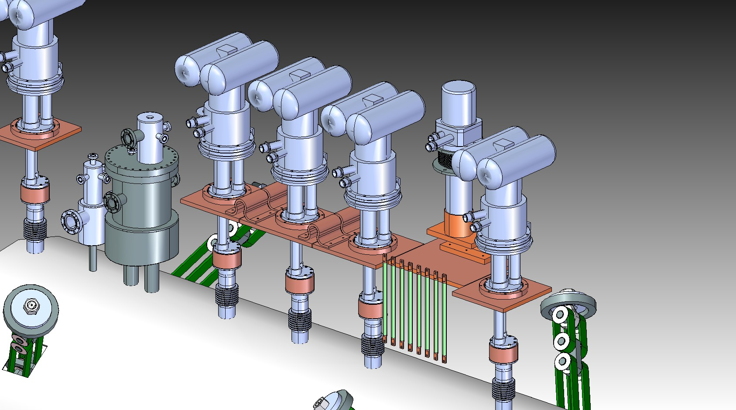

CC5

CC4

CC3

CC2

CC1

CX10 Aluminium flag / Feedthrough to monitor the cold end of the HTS Leads

SD 16

SD11

SD05

CX06

SD06

SD12

CX07

SD07

SD13

CX08

VTL09-16

B A D C F E G H

VTL01-08

CX09

SD15

SD14

SD 27

SD08

CX05

SD10

SD 03

SD 01

H1, H2 and H3 will exit through the He can of the Fill / Vent tower

V1, V2 and V3 will exit through the vacuum can of the Fill / Vent tower

Use these two sensors for thermal interlock. Two sensors to give redundancy