 | Istituto Nazionale di Fisica Nucleare  Sezione di Pisa  Largo Bruno Pontecorvo, 56127 Pisa – Italy. http://www.pi.infn.it

Mechanical tests of Titanium-Stainless Steel bimetallic transition joints
Issue: 1.0
Date: June 6, 2008
Authors: A.Basti¹, F.Bedeschi¹, M.Beghini², F.Frasconi¹

1 - INFN/Pisa, Italy
2 - DIMNP/Pisa, Italy

Change Record

Issue | Date | Affected Paragraphs | Reason/Remarks | Author
1.0 | 6/06/2008 | All | First Draft | A. Basti

Table of Contents

1. Introduction 3
2. The Ti-SS transitioN SAMPLES 3
3. UNIAXIAL TENSion TESTS 4
4. CONCLUSIONS 11
5. References 11

Introduction

This note describes the mechanical tests performed on two bimetallic Titanium-Stainless Steel (Ti-SS) transition joint samples in Pisa.
These tests have been done in the context of collaboration between INFN–Pisa and the JINR-Dubna laboratory for ILC. These bimetallic joints could help simplify and reduce the costs of the cryomodules holding the ILC superconducting cavities.
The two Ti-SS transition joints are part of the last batch (nine pieces) of samples successfully tested at the end of January 2008 at Pisa [1]; they are manufactured in Russia like the others already tested in the past [2].
In these joints two pipe sections (with an external diameter of 1-1/2 inch, 48.2 mm) were welded together by explosion bonding technique applying an external stainless steel collar covering the junction line of the two materials.
The tests have been made in collaboration with the Department of Mechanical, Nuclear and Production Engineering (DIMNP) of the University of Pisa and they were performed in their laboratory.

The Ti-SS transitioN SAMPLES

One Ti-SS transition joint sample welded by explosion bonding is shown in photo in fig.1.

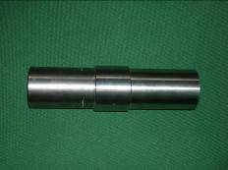

Fig.1. Photo of one Ti-SS transition joint sample.

They are made of two equal diameter pipe sections, one made of Titanium (Ti) and the second one made of Stainless Steel (SS), connected by means of a SS collar explosion bonded on the external surface of the tubes.
The pipe sections have been provided to the Russian company by INFN-Pisa and they were obtained from standard SS (316L) and Ti (gr.2) seamless pipes (1-1/2” NB x sch.10S - ISO 48.3 x 2.6 mm); the SS collars were also supplied by INFN-Pisa and they also come from 316L standard seamless pipes (2” NPS x sch. 40S - ISO 60.3 x 3.9 mm), some mechanical properties of these two materials are reported in table 1.

 | Titanium gr.2 | Stainless steel 316L
Young’s modulus (GPa) | 116 | 193
Poisson ratio | 0.32 | 0.3
Elong. (%) min | 20 | 40
Yielding stress (MPa) min | 275 | 170
Tensile stress (MPa) min | 345 | 485

Tab.1 Mechanical properties of the Ti and SS at room temperature.

The Ti-SS transition joints were externally machined after the explosion bonding process to obtain the dimensions reported in the fig.2, by the Sarov (Russia) Company.

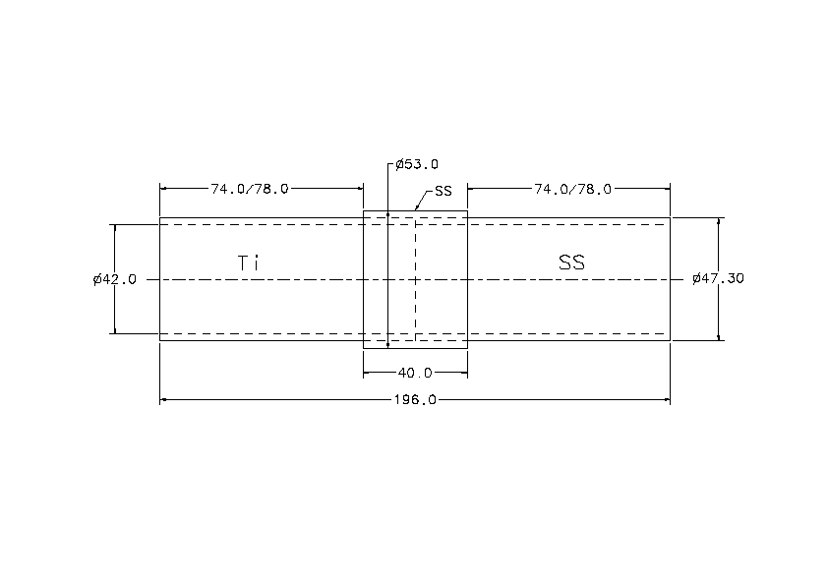
Fig.2. Dimensions (in millimetres) of the Ti-SS transition samples.

An annealing treatment (540˚C for 30 minutes in vacuum) reducing the machining stress underwent by the sample during the explosion bonding process has also been done on some joints by the Russian company. The tests were performed on two samples labelled n.4 and n.10, the thermal treatment was performed only on sample n.4 [1].

UNIAXIAL TENSion TESTS

To connect the samples to the tension machine, we needed to reduce the external pipe diameter and for that reason we welded two connecting pieces on free ends of SS and Ti pipes. The two connecting pieces were made in stainless steel 316L and titanium gr.2 (see photo in fig.3). After welding the connecting pieces were machined to achieve the alignment of the axis of these pieces with the transition joint axis.

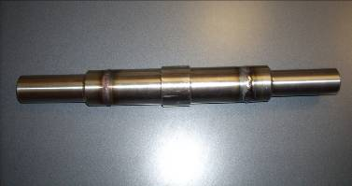

Fig.3. The Ti-SS transition joint sample ready for tension test.

To test the quality of SS and Ti welds we decided to build and test two other samples made with a section of standard seamless 1-1/2” pipe (200 mm long) in 316L and Ti.gr.2 welded to two connecting pieces according the procedure followed to prepare the Ti-SS transition joint samples.
These last two samples were loaded before and they have also been useful to set-up and check the testing procedure.
The photo in fig.4 shows all samples prepared and tested.

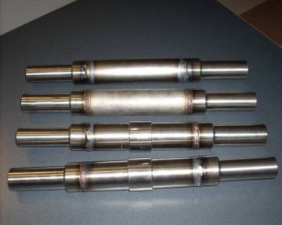

Fig.4. Samples prepared and tested.

All welds were made according the TIG welding procedure. The TIG welding of titanium was made in Argon atmosphere inside a closed box [2]. All welds are made by an Italian company close to Pisa (TECNOINOX s.r.l.).
The mechanical tests have been performed using a standard tension load test machine connected to a computer control system and an acquisition system capable to monitor online the values of the applied load and the displacement of the clamps. The maximum applied load of the machine is about 250 kN. The tests were made in displacement control.
The first uniaxial tensile test was performed with the sample made with the stainless steel 316L 1-1/2” pipe at room temperature. The photo in fig.5 shows the sample before the starting of the test. The load/displacement plot recorded during this test is shown in fig.6.

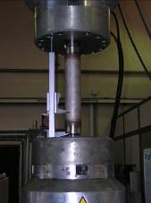

Fig.5.316L pipe sample under test.

Fig.6. Load/displacement plot of the 316L pipe test.

As we can see from the analysis of the plot we didn’t achieve the breaking point of this sample, after we arrived to the maximum load of 220 kN (value close to the maximum load of the machine), the apply load started to decrease because the section of the pipe started to shrink.
This maximum applied load correspond a stress in the pipe thickness of about 622 MPa.
At the end of test we measured a big elongation of the sample (about 40 mm) and a clear reduction of the pipe diameter in the centre (about 2 mm).
The second test was performed with the sample made with the titanium 1-1/2” pipe.
The load/displacement plot recorded during this test is shown in fig.7.
A photo made at the end of this test is reported in fig.8.
Fig.7. Load/displacement plot of Ti gr.2 pipe test.

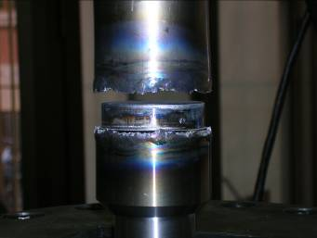

Fig.8. Photo of the broken area in titanium pipe test.

In this test we achieved the breaking limit of one weld between one extremity of titanium pipe and its connecting piece with a load of about 200 kN (566 MPa in the pipe thickness). The breaking has been fragile but it arrived after the yield of the titanium at about 160 kN (453 MPa).
It’s important to notice that from a visual analysis of broken area we found that the welding material didn’t fill the whole thickness of the titanium pipe (see fig.9).
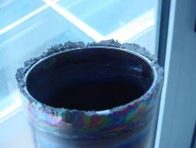

9. Photo of the breaking area in titanium pipe.

After these two preliminary tests we perform the tests on SS-Ti transition joint samples prepared.
The first was the aniaxial tensile test with one transition joint sample (sample n.10) at room temperature. Photos of the Ti-SS transition joint sample during the test and after the breaking are shown in fig.10 and 11. The load/displacement plot recorded during this test is shown in fig.12.

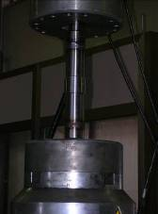

Fig.10. Photo of Ti-SS transition joint sample under test.

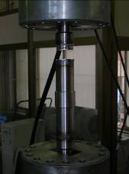

Fig.11. Photo of Ti-SS transition joint sample after the break.

Fig.12. Load/displacement plot of Ti-SS transition joint sample test.

Like we expected we reached the breaking limit of one titanium welding. The breaking has been fragile and it arrived without an evident change of slope of the curve (plasticity of material), the maximum load was a little bit less than before (180 kN), but the corresponded value of stress in the pipe thickness was always high, about 509 MPa.
In this case also, from the analysis of the broken area, we found that the welding material didn’t cover all the thickness of Ti pipe (see fig.13).

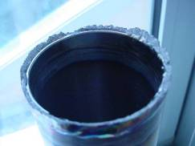

Fig.13. Photo of the breaking area in titanium weld of TI-SS transition sample n.10.

The second test was performed with the second Ti-SS transition joint sample at about 77K.
The Ti-SS transition joint sample has been dipped inside a Dewar filled with liquid nitrogen and we waited until thermal equilibrium was achieved (no bubbles visible around sample surfaces).
After that the sample was quickly taken out of the Dewar and put in a box made with foam material in which the extremities of the samples were outside the box.
We connected the extremities of the sample to the clamps of the load machine in this condition and we started to apply the load.
The load/displacement plot recorded during this test is shown in fig.14.
Fig.14. Load/displacement plot of Ti-SS transition joint sample (n.4) test at 77K

We achieved the maxim load (about 220 kN, 620 MPa in the pipe thickness) without to obtain the breaking of the sample. The behaviour of the material was elastic and the displacement went back to zero after the unloading of the sample.
After the end of this last test we decided to perform another unaxial tension test on the same TI-SS transition joint sample (n.4) at room temperature. We warmed fast the sample putting it in a flow of warm water and we waited that the external surfaces reached the room temperature. Then we loaded the sample in the standard way at room temperature.
The load/displacement plot recorded during this last test is shown in fig.15.
Fig.15. Load/displacement plot of Ti-SS transition joint sample (n.4) test at room temperature.

This time we achieved the break of the sample with a relatively low load, 180 kN (500 MPa on pipe thickness) compared with the previous test on Ti-SS sample n.10 at room temperature, and the break happened in the weld between the SS pipe and its connecting piece.
We supposed that the fast thermal variation between the 77 and 300 K had introduced some microcracking in the weld material of the SS pipe.

CONCLUSIONS

The performed mechanical tests show a high resistance of Ti-SS transition joint samples.
From them we cannot to calculate exactly the strength value of the bond because we always achieved the breaking in the welds between the samples and the connecting rods and the number of samples tested has been very low (only two, in two different conditions).
From the minimum break load (180 kN at room temperature and 220 kN at 77K) we can evaluate that the value of the shear strength of the explosion bond is greater then 60 MPa at room temperature and 70 MPa at 77 K.
In the future we plan to improve the quality of the welding between the Ti pipe and its connecting piece and to repeat the tests with the same procedure; in this way we will try to increase the accuracy of the tests and of mechanical characterization of the joint.

References

[1] A.Basti et al, “Characterization measurements of Ti-SS Bimetallic transition joint samples”, ILC-NOTE-2008-044, May 2008;

[2] A.Basti et al, “Leak rate measurements on bimetallic transition samples for ILC cryomodules”, ILC-REP-PIS-002, September 2007;

