 | Pixel Optical Connectivity
ATLAS Project Document No: | Institute Document No. | Created: 20/04/2004 | Page: 1 of 13
ATLIP-ES-0102 |  | Modified: 18/05/2004 | Rev. No.: 2
Engineering Specification
Pixel Optical Connectivity

Abstract
This document describes the format and functionality of the tables definine Optical Fiber and Ribbon Connectifity from the Opto Daughter-cards at PP0 through PP1 up to the BOC/ROD in USA-15
Prepared by:  E. Anderssen, LBNL | Checked by:  D. Guigni, G Lenzen | Approved by:  PDSG
Distribution List

History of Changes
Rev. No. | Date | Pages | Description of changes
2 | 18/05/2004 | 13 | This is the initial Release (2) of this document--it is the first time that a written explanation of the tables was included in this EDMS Document

Table of Contents

1 Introduction 4
2 Requirements 4
2.1 Opto Card layout 4
2.2 Layout of Opto Cards on PP0 5
2.3 Optical Ribbons and Optical Cables 6
2.4 PP1 Connection 7
2.5 ROD mapping 7
3 Nomenclature and Identification 7
3.1 Patch Panel 0 Nomenclature 7
4 Connectivity 9
4.1 PP0 to PP1 mapping 10
4.2 PP0 to Fiber Mapping 10
4.3 Connectivity Tables for Optical Cables 11
4.4 ROD Mapping 12
5 References 13
6 Appendices 13
6.1 EXCEL File ATL-IP-EP-0102_AppendixA 13

Heading 1

Introduction
This document describes both the physical and logical connectivity of the optical services within and external to the Pixel Detector volume. The Table which defines this connectivity is included as an appendix to this document, and its format is described in this document. Also included here is a brief outline of the assembly sequence for the internal optical ribbon routing. The document will start with a survey of the internal components and routing elements of the optical services within the Pixel Service Panels, culminating in the PP1 optical connector. The table layout will then be discussed mapping elements of the table to physical objects in the prior section. External Optical Cable routing (PP1 to the racks in USA 15) is handled by ID and TC and is not included here. Connectivity of the cables inside of these racks is a Pixel responsibility, and will be covered in the final section of this document. At the present level of release, this is not complete.

Requirements
The connectivity and how it distributes itself across cables formed the major constriction on connectivity. Also considered was the physical assembly order and how it mapped to the connector array. Finally the distribution of cables to the RODs based on function was considered. These are all inter-related, and were considered together to optimize the layouts of PP0 and PP1. Many are not requirements per se, but priorities which make some aspect of the connectivity possible. ‘Requirements’ will be strictly stated below.

Opto Card layout
All optocards plug into an 80-pin surface mount connector at the end of their respective PP0 Flex cards. These cards are arrayed on the PP0 service Panel, and each PP0 and thus optocard services a given local support. In the case of a Stave (Pixel Barrel element), each PP0 serves half of a stave with 6 or 7 modules. Each Sector has only 6 Modules and is also served by one PP0.

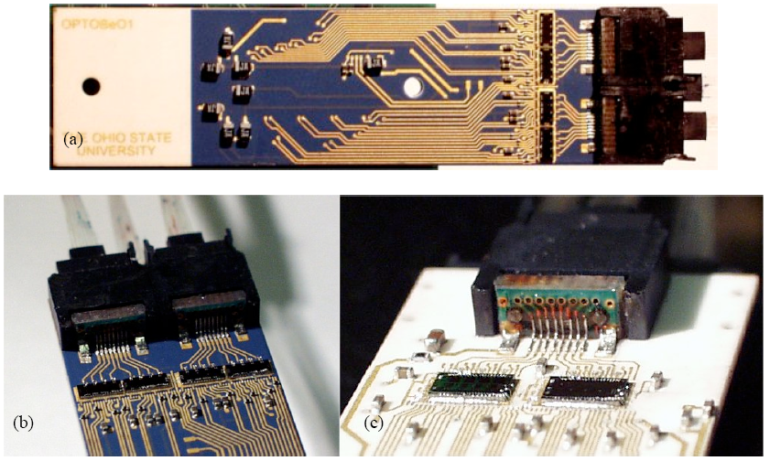
Figure 1 Opto Card--Top of Card (a); DTO Opto packs detail (b); TTC Opto back on bottom of card (c)

On a given optocard, there are electrical and optical connections. They perform the function of translating Optical Control signals on the TTC lines into electrical communiqués to the MCC, and accepting Data Output (DTO) electrical signals from the MCC and transferring this stream to one of two, or both, DTO optical packs. On every optocard there is one TTC Optopack on the underside (same side as 80-pin electrical connector), and up to two DTO Optopacks on top. These are both different types of Optopacks. The TTC Optopack has an array of PIN Diodes to receive optical signals from an 8-way optical fiber ribbon, where the DTO Optopack has a similar array of VCSEL’s to drive signals into an 8-way ribbon. These Opto Packs are contained in housings on the optocard which retain directly an MT8 fiber ribbon connector. The guide pins shown in Figure 2 directly align the MT8 connector with the opto chip array.

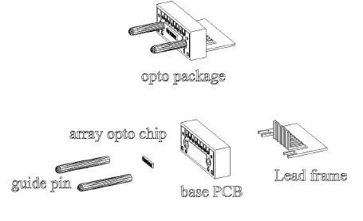
Figure 2 Opto Pack Assembly, array opto chip depends on type of pack TTC/DTO, courtesy Academia Sinica and Radiantech Inc, Taiwan

There are two physical types of Optical Card assemblies. At this stage of Optical Card design, there are now physically two types of cards, one supporting two DTO opto packs, and the other supporting only one, loaded in either position. This may change in the future such that the Optocards differ only by how they are loaded, but currently this is not the case. This current distinction is immaterial to the connection table as the requirements on the opto-cards are such that data must be delivered to one or both depending on the local support serviced. A Disk or Barrel Opto-card has need of only one DTO opto-pack, where a B-Layer optocard needs to use both. All optocards have one TTC input opto-pack on their underside.

Layout of Opto Cards on PP0
A constraint on the optocards is placed on their position as loaded on the PP0 panel. It is required that the outer most optocards have their respective opto-packs loaded toward panel center (so that the outer corner of the service panel is not loaded with an opto-pack). This is an envelope requirement placed on the service panel—it gives a larger clearance to the Pixel Support Tube. This is illustrated below in Figure 3. Panel loading and how it maps the local supports to the RODs was also considered in the initial phase of connectivity layout. Depending on which ROD a given local support must go to determines to first order which opto-cable a local support must report to. This reporting is complicated, but basically means that similar service requirements are grouped together physically where possible on the PP0 panel, with priority given to the B-Layer. This requirement will be described in the ROD section of this document, but enters into where Opto Cards were placed on the PP0 Panel.

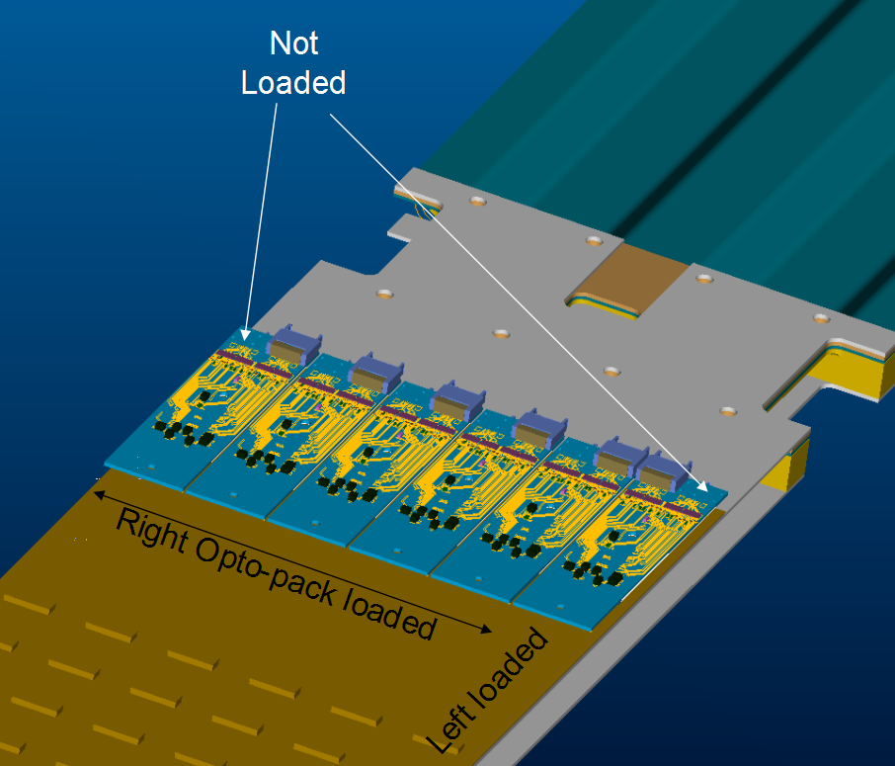
Figure 3 Optocard loading of service panel showing outermost opto packs loaded toward panel center

This requirement, and grouping consideration means that the B-Layer, which requires both DTO opto packs, cannot be loaded in the outer positions. Thus, all B-Layer opto-cards (PP0 flexes) are located in the middle two positions of the service panel (positions 3&4 out of 1 thru 6). Note that the model shown above in figure 3 does not show a double opto-pack in the middle positions. The model shown is only meant to illustrate the requirement that for all other (NOT B-Layer) opto-cards e.g. Disk, Layer-1, Layer-2, optocards that at least a small set of optocards must be loaded with opto pack loaded on the left.
An important distinction here is that for all optocards which are not the B-Layer, the DTO opto pack is simply called DTO-1 regardless of whether loaded left or right; where the B-Layer opto-pack DTO’s are designated DTO-1 and DTO-2, where DTO-1 is loaded right when looking away from IP at an installed optocard ). Depending on the architecture finally decided upon for the optocard itself—whether there is only one or if there are in fact a flavor each for B-Layer and other, then it might make sense to encode which ‘channel’ of DTO is used, but for now it is assumed that DTO-1 will be ‘shorted’ with DTO-2 on all but the B-Layer optocards.

Optical Ribbons and Optical Cables
All Pixel optical fibers are ribbonized into 8-way fiber ribbons. Near and inside the detector volume, ‘Rad-hard’ fiber is used. At a certain distance from the detector, approximately 12m, a splice to a ‘Rad-tolerant’ fiber ribbon is made. The splices and construction of these ribbons and cables is completely described in [4]. What is important from the point of view of connectivity about these ribbons and cables is discussed here.
Inside of the PST, fiber ribbons are terminated in pairs to one MT16 connector at PP1. The PP0 end of each ribbon is terminated in an MT8 for each Opto-card connector. Each ribbon pair is ‘long’ or ‘short’ based on which optocards they service.
Optical cables are bundles of 8 optical ribbons in one ruggedized jacket. Ribbons are split out at each end and jacketed with some reinforcement between the Cable Jacket and their respective connector. At the PP1 end, this connector is an MT16, thus two 8-fiber ribbons are terminated in one connector. At the Rod end, all fibers are terminated in MT8 connectors, one per ribbon. Lengths of these breakouts are intended to allow easier routing and possible splitting of cables at the connection ends.
The splice in the optical cable places a soft requirement on the cable. The type of rad-tolerant fiber spliced to the Rad-hard fiber after the first ~12m of cable depends on whether the ribbon carries a DTO or TTC signal, i.e. on the direction of travel of the light. TTC fibers have a larger core rad-tolerant fiber, and DTO has a smaller core—this minimizes light losses at the splice. The requirement is to minimize the number of different ways these two types of splices are combined into cables. Based on the inventory and connectivity of DTO and TTC, this works out to 5 Data (DTO) cables, 4 Control (TTC) Cables, and 1-Hybrid (half TTC/half DTO) cable per quadrant. All spare cables are Hybrid, and there are two spares per side. This numerology will be laid out in the connectivity tables described later.

PP1 Connection
At PP1 there is a mechanical interface to an Ericsson provided connector. This connector is manufactured under contract by Diamond who also terminates all of the fiber ribbons. This connector is a 4 X 10 array of MT16 connectors, based on a Diamond standard connector. The fiber ribbons internal to the PST and the Optical cables external to the PST are both terminated with this MT16 connector. One row of this connector maps to one optical cable.
On the inside of PP1, there are 10 organizing trays and ribbon seals. These trays are designed to take up differences in length from both routing and connector termination allowances. The seal is a packed silicone block, which is loaded as the ribbons are installed. The internal ribbons are installed starting at the PP1 connector plate, and fed into the routing features in the organizing tray and those along the panels and PP0 up to their respective optocards. The order of assembly is defined in large part by the access available during assembly, and this has the effect of determining which optocards map to which cable in the PP1 connector.

ROD mapping
For the purposes of this document and the connectivity table, ROD will mean a given ROD module (board) in a given ROD Crate, which includes its associated BOC. BOC to ROD is a 1:1 mapping so this should suffice for connectivity.
There are 16 RODs per Crate, and up to 3 Crates per Rack (plus requisite power module per rack). Pixels currently have 4 racks assigned in the Trigger/Daq region of USA 15. Each ROD can handle a particular set bandwidth. This bandwidth is equivalent to 28-modules at 40MBit/s, 14-modules at 80MBits/s or 7 at 160MBit/s. Flavors of the BOC mounted on a given ROD handle some of the multiplexing of fiber ribbon inputs needed to achieve this, but this is ignored here. The aforementioned bandwidths, summarized in Table 1below, determine which local support optocard can attach to which ROD.

Rod Flavor | Number of PP0 Flexes Serviced | Number of DATA Ribbons (MT8 connectors on BOC) | Number of Fiber Ribbons Per Opto-Card | Link Speed per Ribbon | Number of Modules (MAX)
B-Layer | 1 | 2 | 2 | 80 | 7
Layer 1 / Disk | 2 | 2 | 1 | 80 | 14
Layer 2 | 4 | 4 | 1 | 40 | 28
Table 1 Local Support Bandwidth requirements

It is extremely desirable to group ribbons going to the same crate in an optical cable i.e. not split ribbons from one cable amongst two racks. It is also desired to populate Crates in such a way that physical detector elements which are close to each other on the detector are also together in a Crate. The layout will try to achieve this subject to all of the constraints.

Nomenclature and Identification
This naming convention is consistent throughout all connectivity tables, and parts of other connectivity tables are excerpted here to show consistency. The cardinal connectivity table is contained in ATL-IP-ES-0102, ‘Module to PP0 Connectivity.’ This document describes which module from any given local support is connected to which connector on any give PP0 flex. The PP0 Flex Name and it’s associated Local Support appear as the primary cross reference in all connectivity tables.

Patch Panel 0 Nomenclature
This section lays out the naming convention used to locate PP0 Flex boards on a service quarter panel, as well has identification of service quarter panels within the experiment. Information on the overall naming convention can be found in Reference [1], and portions of this section here are replicated from ATL-IP-ES-0073v2.

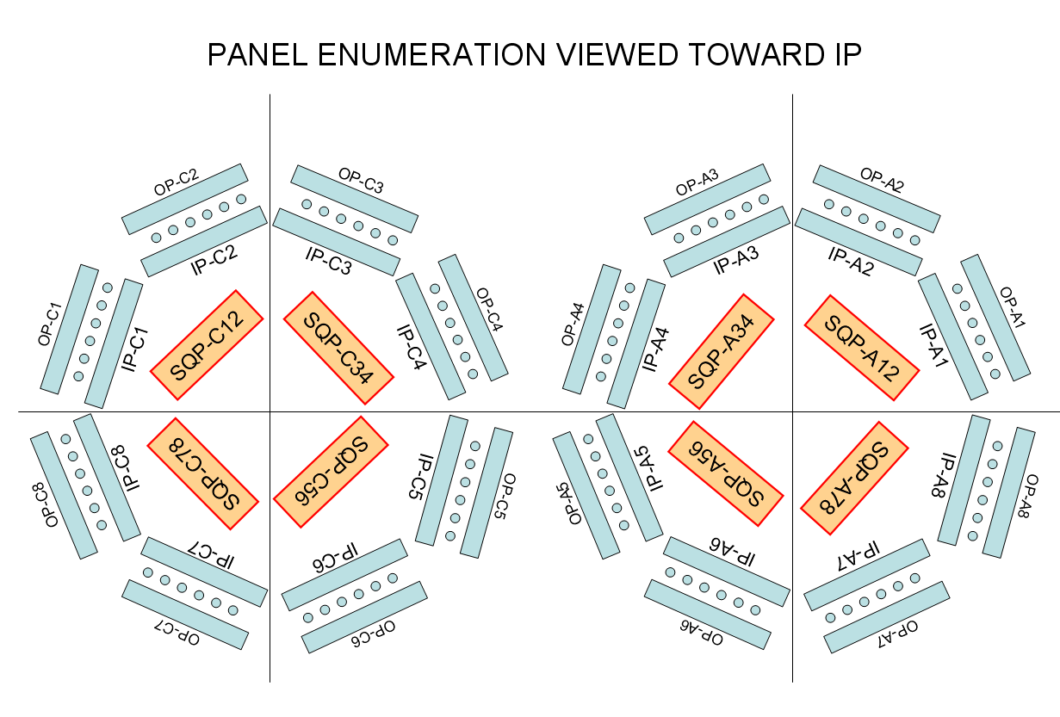
Figure 4 Panel Names within ATLAS service naming scheme

A Service Quarter Panel (SQP) is named by convention as shown in the orange boxes above, and comprises two octants of services, their inner and outer panels, and all included tubes (exhaust and supply). For example, SQPC12 is the Service Quarter Panel on Side C Octants 1&2. The names here denote a physical location in the installed position of the detector. Note from the above figure—PE = Panel External = OSP, PI = ISP, this naming convention is shown in the service document, and may appear in other locations. ISP and OSP (Inner and Outer Service Panels) are used here and in all connectivity tables. The naming convention outlined below defines the position of PP0 flexes on the PP0 panel, the full panel names follow from the naming convention outlined in ref [1], but are summarized here.

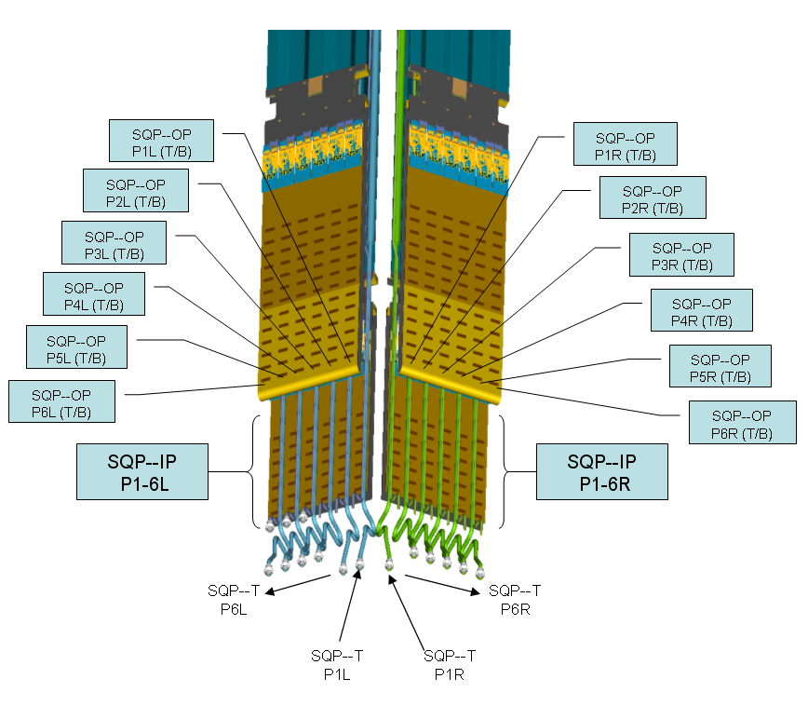
Figure 5 Naming convention for PP0 flexes on a generic Service Quarter Panel

Note that in Figure 5, the numbering of PP0 flexes is from the ‘backbone’ on SQP center outward. Left (L) and Right (R) are defined looking from IP out toward the Panels. There is an additional parameter necessary for the OSP—note that there are two colors in the above figure on the Outer Service Panel. The Light colored PP0 Flex has its Optocard on the underside of the Outer Service Panel, and serves only up to 6 modules. The darker flexes on the Outer and Inner Panels have their Optocards on the top of the panel, and can serve up to 7 modules. So, the final naming of the PP0 flex includes a Top (T) or Bottom (B) designator. For example the full Name of a PP0 would look like: PP0-OP-C5-P3L-B. This PP0 would be on the Outer Panel of SQP C56, in octant 5 side C, third flex on the left. The ‘B’ means that it’s the first row of 6 connectors and that it’s optocard is on the bottom of the Panel.

Connectivity
Connectivity of the Optical ribbons is hierarchical. The Connectivity mapping is by PP0 Flex as mentioned above, and there exists a connectivity table ATL-IP-EP-0092 which maps half staves and sectors, and their respective modules to a unique PP0 Flex. This connectivity is cross-referenced across all connectivity tables, but this mapping is defined at the Module-to-PP0 level. From PP0 out, the connectivity is physically identical by service quarter panel—meaning that the PP1 connector in a given physical location always maps to the same PP0 location on a quarter panel assembly. This simplifies the mechanical assembly of all Service Panels. The layout and mapping is discussed in the following sections.

PP0 to PP1 mapping
The Opto-Connectivity table relies on the same physical mapping of PP0 to PP1 for every opto-card. This mapping also relates to the cables attached to PP1. This is best seen in the figure below.

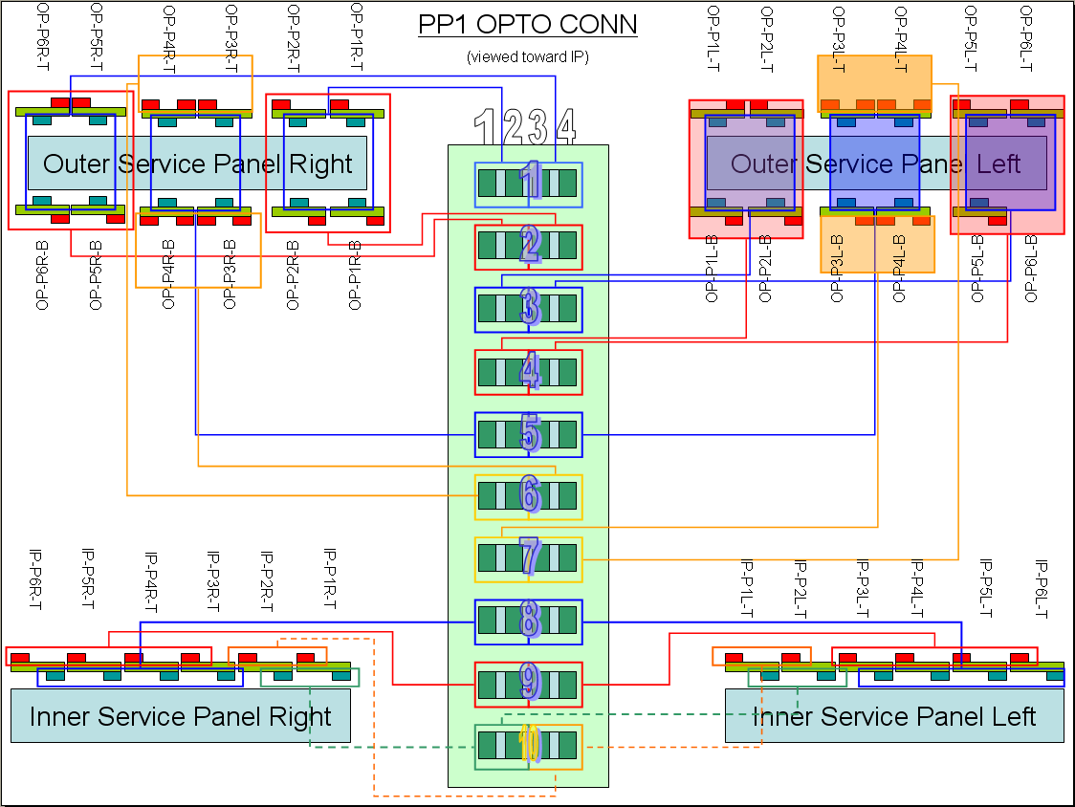
Figure 6 Physical mapping of regions on PP0 to cables at PP1
Figure 6 shows all service panels in a service quarter panel (SQP). The mapping of ribbons to cables is shown by the colored lines, and this ‘connectivity’ is what is documented in the tables below. For example: Cables 1, 2, 3, and 4 service all PP0 flexes outboard of center—these are the PP0 flexes that do not serve B-Layer modules. Cables 8, 9, and 10 serve the Inner Service Panels (third hit modules). The B-layer modules are on the center two PP0 flexes of each OSP for reasons discussed above. This grouping allows the B-layer modules to be served by a group of cables, allowing for the B-layer RODs to be grouped as much as possible in the same Rack. Something to notice here, as well as in the Module to PP0 connection tables, is that of the 4 positions available on OSP center, only up to 3 are ever filled with B-layer half staves. The remaning empty positions are generally filled with a disk sector. This admixture is required for two important reasons. Primally, there are only 44 B-layer half staves, 22 per side, and this number does not well fit an 8-way modularity. Secondly, to allow for an easier staging of services for a two hit system, the B-Layer and Disk services were moved from the inner service panels (ISP) and mixed in with Layer 2 services on the OSP moving all ‘third hit’ modules (Disk 2 and Layer 1) to the ISP. While this admixture is required for the above reasons, the other constraints mentioned above on PP0 means that in any given position eg P4L-T is not always loaded with a B-layer module, so all central positions are treated as if a B-Layer optocard could be loaded there (meaning that *TWO* DTO Ribbons are routed to all Central OSP positions Top and Bottom. In most cases this leads to at least 1 unused ribbon, but in a few cases there are two unused ribbons in a given octant. This under use of ribbons cannot be avoided due to various modularity requirements, and the inability to randomly place DTO and TTC in a cable. The Dark ribbon ratio is still well under 5%, dark fiber ratio is higher due to the use of 8-way ribbons to serve 6 or 7 modules. Dark ribbons are also present in PP0 locations which are not filled—as indicated in the Module to PP0 connectivity table (ATL-IP-EP-0092).

PP0 to Fiber Mapping
PP0 flexes are all electrically identical whether installed on top or bottom of the OSP. For the purposes of electrical connection, the connectors are numbered as they are laid out on the PP0 panel. The optical connection however follows the electrical connectivity of the PP0 Flex. This is shown in the figure below.

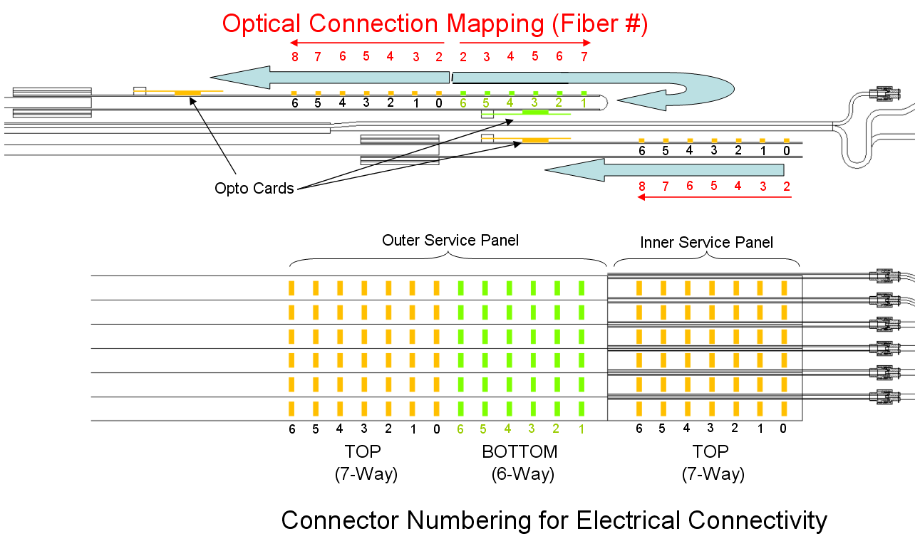
Figure 7 Module connector to Optical fiber within Ribbon Mapping

The mapping illustrated above should hold for DTO and DTO2. There is a possibility that for certain optocards with dead VCSEL or Pin diodes in their arrays, that the connection will be re-mapped to improve yield of Optocards, but nominally this is the current mapping. Should a re-mapping be done, the Connectivity table will be updated to reflect this for the given optocard.

Connectivity Tables for Optical Cables
The spreadsheet also loaded as an appendix in this document is broken into 11 sheets. The first 8 sheets map all 8 SQP, 4 per side. The next sheet lists the 4 Spare Optical Cables (all Hybrid Layouts) without any connectivity until needed. The final two sheets are aimed at the Rods, discussed in the next section.
The tables defined to illustrate optical connectivity follow 1 cable from Optocard (PP0) all the way through to the set of RODs that its component ribbons connect with. The Local Support Cross-reference is not currently added to the Opto-Connectivity table, but will be after the Module to PP0 table is approved. The primary aim of the Opto-connectivity table is to demonstrate which ROD is attached to a given Optocard (PP0). The tables as built have used the current Module to PP0 connectivity table to assure that the correct RODs were loaded in a given rack, but all cross-references have not been filled in at this release level.
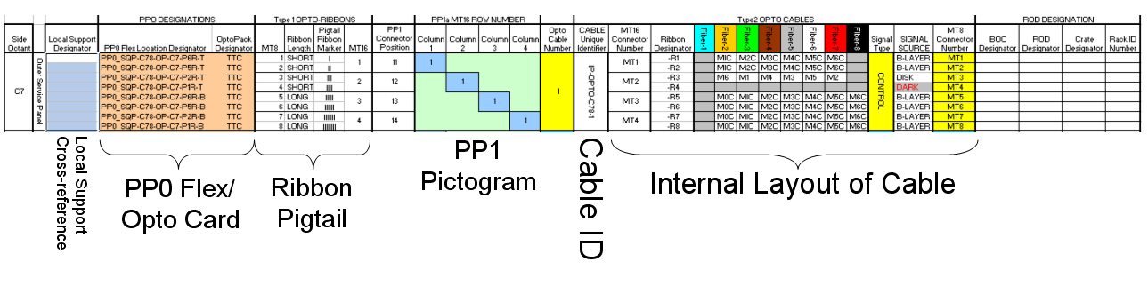
Figure 8 Section of Connectivity Table Showing 1 Cable and its breakdown.
The internal layout of the Cable serves as a cross-reference also with the Module to PP0 table. It captures the phenomenon illustrated in Figure 7. The table once checked and entirely cross-referenced will indicate down to the fiber level which module is served.

ROD Mapping
In the appendix spreadsheet, the final two sheets are aimed at ROD and Rack layout. The ROD Connectivity Table takes the final columns from the previous 8(9) sheets which are formatted by cable, and re-maps this by ROD, easing connection at the ROD Racks. The final Sheet, shown in the figure below is a summary table of cross-referenced local support (from ‘Module to PP0’ connectivity table) showing the physical layout of the racks in an easier to view format to lend the ‘big picture’ of the connectivity.

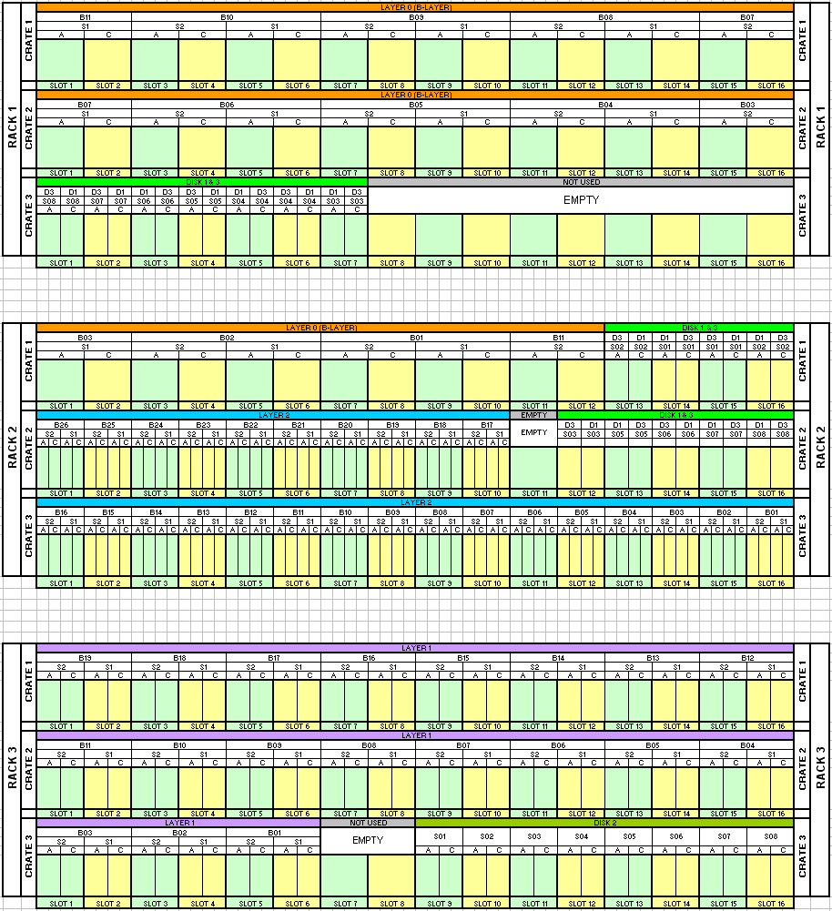
Figure 9 Rack Layout of the ROD Racks, showing Local Support Serviced by ROD Crate Slot Number
The above figure is the entire sheet ‘Rack Layout’ excerpted in entirety. Below is shown a ‘unit cell’ from the ‘ROD Table’ Sheet.

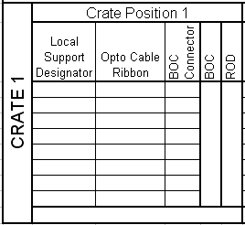
Figure 10 Unit Cell from 'ROD Table' Sheet showing information on a given ROD encoded in the table.
The ‘unit cell’ shown is for a Layer 2 ROD, as these RODs (BOC’s) can have up to 8 ribbons heading to them—4 DTO and 4 TTC ribbons. The table will be pruned to size with an appropriate number of cells for ribbons based on the type of ROD installed in a given ‘Crate Position’ and RACK Location.

References
[1] Requirements for Pixel Detector Services
ATL-IP-ES-0007
[2] Pixel PP1 Patch Panel Design
ATL-IP-ES-0072
[3] Pixel Electrical Services”
ATL-IP-ES-0069
[4] Pixel Optical Services”
ATL-IP-ES-0070
[5] Inner Detector Evaporative Cooling System”
ATL-IC-ES-0006
[6] Inner Detector Thermal Management and Environmental Gas System”
ATL-IC-EN-0009

Appendices

EXCEL File ATL-IP-ES-0102_AppendixA
File includes 11 sheets,
1-8 Service Quarter Panel Cable Services
9 Spare Cable Services
10 ROD Connection Table
11 Rack Layout

