 | Pixel Local Supports PRR
ATLAS Project Document No: | Institute Document No. |  | Created: 20/06/2001 |  | Page: 1 of 9
ATL-IP-EP-0006 |  |  | Modified: |  | Rev. No.: Draft 0
Pixel Local Support Interface Document

Abstract
The interfaces to the ATLAS Pixel Local Supports are given.
Prepared by:  E. Anderssen  S. Cuneo |  | Checked by: |  | Approved by:
Distribution List

History of Changes
Rev. No. | Date | Pages | Description of changes
0 | 01-June, 2000 |  | Release for Comment

Table of Contents

1 Overview 4
2 Description of Local Supports 4
2.1 General 4
2.2 Stave 4
2.3 Sector 4
3 Common Interfaces 4
3.1 Environmental Conditions 4
3.1.1 Gas 4
3.1.2 Pressure 4
3.1.3 Temperature 4
3.1.4 Radiation 5
3.2 Cooling System Interface 5
3.2.1 Physical Interface 5
3.2.2 Coolant 5
3.2.3 Temperature Range 5
3.2.4 Pressure Range 5
3.3 Intermediate support interface 5
3.4 Module Interface 5
3.5 Services 5
3.5.1 Cables 5
3.5.2 Cooling 5
4 Stave Specific 5
4.1 Module 5
4.2 Support Points 5
4.3 Cooling Termination 5
4.4 Service supports 6
5 Sector Specific 6
5.1 Modules 6
5.2 Support Points (Sector-to-Ring) 6
5.3 Cooling Termination 7
5.4 Services Support and Routing 7
5.4.2 Strain-Relief 9

Overview
This document will cover the interfaces of the Pixel Local supports. We describe what is and is not a local support and then describe the qualities that the boundaries must posses such that the local support design need not change in response. As such the document will contain, information also found in the various requirement documents for the bounding systems.
The interfaces for the local supports are broken into three sections. The first covers common interfaces and definitions. A section on Staves and Sector interfaces follows.

Description of Local Supports
The functional definitions of the local supports are given below. The sections on the staves and the sectors describe the local environment, and what is and is not included in the local support, providing a starting point for the definition of interfaces

General
Local Supports are integrated support and cooling structures for Pixel Modules. They take the form of Staves and Sectors for use in the Barrel and Forward regions respectively. Specific interfaces vary in the two regions, with some common system-level interfaces.
Figure 1 Envelope dimensions of Local Supports and neighboring structures

Stave
As is not much meaningful to consider, from the point of view of the interfaces with other systems and/or structures, a stand-alone stave, in the following we’ll consider the interfaces of the bi-stave subassembly. The pixel barrel layers, composed of staves on shell supporting structures with the relevant services, will feature the envelopes as in Figure 2.

Figure 2. Bi-stave assembly.

Sector
The Sector provides support and cooling for 6 modules—3 per face - as shown in Figure 3. Sectors are mounted to Disk Support Rings by way of a 3-point rigidly bolted through-hole mount. Mounting pads for this mount are included on the sector, and abut pads on the Disk-Ring. These pads also provide clearance for the electrical services. Modules are attached to the facings of the sectors with thermally conductive material. Module services are attached and terminated to the module, but supported by the sector facing or Disk Support Ring. On the Ringside facing, the module services pass between the ring and the sector. Cooling Services terminate to the Sector Cooling Tube, which runs between both facings, presenting ends at the sector outer-radius for inlet and outlet termination. The termination for the cooling interface is included as part of the sector.

Figure 3. Disk sector.

Common Interfaces

Environmental Conditions
It is assumed that if anything listed below changes significantly, the design requirements and performance should be reviewed to assess the impact.

Gas
It is currently foreseen to use Nitrogen for the environmental Gas. All structures must be compatible with Nitrogen in an irradiated environment.

Pressure
Gas pressure will be controlled to within a few tens of millibars of Atmospheric pressure—no special pressure environment exists exterior to the local supports

Temperature
Ambient temperature of the environmental gas is delivered at –7°C, but not controlled to any level inside the volume. It is intended that little to no thermal exchange will occur between the environmental gas and the local supports. All cooling power for the pixel modules will be provided by the local supports.

Radiation
The maximum radiation environment within the Pixel Detector occurs on the B-Layer. However, this is a replaceable structure. Layer 1 and the inner radii of the disk structures must withstand 30Mrad ionizing radiation, and 10¹⁵ Neutron/cm². The requirements for radiation hardness of the structures are based on the above number, with some safety factor i.e. yielding 50Mrad as the requirement.

Cooling System Interface
The same cooling system(evaporative C₃F₈) will be used for both disks and staves, with appropriate adjustment of inlet and exhaust tube diameters.
The Leak Rate required of each local support termination is 5x10⁻⁶ Torr-L/s as measured by a Helium vacuum leak checker.

Physical Interface
Covered in Stave/Sector physical interfaces.

Coolant
The Pixel detector will use the same coolant as the SCT to minimize overhead involved in system development. The coolant used will be C₃F₈

Temperature Range
Minimum temperature allowable is –35°C. This is a no-power condition with cooling system running. It is foreseen during startup conditions. The operating temperature is a function of module power and cooling system parameters and is not covered here.

Pressure Range
Maximum pressure that is allowed in the cooling system during failure conditions is 8bar absolute. Local supports are designed to be acceptably stable up to 4bar absolute operating pressure.

Intermediate support interface
The local supports are to be electrically isolated from the intermediate supports(barrel shells for staves and support rings for sectors). However, a provision for a controlled electrical connection between the local supports and the intermediate supports must be included in the local support design.

Module Interface
The interface itself is between the front-end chip substrate side on the module and a flat surface provided by the local support. The accuracy of these interfaces is covered in the Requirements Document for the Local Supports. The local support design should include a provision for a local electrical connection between the pixel module(flex hybrid) and the local support.

Services

Cables
Modules are serviced electrically by pigtails, which terminate to the flex hybrid on each module. All strain relief features for the pigtails will be implemented by gluing features to the local supports.

Cooling
Cooling pipes terminate to Stave and Sector Pairs, with a series connection between paired local supports. These terminations will be covered in Stave/Sector sections more directly. Strain relief, if necessary, will be implemented on the intermediate supports.

Stave Specific

Module
See Local Requirements and Local Supports Overview documents (done by M. Olcese).

Support Points
Staves are mounted to common supports by means of screws and dowel pins, then forming subassemblies called “bi-staves”. These last, on their turn, are mounted to shell supporting structure by means of screws. Purpose-shaped rings, integral with the shell structure, will feature precisely machined grooves that should allow the accurate location of the bi-stave on ϕ. The mating surface between the above-mentioned rings and the stave supports is the interface between the bi-stave and the supporting structure. More details can be found in the Stave Design Status document.

Cooling Termination
The cooling pipe are clamped and glued to PEEK terminations, protruding outside the staves. Such terminations are glued inside the cooling channel when the omega profile is bonded to the TMT. Their geometry allows the U-bend pipe that connects two staves in series, as well as the exhaust pipe, to be clamped and glued outside their diameter, while the capillary termination can be glued inside. As both U-bend and exhaust pipe will be components of the bi-stave assembly, the interfaces with the cooling circuit will be the stave termination where the capillary end will have to be glued in and the hydraulic connector at the end of the exhaust pipe.

Service supports
The exhaust cooling pipes will be strain-relieved to an intermediate ring, placed in between the pipes themselves and the shell support structure. The pipe saddles on such a ring will be the interface between the bi-stave exhaust pipes and the shell support structure.
The electric connections (“pigtails”) are supposed to have an envelope section of 3x7 mm; their strain-relief is foreseen on the end cone, where the electrical connector will be glued/screwed on: then the end cone is the first interface the electrical and optical services will find after the modules on the staves.

Sector Specific

Modules
The layout of the sectors follows directly from the placement of the modules in the detector layout. In the disk region, the primary driving parameter in the layout is the physical width of the module. This is due to module to module clearance near the inner radius on a given face, which is nominally 1mm - see Figure 4 Modules mounted on disk sectors and disk sectors on support ring..

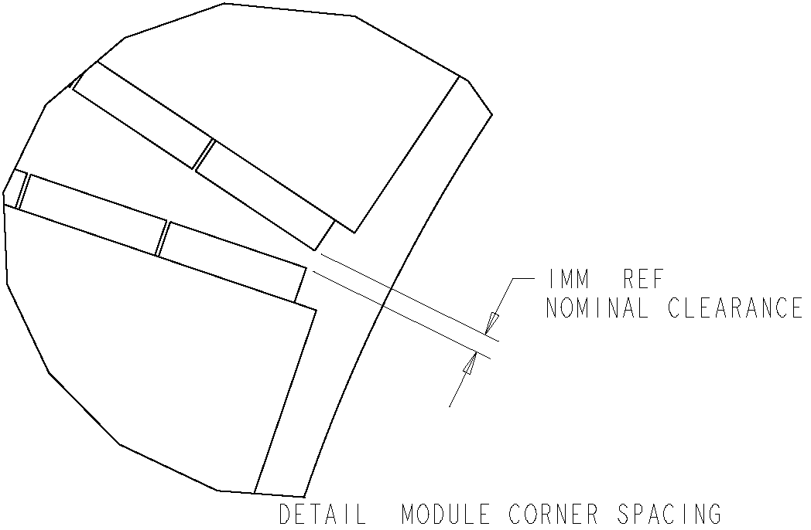
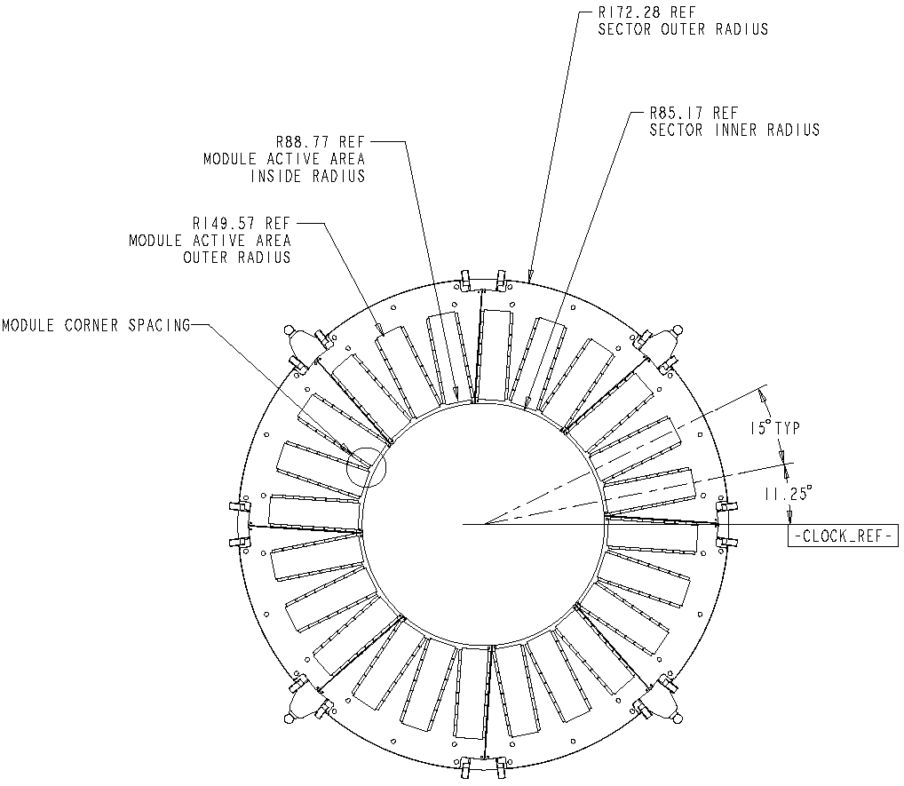
Figure 4 Modules mounted on disk sectors and disk sectors on support ring.

The nominal clearance used in the layout of modules (1mm) is deemed sufficient to contain all module placement errors and tooling clearance. The module envelope is under change control.

Support Points (Sector-to-Ring)
The three support points for each sector are replicated in the disk support ring. A master gauge will determine the locations of the three support points in a sector. The corresponding locations in the disk support ring will be referenced to the master gauge eg. by a mistress gauge. The requirement is that any sector be mountable at any point on a disk support ring. Disk Sector datums are tied to physically measurable features as illustrated in Figure 5. Sector Datums and Mounts. The mount faces of the three sector mount washers define datum plane –A-
. Datum plane –B- is defined through the centers of the two holes at the edges of the sector. Datum –C- is perpendicular to A and B, and through the hole indicated.
Datum “D” is a non-physical datum that lies on the sector mid-plane—it is used in the physics layout to describe the position of the sector. It is a surveyed feature and will be measured and recorded for each sector.

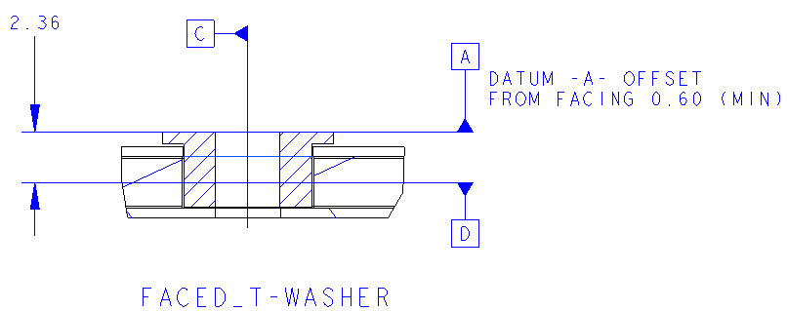
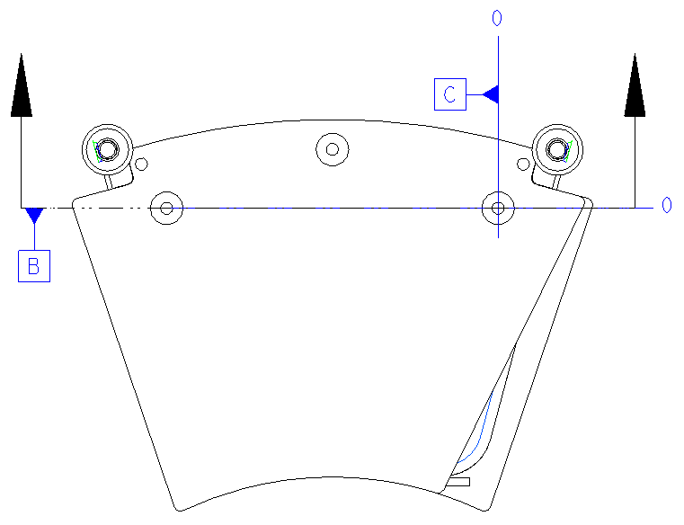

Figure 5. Sector Datums and Mounts
The Sector Mount Washers are electrically non-conductive. The mounting hardware will consist of metal pins, nuts and washers. The “C” hole, which defines datum –C-, will locate the sector relative to the ring to ~8μ with appropriately toleranced pins (H7/h6 on 3mm dia.). The B-hole will define orientation, with the intention of using the same tolerance class pins as in the C-hole. The Central Hole, at the larger radius, could potentially use the same pins, but its primary purpose is only clamping—pins in this hole can be undersized if needed.

Cooling Termination
The sector includes one side of a cooling termination (fitting) that is used to make (a) and inlet connection (capillary); (b) a series connection to the adjacent sector; or (c) and exhaust tube connection. The two sector terminations are identical. The termination is laser welded to the aluminum cooling tube that has been swaged round to an outer diameter of 4.5mm.

Services Support and Routing
Pigtails attached to the modules on the sector must be routed to clear the coolant tubes and the mount buttons. Any termination tabs on the module must not exceed the envelope dimensions indicated in Figure 6 Pigtail and Module Tab Stay in regions. The Ring overlaps the module by 2.3mm radially as shown in Figure 7 Ring to Sector Facing Clearance for Module and Pigtail, a clearance of 2.5mm is allowed between Ring and Sector Facings to route the Sector Pigtails. The pigtail design for the disk sectors is not complete but must meet this requirement.

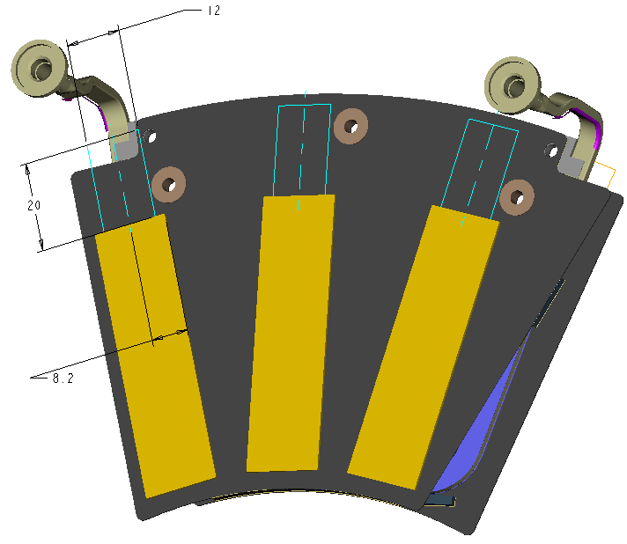
Figure 6 Pigtail and Module Tab Stay in regions

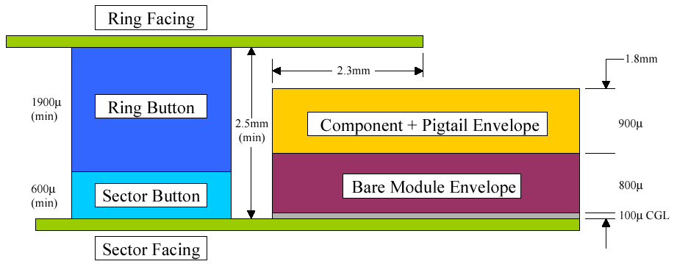
Figure 7 Ring to Sector Facing Clearance for Module and Pigtail
The Sector Cooling tubes are routed away from the IP over the Disk Support Ring. The Inlet capillary and Exhaust tubes are attached to the sector cooling tubes that cross over the ring adjacent to the Ring Mount Ears. This allows the external service runs to be adequately strain relieved. The sectors “U-Tubes,” which join adjacent sectors into a common cooling circuit are located between the mounting ears. All sector tubes will be strain relieved to the Disk Ring. Nominal clearances are shown in Figure 8 Ring to Sector Cooling Tube Clearance. Nominal Clearance between Ring and Sector Tube (3mm) is shown on the left, the figure on the right shows the closest approach.

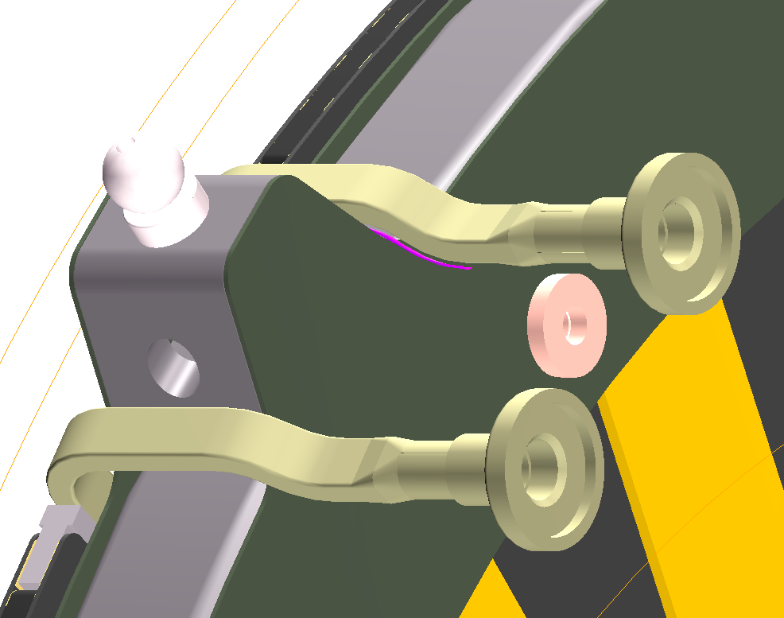
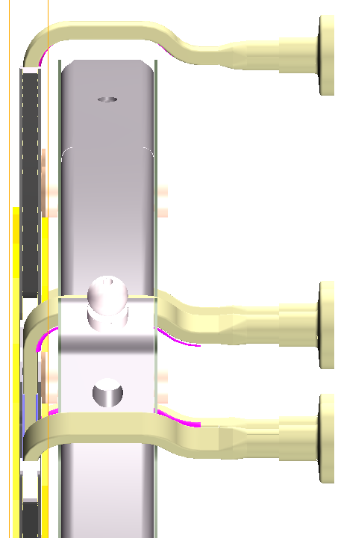
Region of Closest Approach (0.5mm)
Figure 8 Ring to Sector Cooling Tube Clearance

Controlled Parameters

Cooling Tube to Ring Ear: 0.5mm

Sector to Ring Facing Clearance: 2.5mm

Tab Width: 12mm

Pigtail Width: 10mm

Tab Length: 20mm

Connection Thickness: 0.9mm

Strain-Relief
Strain relief of the pigtail is trivial; the global support frame supports the connection on the opposite end from the module. Locally, the pigtail and module tab may be glued to the sector facing. There is ample space for this, excepting the neighborhood around mound tabs
Sector Cooling tube strain relief will be to the mounting ear of the Disk Ring immediately after making the right angle bend. Strain relief of the section of tube terminated to the sector has not been designed.

