 | Pixel Detector Mechanics Conceptual Design Review
ATLAS Project Document No: | Institute Document No. | Created: 14/06/2001 | Page: 1 of 2
 |  | Modified: | Rev. No.:
Technical Specification
ATLAS Pixel Detector Support Tube

Abstract
The technical specification for the ATLAS pixel detector support tube are presented.
Prepared by:  E. Anderssen, M. Gilchriese, N. Hartman | Checked by: | Approved by:
Distribution List

History of Changes
Rev. No. | Date | Pages | Description of changes

Table of Contents

INSERT TABLE OF CONTENTS

Introduction
The pixel support tube (PST) and endplugs are illustrated schematically in Figure 1 and 2. The PST consists of three sections - a barrel section and two forwards. A barrel section is connected to a forward section through mating flanges. The PST has rails to allow the pixel detector and its services to slide into position inside the Inner Detector. The endplugs provide a thermal and gas barrier, support electrical and coolant feedthroughs and are part of the EMI screening around the pixel detector. The support tube and related supports at the end of the Inner Detector also support the vacuum beam pipe in the region of the Inner Detector. The barrel section of the PST is supported by the SCT barrel structure. These supports are also described in this document. The PST/endplug/beampipe are supported at each end of the Inner Detector by supports linked to the barrel cryostat.
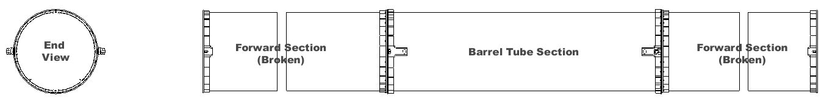
Figure 1. Current pixel support tube conceptual model (two views shown – side view shown broken for clarity).
Figure 2. Schematic of PST and endplug interface.

General Requirements
The pixel support tube and associated structures(endplugs, end supports) must satisfy some general requirements:
- The PST must allow the pixel detector and its services to be installed via the rail system in the PST from Side C of ATLAS.
- The PST and rails are to be designed for a minimum of twenty insertion cycles. However, sliding interface blocks (“sliders”) may be replaced after each insertion/extraction cycle.
- The pixel detector is held by supports connected to the PST barrel flanges. Once transition is made from the PST rails to the pixel supports, no contact between the pixel detector and PST will exist.
- The PST and the endplugs provide a gas barrier for the environmental gas around the pixel detector. The allowable leak rate through the PST+endplugs is not yet specified.
- The PST and endplugs help to provide EMI shielding of the pixel detector. The EMI shielding on the barrel- and end-sections of the PST must be connected. The endplugs complete the EMI shielding and are connected to the PST. A provision for connection of the endplug EMI shielding to EMI shielding around the beam pipe must be made.
- The PST/flanges are electrically isolated from the SCT and the cryostat(?).
- The outside of the PST and endplugs must have a temperature above 15^{O}C, and it must be possible to maintain this temperature for all operating conditions of the pixel system and the remainder of the Inner Detector.
- The PST/end supports must support the beam pipe and allow adjustment of the beam pipe in radius by up to 9mm.
- The PST/rails must be constructed such that carbon dust or fibers are not created as the pixel system and services slide into the operating position. This will be accomplished by incorporating a thin layer of fiberglass on top of all sliding surfaces.

Support Conditions
The support conditions for the PST are given in Figure 3. The barrel of the PST mounts to the SCT interlinks (four in the horizontal plane), while the ends of the forward support tubes are mounted to supports extending from the cryostat wall (previously beampipe supports). The forward end supports are designed to give flexure in the z-direction of up to 1.2 mm with minimal loading. Since shell modes dominate the lowest frequency modes for the PST, all supports give no freedom of motion in the horizontal (x-direction). The entire PST structure is constrained in the z-direction by mounts on the C-side of the SCT barrel. Mounts on the A-side of the barrel allow flexure in the z-direction, as well as compensation for misalignment between the barrel supports.
Figure 3. Schematic of support conditions for the pixel support tube.

Dimensions and Global Envelope
The nominal dimensions of the PST are given in Figure 4. Dimensional envelopes in critical regions are covered under Interfaces.

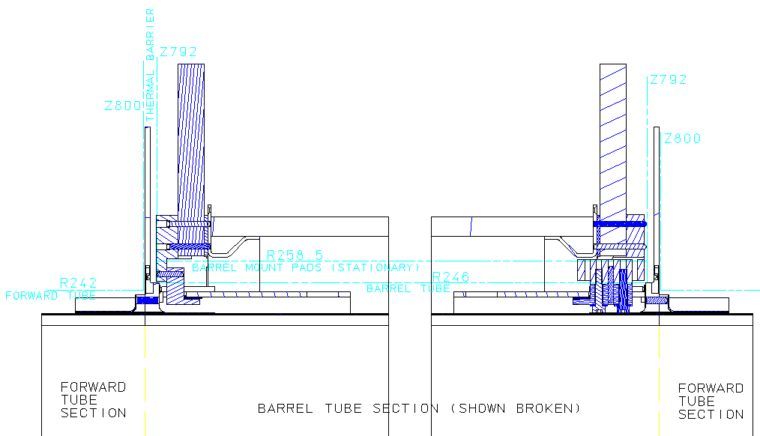
Figure 4. Envelope interface dimensions between PST and SCT barrel.
The envelopes for the PST vary between SCT barrel and forward. In the forward, the PST envelope is 242 mm in radius, as the SCT forward must be installed with the PST in place. In the barrel, where more space is available and the alignment can be more readily assured, the envelope is 246 mm in radius. All flanges, ribs, heaters, EMI shielding, etc., must reside within this envelope. The mounts, however, which protrude through the envelope to attach to the SCT interlink, have an envelope of 258.5 for the parts that must move relative to the SCT (through flexure actuation). The thermal barrier envelope is given as 792 to 800 in the z-direction, where 799 is the nominal half-length of the PST barrel.

Interfaces
The critical dimensional interfaces, thermal interfaces and electrical interfaces are covered in this section.

Pixel Detector
The pixel detector is supported by mounts that are attached to the barrel flange of the PST. These mounts are not yet defined, but the fixation scheme is shown in Figure 5. The pixel detector will be fixed in the z-direction on the C-side of the ID (the installation direction side), but allowed to float on the A-side. It will not be constrained in the x-direction (across the barrel). After delivery of the pixel detector to the barrel PST on the installation rails, the detector will be transferred (most likely by rolling means) to the pixel detector supports (which are integrated into the PST barrel flanges).

These mounts are electrically isolated from the pixel detector through the use of fiberglass pads and ceramic washers at all of the bolt interfaces (including the rolling interface between pixel detector and supports).

Figure 5. Pixel detector fixation scheme within the PST.

SCT Barrel
The PST is supported by the barrel SCT interlink structure by interface blocks. These blocks are comprised of one-dimensional flexures that allow movement in one direction while retaining stiffness in other directions. On the C-side of the detector, the blocks incorporate angular flexures that allow the PST to be tilted up or down (in the vertical plane). The blocks on the A-side provide z-flexation in order to absorb misalignment and CTE mismatches between the PST and SCT barrel (though these are predicted to be very small). The block concepts are illustrated in Figure 6.

The PST/flanges are electrically isolated from the SCT barrel interlink structure using the same techniques applied to the pixel/PST interface.
Figure 6. PST to SCT mounts at the SCT barrel – conceptual design.

SCT Forward
There is no connection between the PST and related structures and the SCT forward systems. However, the PST will be affixed to supports suspended from the cryostat (previously these supports were slated for use by the beampipe). Since the PST forwards are long and potentially flexible, the end supports are designed to absorb significant z-direction flex (up to 1.2 mm). The conceptual flexure mount is shown in Figure 7.
Figure 7. PST mount blocks for fixation to the cryostat supports.

Beam Pipe
The beam pipe will be supported in the PST at three points. The capability to adjust the beam pipe in radius up to 9 mm is required. The beam pipe supports/adjustment must be electrically isolated from the PST. The degree of thermal isolation needed for these mounts is not yet known. The mounting points are at approximately Z= -3350, -850, and 3350 (two points on side A, one on side C). The beam pipe mounts and adjustment are not yet defined.

Polymoderator, Endcap Calorimeter and Cryostat
The endplug does not touch the polymoderator or endcap calorimeter. The critical dimensions(envelopes) are given in ****figure needed here***).

There are supports at each end of the ID to hold the PST/endplugs. These supports are connected to the barrel cryostat as shown in **figure needed or say not defined at this time***

Installation and Assembly

Support Tube
The barrel section of the PST is attached to the SCT barrel structure before the barrel TRT/SCT is lowered into the ATLAS pit and installed in the cryostat. The end-sections of the PST are connected to the barrel section before the forward TRT/SCT elements are installed into the cryostat. The end-sections are only supported by the barrel connection during the forward TRT/SCT installation.

Endplugs
The endplugs are installed after the pixel detector, its services and the beam pipe slide into the PST.

Operation
The thermal control on the PST/endplugs must provide an external temperature of at least 15⁰C under the following operating conditions:
- Pixel system, SCT and TRT all fully operational. Detector open or closed.
- Stand-alone operation of the pixel system(eg. during testing after installation). SCT and TRT not powered(or partially powered). Detector open for access to endplugs.
- Pixel system not powered, but cooled. SCT and TRT operational. Detector open or closed.

Load Conditions, Stability and Analysis
Analysis has begun on the PST stability and load conditions. In particular, some load cases on the SCT have been analyzed, and the PST has been analyzed for stand-alone vibrational stability. Detector and service masses are currently being added in order to determine how the PST behaves during operation, and how it may impact the SCT barrel or forwards.

Production Plan

Overview
The design and fabrication of the following components is currently the responsibility of Lawrence Berkeley National Laboratory(LBNL):
- Barrel and end sections of the PST, including flanges, EMI shielding and thermal control;
- Endplugs(mechanical, EMI and thermal, but not including connectors or pipe feedthroughs);
- Pixel mounts; and
- Mounts to the SCT structure

The design of the supports at each end of the PST is currently also an LBNL responsibility. However, fabrication costs are currently the responsibility of the beam pipe group.

The design of the beam pipe supports and adjustment is currently a joint responsibility of LBNL and the beam pipe group. Fabrication costs are currently the responsibility of the beam pipe group.

Tube Sections
The PST nominal tube section is 437 microns in thickness, with a 228 mm inner radius. It is comprised of a quasi-isotropic layup (8 plys) of high modulus graphite cloth in a cyanate-ester resin system.

Flanges
The barrel and forward PST flanges are both based on the same construction technique. The flanges are bonded assemblies consisting of three parts: 1) an inner ring, or base piece, which is 0.5 mm thick and 40 mm long; 2) a flange face, which is machined from a solid carbon laminate; and 3) a flange stiffening unit, which is nominally 0.5 mm thick, and which is repeated around the flange circumference. Bolted connections to the flanges are made to T-nuts which are bonded into holes drilled into the flange assembly. A picture of the generic flange assembly is shown in Figure 8.

Figure 8. PST flange construction concept.

Integration of Tube Sections and Flanges
Integration of the PST barrel flanges and shell will occur in a step-wise fashion along with the bonding of support points and pixel mount pads. In the forward PST, the flange integration will be combined with bonding of the forward supports mount pads.

Endplugs

Beam Pipe and End Supports

Trial Assembly

Final Assembly/Installation

Quality Assurance

