ASSEMBLY PROCEDURE
polyimide heaters on atlas beampipe

Abstract
This document describes how to mount the polyimide heaters on the ATLAS beampipe.
Prepared by :  [Name]  Hendrik KOS LHC/VAC  [hendrik.kos@cern.ch] |  |  | Checked by :  Raymond VENESS LHC/VAC
History of Changes
Rev. No. | Date | Pages |  | Description of Changes
0 | 24.07.2002 |  |  | First release

Table of Contents
1. Description of mounting heaters in nine steps 4
2. TWO ADDITIONAL STEPS FOR DOUBLE WALL OPTION……………………………9

OPERATION # A

Operation description
- Preparation inner tube.
- One extremity in manipulator, other extremity on rolling support.
- Make sure that the tube surface is clean and without sharp irregularities.

Resources required
- Manipulator.
- Rolling support.
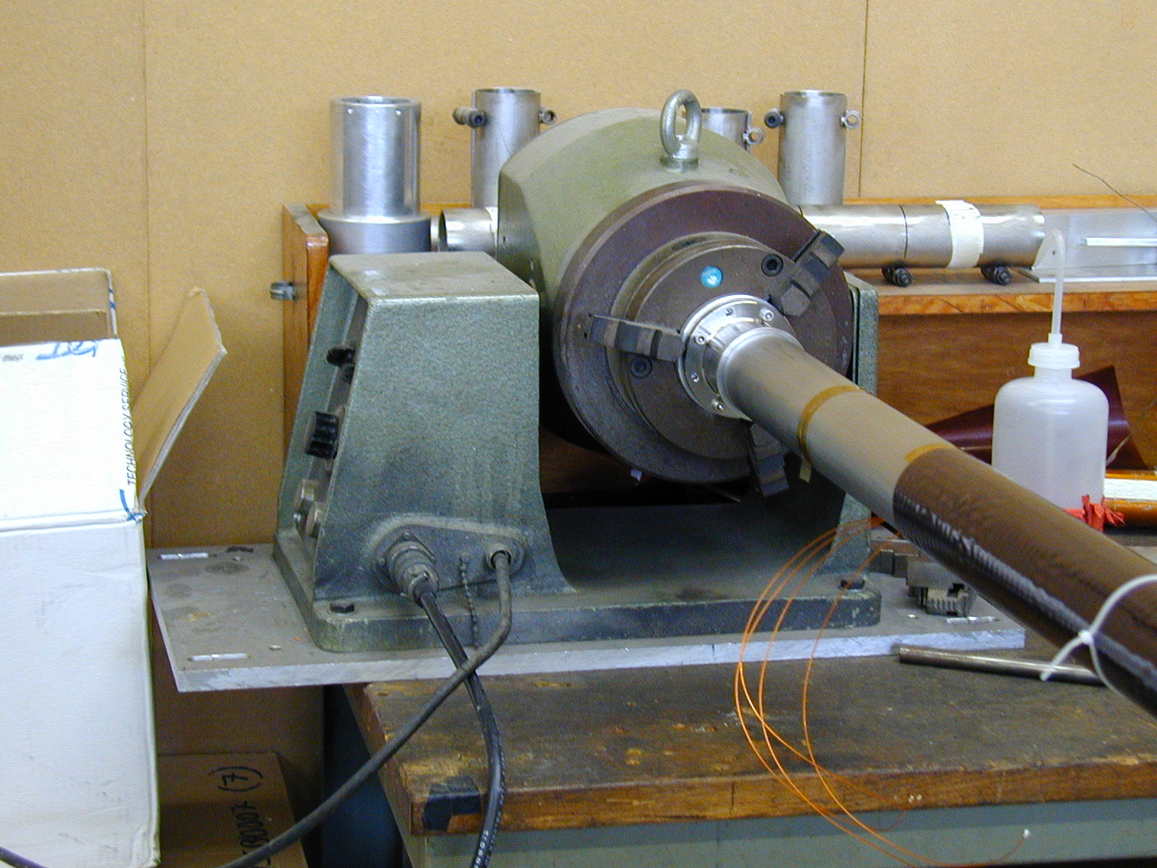
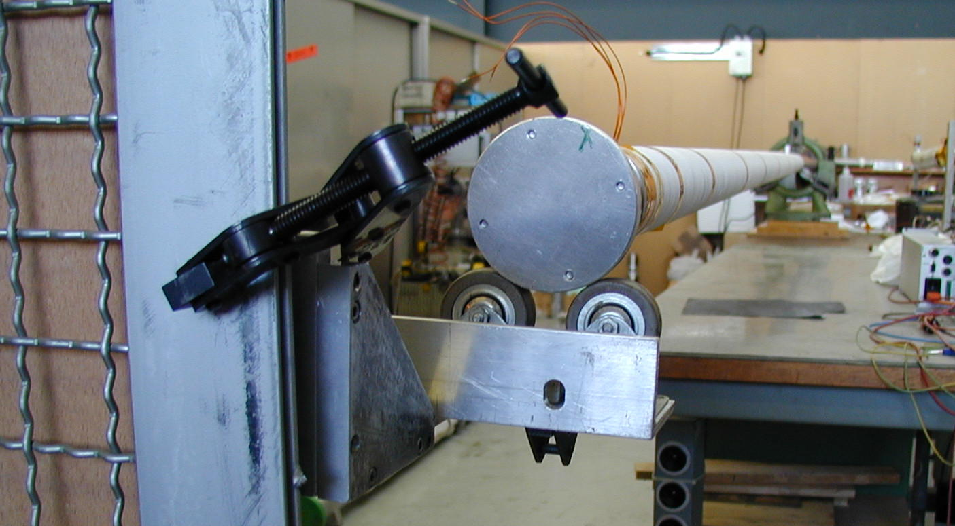

OPERATION # B

Operation description
- Mounting heater.
- Attach heater to the tube with self adhesive tape and cable ties.
- Fill the gaps in between the heating patches with polyimide tape, glue side on the outside.

Resources required
- Polyimide tape, Pixeo Kaneka.
- Cable ties L=250.
- Gloves
- Heater, Rica.
- Polyimide self adhesive tape, Permapack P221.

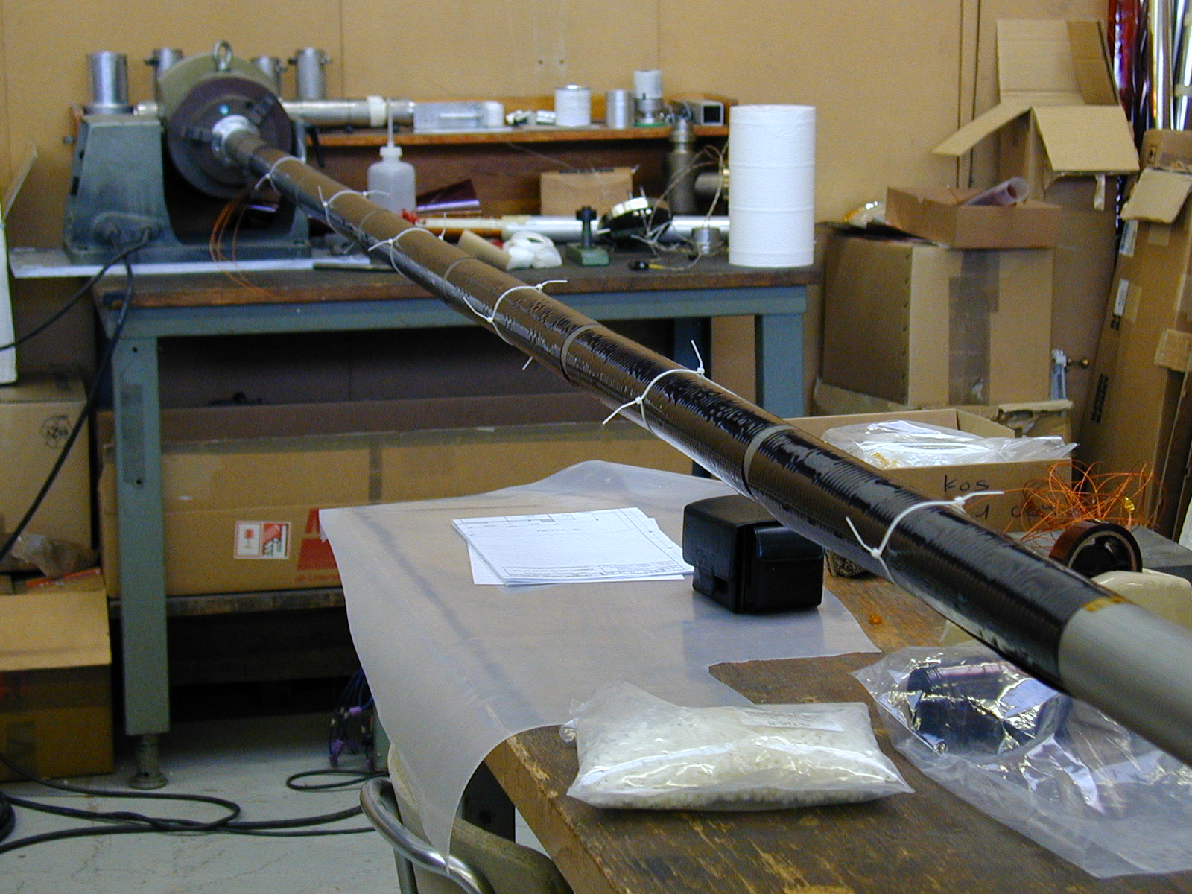

OPERATION # C

Operation description
- Polyimide tape spirally wrapped around the tube, half overlapped. This gives two layers of polyimide tape around the heater.
- When wrapping polyimide tape, remove self adhesive tape and cable ties.
- The polyimide tape should never be glued to the tube, only to itself or to the polyimide heater.

Resources required
- Polyimide tape, Pixeo, Kaneka.

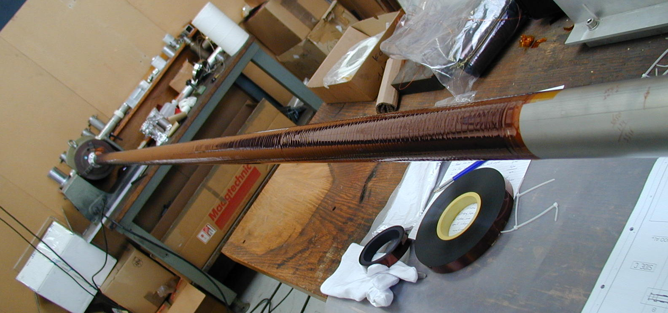

OPERATION # D

Operation description
- The polyester tape is wrapped spirally around the assembly. First 3 rotations straight, than with an angle to create a 50% overlap, giving two layers.
- At the extremities and also at every half a meter the polyester tape is attached by polyimide self adhesive tape.

Resources required.
- 30 mm polyester tape, Fratec 117803.

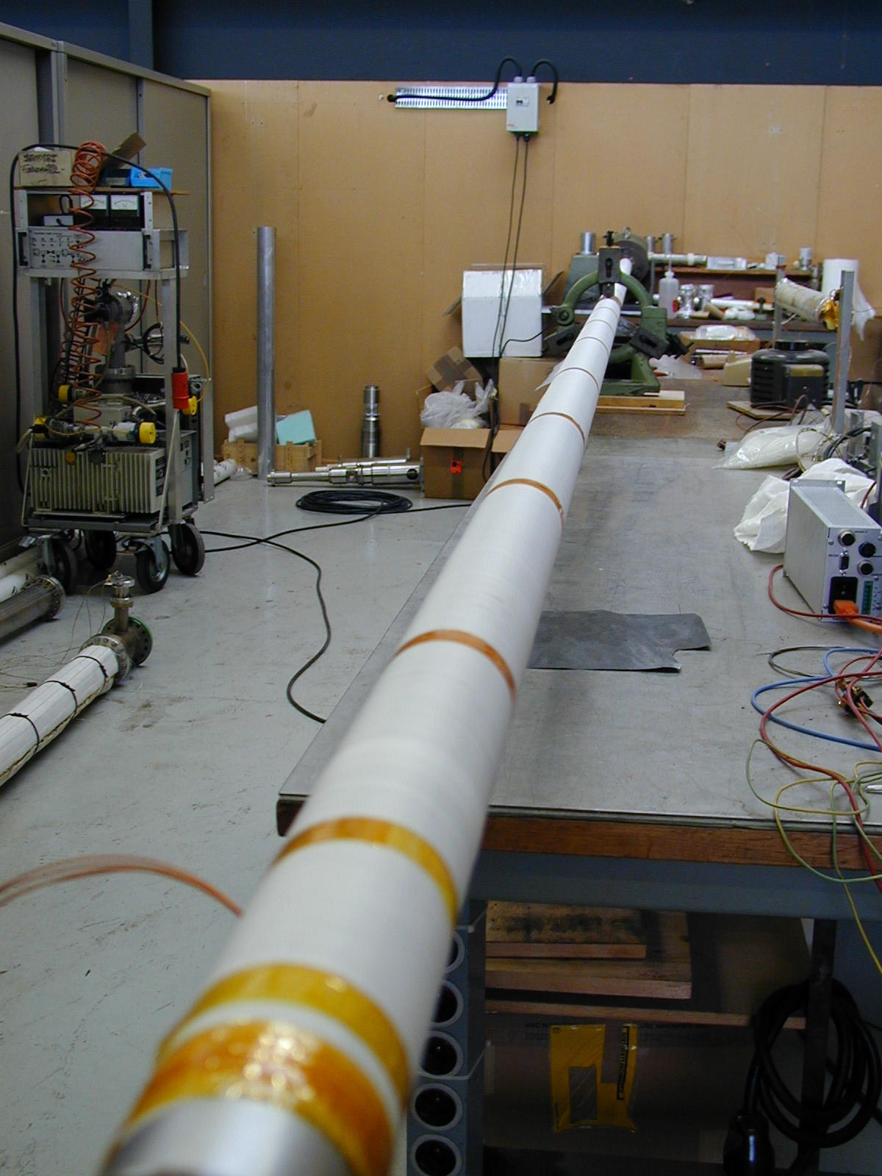

OPERATION # E

Operation description
- One layer of aluminized polyimide foil is wrapped around the assembly and attached by means of polyimide self adhesive tape.
- Ceramic spacers are taped around the tube with self adhesive tape with glass-cloth, to avoid thermal losses to the vacuum chamber.
- The distance between the spacers is 2.5 meters.

Resources required
- Aluminized polyimide, Tricon.
- Self adhesive tape with glass-cloth, 3M scotch 27.
- Ceramic spacers.

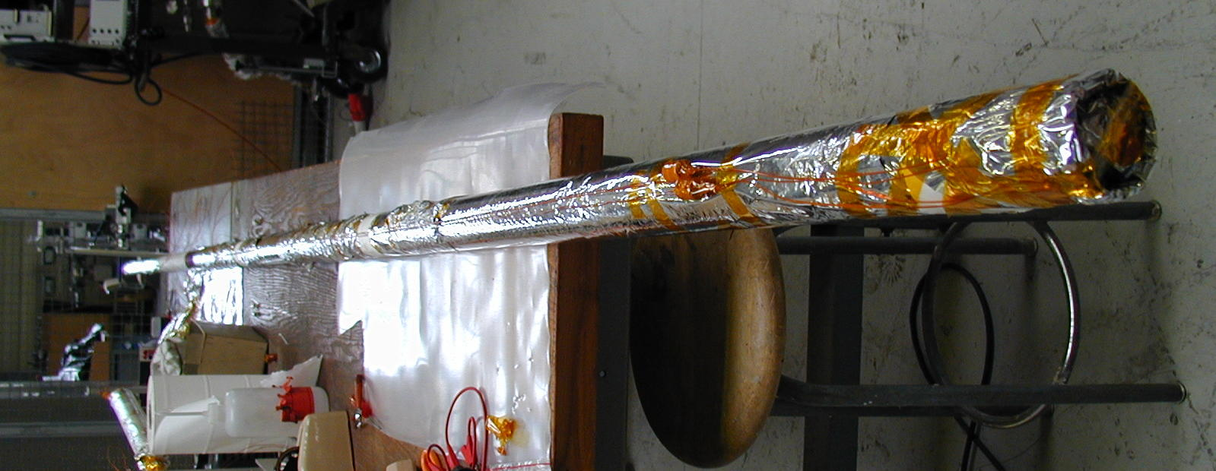

OPERATION # F

Operation description
- Heater connected electrically with flexible wire, polyimide, and ceramic connector blocks to electric feedthrough.

Resources required
- Flexible wire, polyimide, Habia H-H2419.
- Ceramic connector blocks.
- Electric feedthrough for vacuum chamber.

OPERATION # G

Operation description
- Elecrically test the circuits.
- Insert assembly into vacuum chamber.
- Thermocouples on the inside of the tube.
- Close vacuum chamber.
- Pump vacuum chamber down.

Resources required
- Vacuum chamber, inner diameter 100 mm+, 7.5 m+ long.
- Vacuum pumping station.
- 4 thermocouples, E-type.
- Thermocouple recorder.
- Multimeter.

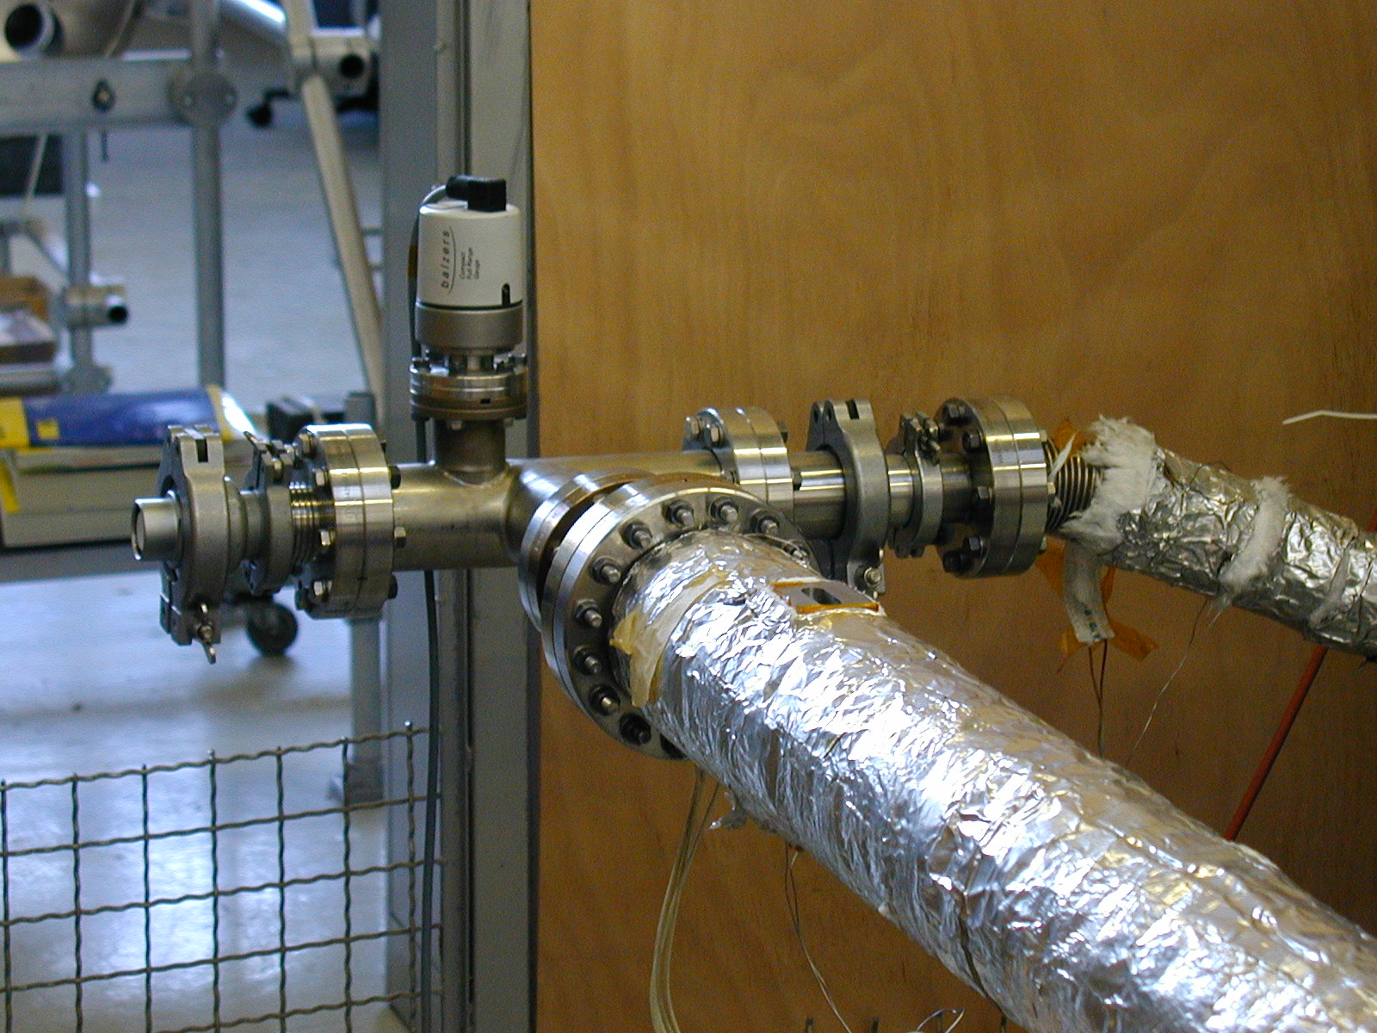

OPERATION # H

Operation description
- First several hours of pumping, preferably overnight, to obtain a good vacuum.
- Start heating. Two times 150 V AC gives a stable 200° C.
- 200° C for 1 hour will cure the glue.

Resources required
- Two variable transformers. Each transformer feeds two serial linked circuits of the heater.

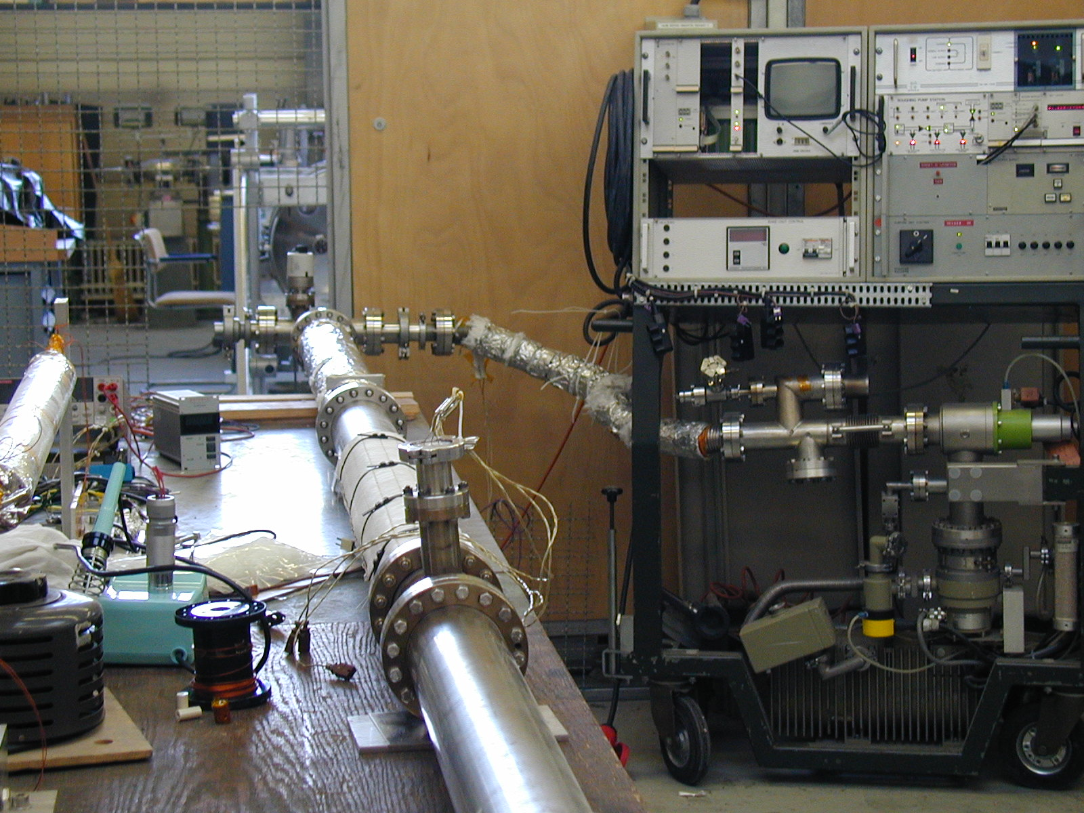

OPERATION # I

Operation description
- Stop Pumping.
- Let the tube cool down.
- Open vacuum chamber and take the assembly out.
- Take of the aluminized polyimide foil and ceramic spacers.
- Check visually if everything is OK.
- Electrically test circuits.

OPERATION # J (For double wall option.)

Operation description
- Mount vespel spacers.
- Wrap two layers aluminized polyimide foil loosely around the tube.
- Cut small holes in the aluminized polyimide foil where the spacers touch the outer tube.
- Carefully insert the inner tube into the outer tube.

Resources required
- Vespel spacers
- Cutter.
- Polyimide strips cut out of a 0.15 mm foil, 2 mm wide, 300 mm long.
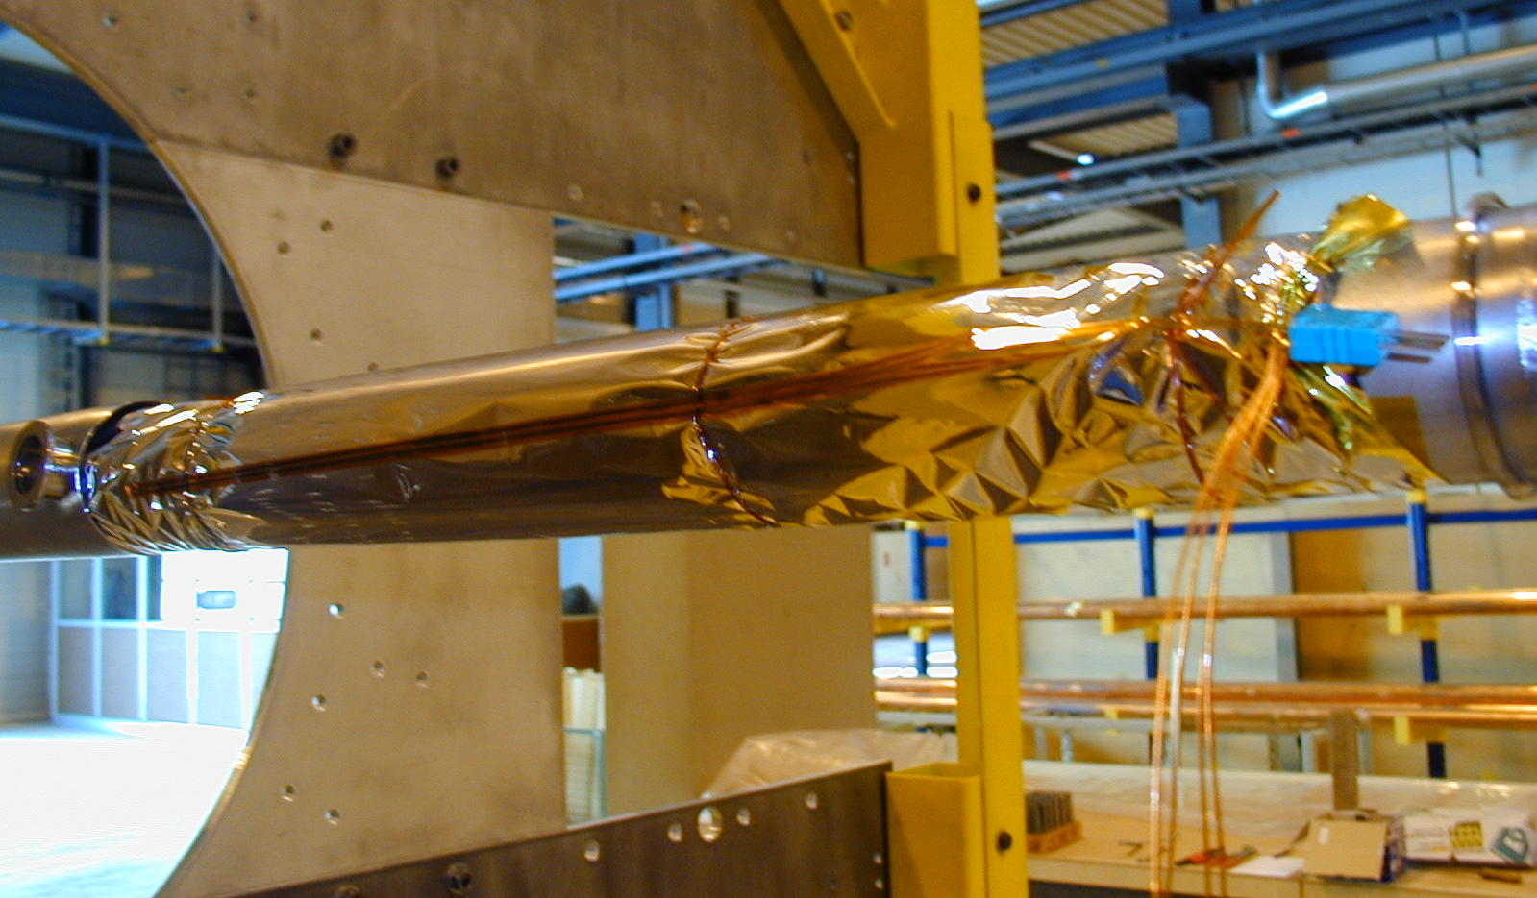

OPERATION # K (For double wall option.)

Operation description
- Compress bellows 12 mm.
- Make sure that 4 wires protrude from each pumping port.
- Weld second flange on the inner tube.
- Release bellows compression tool.
- Check electric resistance of the polyimide heaters.
- Close pumping ports with KF covers.

Resources required
- Bellows compression tool.
- Welding equipment.
- Multimeter.
- KF covers.

