Date: May 20, 2003

Material Test Report

Title: Rapid Prototyping Materials Exposed to Ionizing Radiation

Introduction

Rapid prototyping refers to the fabrication of a physical, three-dimensional part of arbitrary shape directly from 3D computer-aided design (CAD) data. RP technology is an additive process that can generate free-form fabricated parts using powdered metals, polymers, paper, and other materials. RP machines fabricate 3-dimensional objects by depositing these materials layer by layer based on thin horizontal cross sections taken from a computer model.

Scope

Fabricate tensile test samples on Fused Deposition Modeler (FDM) and Stereolithography (SLA) rapid prototyping machines. Tensile test samples that have been exposed to ionizing radiation and compare the results with control samples that have not been exposed to radiation.

Description

Make 10 samples of each desired material. Irradiate 5 samples from each material. Tensile test all samples to failure per ASTM Designation: D-638-97 “Standard Test Method for Tensile Properties of Plastics” and report the following:

Stress at Failure,MPa
Yield Strength,MPa
Elastic Modulus,MPa
Ultimate Strength,Mpa

Sample geometry Compliant with ASTM D-638:

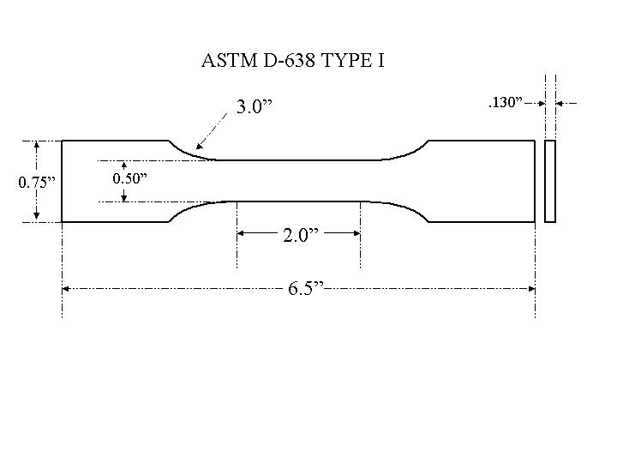

Materials

- SLA - Photo Epoxy Resin # 5170. Samples run in flat orientation where sample
thickness is parallel to build platform. Built at LBNL RP lab.
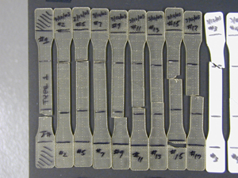
- FDM – ABS plastic # P-400. Samples run in flat orientation where sample
thickness is parallel to build platform. Built at LBNL RP lab.
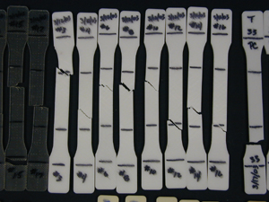
- FDM – PC (polycarbonate). Samples run in flat orientation where sample
thickness is parallel to build platform. Built at Stratasys Inc. RP lab.
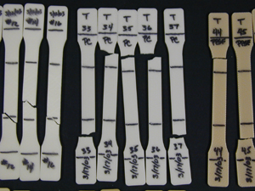
- FDM – PPSF (polyphenylsulfone). Samples run in flat orientation where sample
thickness is parallel to build platform. Built at Stratasys Inc. RP lab.
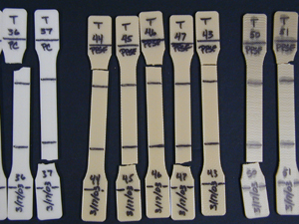

- FDM – PPSF (polyphenylsulfone). Samples run on “edge orientation” where
sample thickness is normal to build platform. Built at Stratasys Inc. RP
lab.
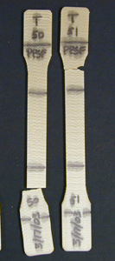

Radiation

Ionizing radiation from a Cesium source. Sample exposure rate is
4.9 kRad/minute to a total of 50MRad.

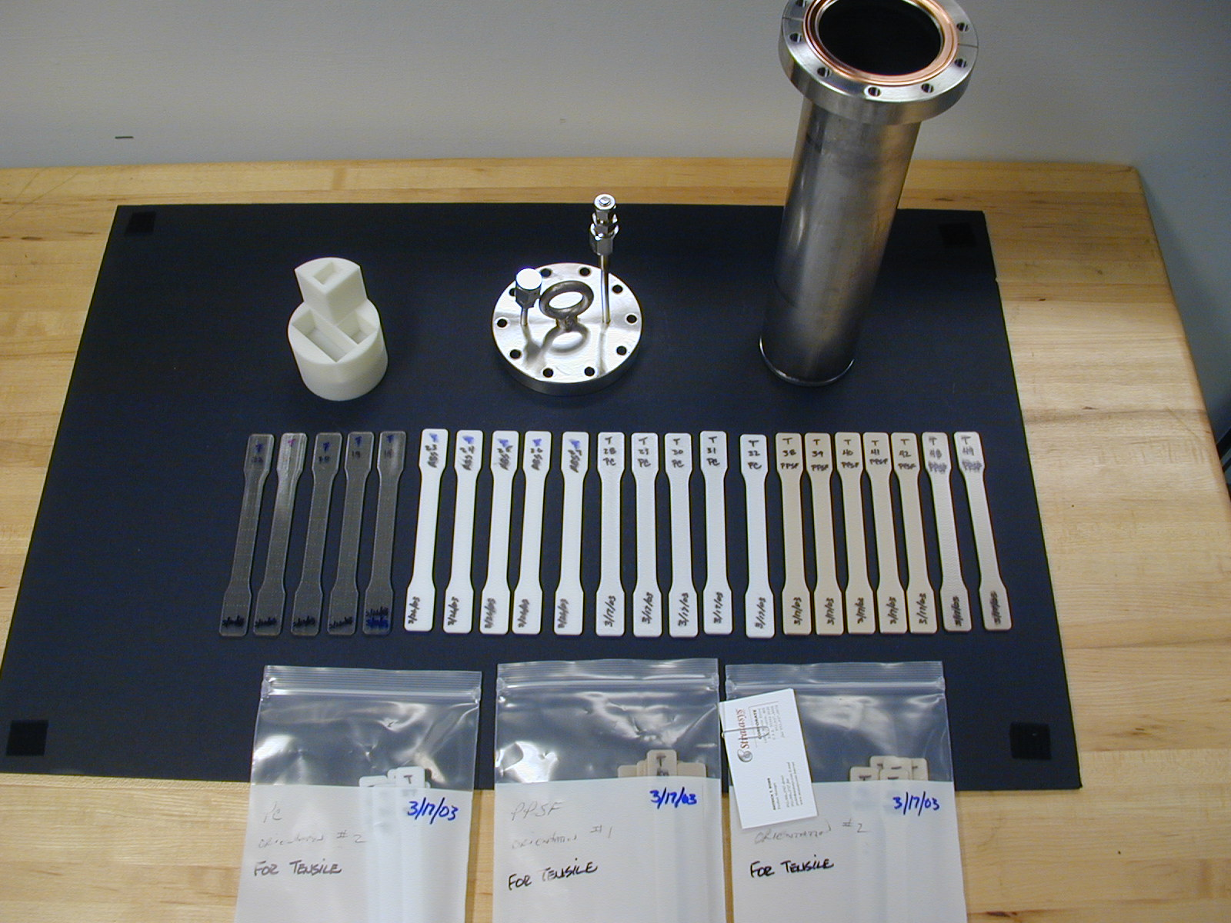

Tensile test facility and parameters

Tensile test apparatus: Dillon Model: DTM serial #97028 with floating grips.

Load cell: Dillon “Weight-Tronix Inc.” Model #0155, serial #98121, capacity - 5000lbs.

Extensometer: MTS Model #634.25E-24, serial #0388516 – 2.0” extension.

Control Software: Labview – Custom V.I. “Dillon DAQ two-axis 7.vi”
Scan rate: 100Hz
Pull Velocity: 0.204 in./min.

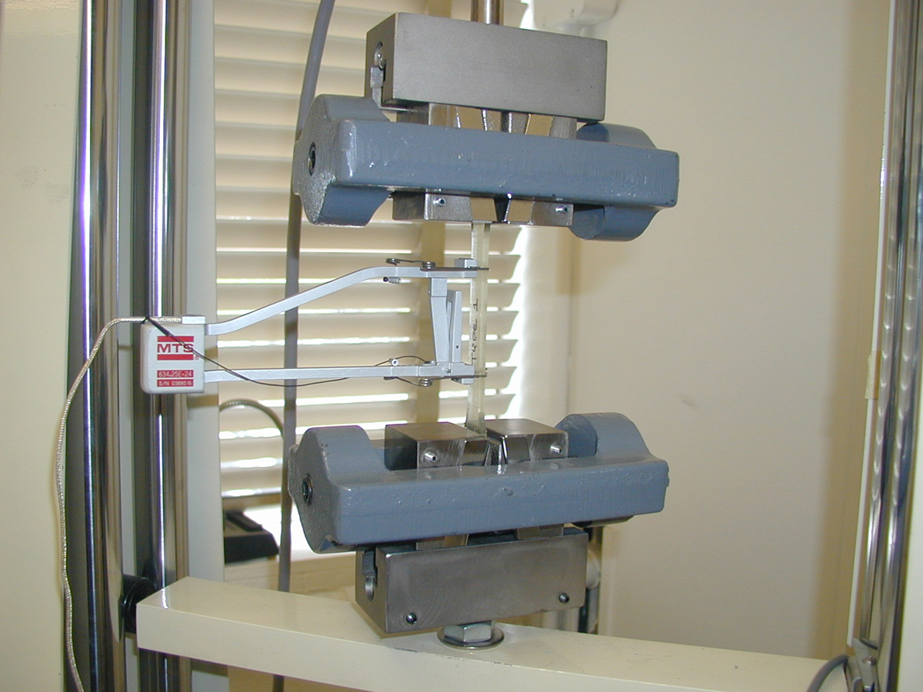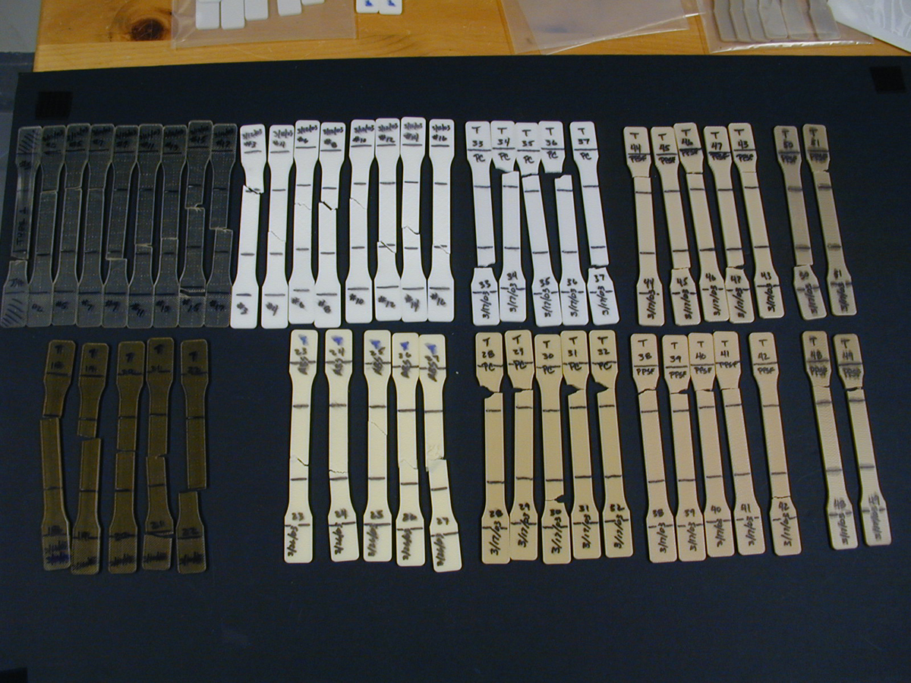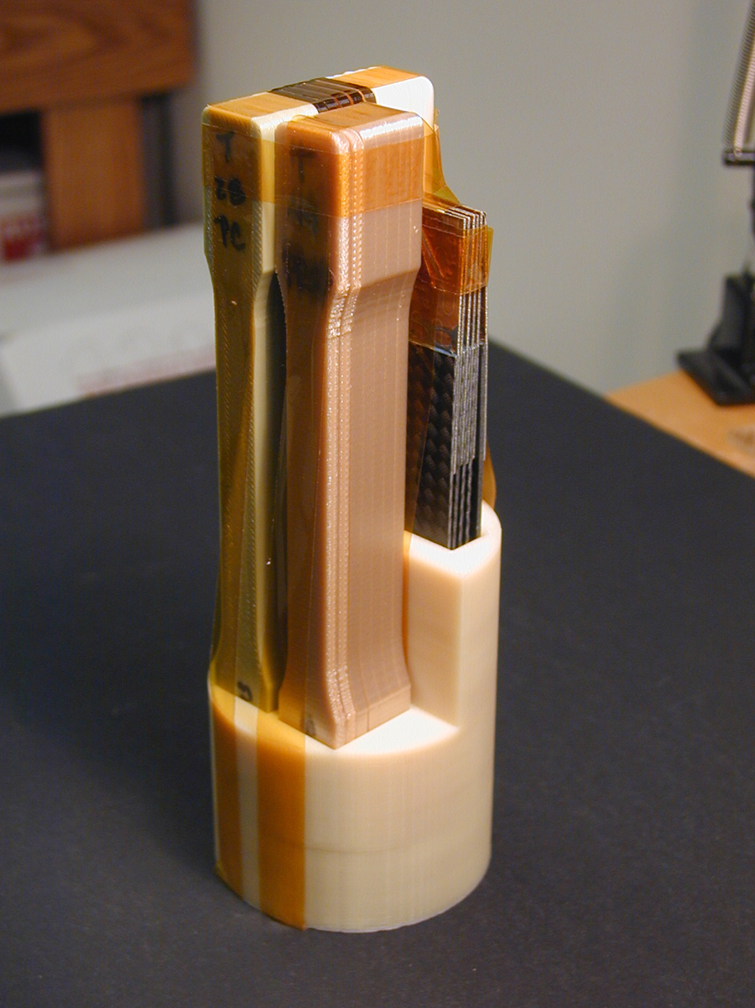

Tensile test results

See summary charts:

“elongation.xls”, “failure.xls”, “modulus.xls”, “ultimate.xls”, “yield.xls”

Observations / Comments

None of the samples show a significant change in material mechanical properties or physical dimensions at this level of radiation exposure. There was a significant change in material color on all samples except the PPSF material. It should be noted that the SLA epoxy and FDM ABS materials broke at or within the sample gauge length. The FDM PC, PPSF, and PPSF “edge” all broke outside of the sample gauge length near the “gauge / radius” transition.

