Requirements and Interfaces for
ATLAS Pixel Detector Support Tube
ATLAS Project Document No: | Institute Document No. | Created: 07-04-2001 | Page: 1 of 21
ATL-IP-ES-0019 |  | Modified: 12-02-2003 | Rev. No.: 3
Requirements and Interfaces for
ATLAS Pixel Detector Support Tube

Abstract
The requirements and the critical interfaces for the ATLAS pixel detector support tube (PST) are presented.
Prepared by:  E. Anderssen, M. Gilchriese, N. Hartman, M.Olcese | Checked by:  R.Hawkings, E.Perrin | Approved by:  PDSG
Distribution List

History of Changes
Rev. No. | Date | Pages | Description of changes
1  2  3 | 4/7/01  20/05/02  12/2/03 | All  All | Original version  Complete revision  Complete revision for PST PRR

Table of Contents

1 Introduction 4
2 General Requirements 4
3 Support Conditions 5
4 Dimensions and Global Envelope 6
5 Interfaces 6
5.1 Pixel Detector 6
5.2 SCT Barrel 8
5.3 SCT Forward 9
5.4 ID End Support Plate 9
5.5 Beam Pipe 12
5.6 Rails 14
6 Assembly and Installation 14
6.1 Assembly of the Pixel Support Tube 14
6.2 Installation and Integration into the Inner Detector 15
7 Design Parameters, Load Conditions and Stability 16
7.1 Design parameters and specific requirements 16
7.2 Load conditions and stability requirements 17
7.2.1 Short Term Stability 17
7.2.2 Medium/Long Term Stability 18
7.2.3 Strength or Structural Integrity 19
8 Production Plan and Responsibilities 19
9 References 19

Introduction
This document describes the requirements and critical interfaces for the pixel support tube and associated structures (two service end plugs, end supports and barrel supports).
The pixel support tube (PST) consists of an approximately 7m long cylinder extending coaxially all the way through the Inner Detector (ID) volume. This is to allow and independedent installation and removal of the Pixel Detector while the rest of the Inner Detector is in place.
The PST is illustrated schematically in Figure 1. The PST consists of three sections - a barrel section and two forwards. A barrel section is connected to a forward section through mating flanges. The PST has rails to allow the pixel detector and its services to slide into position inside the Inner Detector. The endplugs provide a gas barrier, support electrical and coolant feedthroughs and are part of the EMI screening around the pixel detector. The barrel section of the PST is supported by the SCT barrel structure. The forward sections of the PST are flanged onto the barrel section and supported at each end of the ID volume by supports linked to the barrel cryostat through the ID Endplug. The pixel support tube and ID Endplug also support the VI section of the vacuum beam pipe. Figure 2 shows a schematic of the PST with the internal pixel system in place.
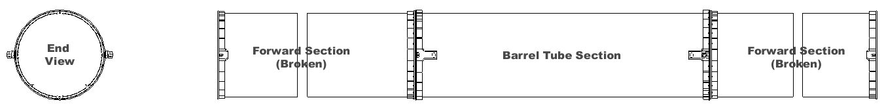
Figure 1. Current pixel support tube conceptual model (two views shown – side view shown broken for clarity).

Figure 2:Schematic cross-section of Pixel Support Tube with internal pixel system

General Requirements
The pixel support tube and associated structures (endplugs, end supports) must satisfy some general requirements:
- The PST must allow the pixel detector and its services to be installed via the rail system in the PST from Side C of ATLAS.
- The PST and rails are to be designed for a minimum of twenty insertion cycles. However, sliding and/or rolling interface blocks (“sliders”) may be replaced after each insertion/extraction cycle.
- The pixel detector is held by supports connected to the PST barrel flanges. Once transition is made from the PST rails to the pixel supports, no contact between the pixel detector and PST will exist.
- The PST and the endplugs provide a gas barrier for the environmental gas around the pixel detector.
- It must be possible to keep the internal volume of the gas enclosure at a slight overpressure with respect to the outside environment with a moderate dry gas input.
- It must be possible to maintain the outside of the PST and endplugs above a temperature of 15^{O}C for all operating conditions of the pixel system and the remainder of the Inner Detector.
- The PST and endplugs provide EMI shielding of the pixel detector. The EMI shielding on the barrel- and end-sections of the PST must be connected. The endplugs complete the EMI shielding and are connected to the PST. A provision for connection of the endplug EMI shielding to EMI shielding around the beam pipe must be made.
- The PST/flanges are electrically isolated from the SCT and the cryostat.
- The PST mounts to the SCT barrel have to allow x and y adjustments of the PST wrt the barrel SCT on the perpendicular plane to the detector axis by up to +/-3 mm. There is no adjustment in z. Adjustments are to be possible without impacting the thermal integrity of the barrel SCT.
- The PST/end supports must support the beam pipe and allow adjustment of the beam pipe in radius by up to 9mm.
- The PST/rails must be constructed such that carbon dust or fibers are not created as the pixel system and services slide into the operating position. This will be accomplished by incorporating a thin layer of fiberglass on top of all sliding surfaces.

Support Conditions
The support conditions for the PST are given in Figure 3. The barrel of the PST mounts to the SCT interlinks (four in the horizontal plane), while the ends of the forward support tubes are mounted to supports extending from the ID endplug connected to the cryostat wall.
The ID endplug plate supports the PST, the beam pipe and the external pixel services from the end plug patch panel (PP1) up to the barrel cryostat corner (PPF1).
The forward end supports are designed to give flexure in the z-direction of up to 1.5 mm with minimal loading. Since shell modes dominate the lowest frequency modes for the PST, all supports give no freedom of motion in the horizontal (x-direction). The entire PST structure is constrained in the z-direction by one of the two mounts on the C-side of the SCT barrel. The second mount on the C-side and the mounts on the A-side allow flexure in the z-direction.

Figure 3. Schematic of support conditions for the pixel support tube.

Dimensions and Global Envelope
All these envelopes are controlled at ID level.
The outer envelope of the PST and the inner envelopes of the SCT are given in Figure 4.
These envelopes include deflections and as-built tolerances.
The nominal positions for the PST mounts to the SCT interlinks are Z=+/-780, while the ends of the barrel PST (location of the flange faces) are at +/-815.5.
Figure 4. Envelopes between PST and SCT barrel/forward.
All flanges, ribs, heaters, EMI shielding, etc., must reside within the 242 mm radial envelope.
The barrel mounts, however, protrude through the envelope to attach to the SCT interlink through the inner SCT thermal barrier. The detailed interface of the mounts to the SCT interlinks is described in the interface section.
The axial envelope of the PST end plugs is provisionally set to +/-3092 mm. The final axial position of the two end plugs is driven by the service layout in the PP1 area, which is still under development. The final length of the PST forwards will be adjusted during production as necessary to accommodate the PP1 design.

Interfaces
The critical dimensional interfaces, thermal interfaces and electrical interfaces are covered in this section.

Pixel Detector
The pixel detector is supported by mounts that are attached to the barrel flange of the PST. The mount fixation scheme is shown in Figure 5. The pixel detector will be fixed in the z-direction on the C-side of the ID (the installation direction side), but allowed to float on the A-side. It will not be constrained in the x-direction (across the barrel). After delivery of the pixel detector to the barrel PST on the installation rails, the detector will be transferred by rollers to the pixel detector supports (which are integrated into the PST barrel flanges).
These mounts are electrically isolated from the pixel detector.
The interface between the pixel detector and the PST is controlled by an integrated 3D model of the pixel outer frame, mounts and PST: all this parts are under the responsibility of LBNL.

Figure 5. Pixel detector fixation scheme within the PST.
The pixel detector mounts consist of rolling v or flat shafts mounted to the endplates of the pixel frame, with v shafts mounted on the negative x side and flat shafts mounted on the positive. The mounts are identical on both ends of the detector, but roll into two different types of grooves on the PST mount block. On the A side of the detector, the mount blocks consist of a ramp and level track (v on one side and flat on the other) in order to allow for the free motion of the mounts in the Z direction. On the C side of the detector, the mounts consist of a short ramp and then notch to capture the roller in the Z direction. The use of v and flat rollers and ramps, combined with level and notched tracks provides the full range of support conditions shown in Figure 5, and provides for lifting of the detector off of the installation rails once engagement with the mounts is achieved. All of the mount rollers utilize ceramic bearings in order to isolate the pixel detector from the SCT. Each mount is also equiped with a preload roller that runs against the mount on the PST. This preload roller applies approximately a 1 g vertical downforce above the pixel mass (about 100N per mount). An example of one of the pixel mounts is shown in Figure 5a.
Figure 5a. Pixel detector mount showing mount block with groove and ramp (wireframe at left) and rolling v-shaft with preload roller (at right).

SCT Barrel
The PST is supported from the barrel SCT interlink structure by interface blocks. One of the two blocks on the C-side of the detector is monolithic, and thus gives the fixed reference point of the pixel detector relative to the SCT barrel. The other block on the C-side and the two blocks on the A-side are comprised of two-dimensional flexures that provide z-flexation and rotational flexibility in the y axis, in order to absorb misalignment and CTE mismatches between the PST and SCT barrel (though these are predicted to be small).
The interface and envelopes of PST to SCT barrel mounts are shown in Figures 6 and 7.
Figure 8 illustrates the z/rot-y flexure, as well as the composite mount pad and its interface to the PST shell and flange.
The PST/flanges are electrically isolated from the SCT barrel interlink structure using pads of insulative material (fiberglass composite) between the mount blocks and PST mount pads.
Figure 6. Interface of PST to SCT mounts at the SCT barrel.

Figure 7. Interface of PST to SCT mounts at the SCT barrel: thermal barrel penetration and envelopes.

Figure 8. Concept of PST to SCT x-flexure mount
Both the PST barrel and the SCT barrel inner thermal enclosure are equipped with heaters which in certain conditions will have to keep these two surfaces above 15 °C to prevent condensation.
There are three possible operating scenarios:
- Normal running: both heaters are turned off, since the gas in the gap will be maintained dry
- Pixel removal with the rest of SCT in place and cold: the inner volume of the pixel system will be exposed to cavern air and the heaters on the PST will have to be turned on to prevent condensation. However, the total incoming heat flow into the SCT barrel will be small (far less than 100 W) due to the thermal insulation of the two in series gaps: in between the PST and the inner SCT thermal enclosure and in between the inner SCT thermal enclosure and the SCT first support cylinder.
- failure of the ID dry environmental gas system: the dew point in the gap in between the PST and the SCT can be as high as the cavern one (13 °C) and both the heaters on PST and SCT thermal barrier will have to be turned on to keep the surface temperature at least at 15 °C.
The PST Heater system and prototype test results are described in greater detail in the document “Pixel Support Tube Heater System Description and Performance”, ATL-IP-ER-0008.

SCT Forward
There is no connection between the PST and related structures and the SCT forward systems.
The thermal interface between the PST and the SCT forward inner thermal enclosure is in similar condition like the barrel one. There are heaters on both surfaces facing the gap, and the same operating scenarios as described in the previous section for the barrel are expected.

ID End Support Plate

The two ends of the forward PST will be affixed to the ID Endplug which is connected to the cryostat end chamfer. Since the PST forwards are long the end supports are designed to absorb significant z-direction flex (up to 1.5 mm) due to the CTE mismatch and differential temperature between the PST and the cryostat wall. The flexure mount is shown in Figure 9.
Figure 9. PST mount blocks for fixation to the cryostat supports.
The ID Endplug also provides the support for the pixel services going out radially from PP1 up to PPF1 and for the beam pipe supports located immediately outside the pixel volume at the two ends of the VI section.
The provisional envelopes of this region, whose design is still very conceptual, are shown in Figure 10.
At the end of the ID volume there is an End Plate, sealed around the beam pipe. The End Plate extends from the beam pipe over the services routed along the cryostat side surface. The end plate should protect the services and equipments at the end of the ID volume and should act as an overall gas enclosure for the ID volume. Although it will be impossible to seal efficiently the end plate outer edge given the large amount of services coming out radially through this region, it should be possible to maintain a reasonably dry environment in the area around the beam pipe in front of the pixel PP1.
This is a very important requirement as it will be extremely difficult, if not impossible, to achieve a condensation-poof design of the end plug feed throughs and of the cold return cooling tubes, due to the
Figure 10: envelopes at the end of the ID volume around the beam pipe

complexity of the area.
Figure 11 illustrates a conceptual design of one quadrant of pixel PP1 (services are arranged in octants, but the PP1 panels are divided in quadrants) . This model gives an idea of the congestion in this area.
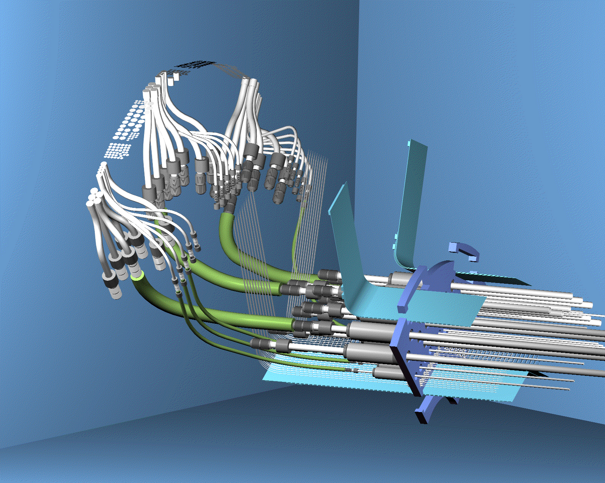
Figure 11: Conceptual design of pixel PP1 (1 quadrant); end plug in blue. Electrical services can be seen to be grouped in octants.

Beam Pipe
The VI section of the beam pipe will be supported at four points: two internal to the pixel gas enclosure located at the end of the ID barrel (z = +/- 850) and two external, located immediately outside PP1. All of the 4 supports will fix the beam pipe in x and y.
The two internal beam pipe supports will be connected to the PST rails and the two external ones will connect to the ID Endplug.
During the installation and the removal of the pixel system, two additional, temporary fixed supports connecting the VI section of the beam pipe to the two PP1 end plug structures will be required, since the two external supports to the ID Endplug will not be present.
The two internal beampipe supports are provided by wire systems affixed to two frames that run on the PST insertion rails. These frames, known as service/beampipe support structures, serve to both hold the beampipe and provide a carriage for the pixel service panels, which are arranged in octants, grouped into quadrant assemblies, and then bolted to the structure. The service/beampipe support structures also provide temporary fixation for PP1, so that it can be utilized as a rigid attachement to the beampipe during insertion of the pixel package. A picture of one service/beampipe support structure is shown in Figure 11a.
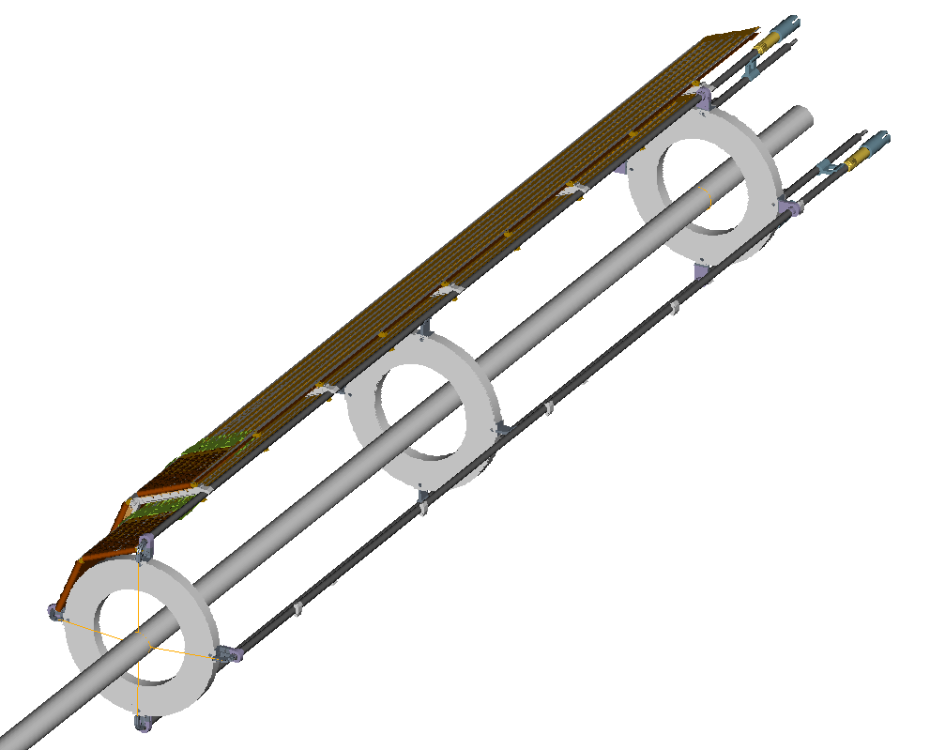
Figure 11a: One service/beampipe support frame (A or C side only)showing a single quadrant of services attached.

The beam pipe will be fixed in z direction only by the external support at side A: the other three supports will allow float in z. The max design axial movement of the z-floating support is 25 mm (worst case, external support at side C); this is the expected beam pipe expansion over 7 m during a 250C bake out process, which will be carried out with all the beam pipe supports in place.
The z-floating supports are all wire supports with built in spring-loaded load-limiter mechanisms, working like rigid supports until a given threshold is exceeded. The nominal threshold for activation of the load limiters is 70N, while the maximum force ever expected in the wires (at full bakeout temperature) is 100N.
The beam pipe support scheme is illustraded in figure 12.

Figure 12: position and type of VI section beam pipe supports

The adjustment of the internal supports is made possible with the ATLAS detector in a short access configuration (from outside of the pixel volume) by having the adjustor mechanisms protrude through the PP1 endplug panel.
The beampipe support structure is not electrically isolated from the PST; however, there is no electrical contact between the support wire and the beampipe supports, effectively isolating the beampipe from the PST.

Rails

The pixel system will be installed as a package consisting of the pixel detector itself, the forward services along the beam pipe, the end plugs and the VI section of the beam pipe.
All these components will move and be slid into the PST as a 7 m long solid object not compressible in z but with some bending flexibility.
Two rails are located inside the PST to allow the installation and removal of the pixel package: their position and shape is shown in Figure 13. The v-rail serves as a longitdinal guide while the flat-rail simply provides vertical support for the package, allowing its rider to follow the path of the v-rail.
The rails will also be the final support of the forward services structures, which include the beam pipe supports, while the pixel detector load will be transferred to independent supports connected directly to the PST mountpads located at the SCT barrel.

Figure 13: PST rail system

Assembly and Installation

Assembly of the Pixel Support Tube
Since the PST is comprised of three independent sections that must be well aligned to each other (in order to guarantee fit into the envelope of the ID), the bonding of flanges, rails, mount pads, and mounts must be performed with good dimensional accuracy. In order to achieve this, a precise bonding jig has been constructed that provides flat and parallel reference surfaces for the PST flange ends, as well as accurate alignment pins on the horizontal diameter of the flanges. These alignment pins provide the references for attachment of the PST forward and barrel sections, as well as for all bonding processes, including mount pads, rails, and flanges. The locations of these pins are accurate to within 25 microns of nominal dimensions. A schematic of the bonding jig is shown in Figure 14. Note that the same bonding jig is used for both barrel and forward PST sections, by switching only the length references that separate the flange bond plates.
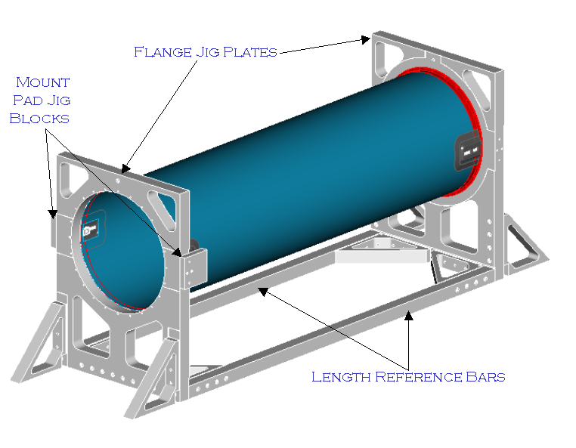
Figure 14. PST Bond Jig showing Barrel PST in place.

Installation and Integration into the Inner Detector
The barrel section of the PST is attached to the SCT barrel structure before the barrel TRT/SCT is lowered into the ATLAS pit and installed in the cryostat. The forward-sections of the PST are then connected to the barrel section before the forward TRT/SCT elements are installed into the cryostat. The forward-sections of the PST are only supported by the barrel connection during the forward TRT/SCT installation, leaving them cantilevered approximately 2.2m during the process. Since this stage of installation presents a high risk of damaging both the PST and the SCT, it is anticipated that a jig will be slid along the cryostat rails to ascertain the PST’s dimensional conformity before the SCT/TRT forwards are moved into place.
. Once this process has been completed, the ID Endplug is installed and the PST forward end flexure mounts are connected to it. Now that the PST is supported from both the SCT barrel and the cryostat ends (through the ID Endplugs), it is possible to install the pixel package. Since the SCT/TRT forwards cannot be removed without removing the ID Endplug, the Pixel package must first be removed if it is desired to remove the SCT/TRT forward sections.
During the assembly and installation procedure of the PST into the ID there are some alignment steps to be carried out:
- Before any integation of the PST into the SCT occurs, the PST/SCT mounts must be bonded into the PST so that its axis coincides with the theoretical ID axis as defined by the cryostat rails. This alignment will be accomplished by using a transfer jig from the SCT to the PST. Once the SCT barrel is fully assembled, the transfer jig will be installed into the SCT, aligned, surveyed, and then gauge blocks monted to the SCT interlinks will be bonded in-place to the transfer jig. This jig will then be installed in the PST bond jig on the PST nominal axis, and another transfer will be made to bond fixtures on the PST bond jig. Finally, the PST will be installed in the bond jig and these transfer fixtures will be used to bond the SCT mount blocks into nominal position. Figure 15 shows the transfer jig (made from low-CTE composite tooling bar), gauge blocks, and PST bond jig.
- When the barrel section of the PST is installed into the barrel ID in the surface lab, the two forward PST sections will be temporarely connected and the whole PST/SCT/TRT unit will be aligned to nominal position wrt the ID dummy rails . Since the PST, SCT, and TRT axes will all already have been aligned coxially (during the fabrication process) this alignment of the barrel ID will be carried out by using only the barrel ID to ID rails adjustments.
- Once the ID barrel with the barrel PST has been installed into the cryostat, the position of the barrel PST will be surveyed wrt the cryostat end survey reference marks. After the ID barrel has been aligned to the cryostat rails, the two forward PST sections will be mounted again to the barrel section and the position of the two ends of the PST wrt the ID rails will be checked. In case of macroscopic misalignment which might unacceptably affect both the PST-SCT forward clearances (and hence next assembly steps) and final pixel position, possible emergency x, y corrections of the PST position will be done within the max allowable range of +/- 3 mm per side. For x corrections, shims between the PST/SCT mount flexures will be adjusted, but for y corrections, the PST/SCT mount flexures will have to be changed out with ones that have had holes machined in a different y position. It is anticipated that a few different flexures (with holes in position increments of 1 mm) will be fabricated ahead of time in order to expedite this adjustment process, should it be necessary.
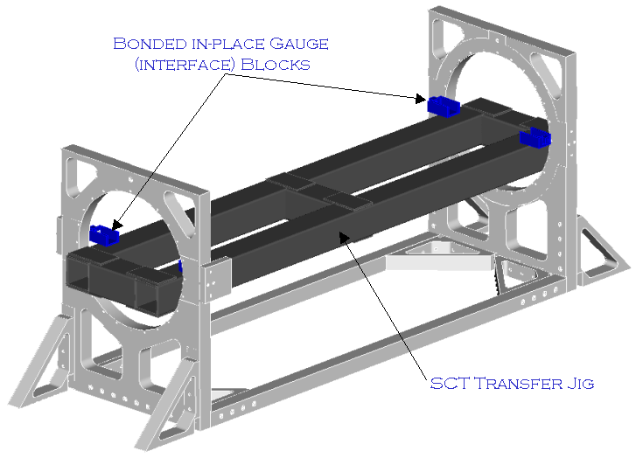
Figure 15. PST Bond Jig with SCT Transfer Jig in Place.

Design Parameters, Load Conditions and Stability

Design parameters and specific requirements
The following design masses have been assumed for the PST analysis:
- Pixel detector: 35 kg
- Forward services (including support structure and beam pipe supports): 20 kg (per side)
- PP1 endplugs: 15 kg each
- Beam pipe (only the straight section up to PP1): 4 kg
It is assumed that all the PP1 connections (both electrical and hydraulic) are supported by the PST end supports.
Overall mechanical tolerances:
- As built straightness (not including sag) of the three assembled sections of the PST: +/-1 mm (this has to be measured on the ID rails wrt the mount points to SCT)
- Sectional profile tolerance of the PST (all points must lie within this distance of their nominal profile size): +/-½ mm
- Gravity sag of the PST (any point), without the pixel system installed, while one of the forward sections is cantilevered (worst case deflection): 1 mm
Rail mechanical tolerances (these apply to every section):
- Absolute position of pixel insertion rails: +/-0.25 mm over 2.4 m

- Straightness of pixel insertion rails: +/-0.25mm over 2.4 m
PST mounts to SCT mechanical tolerances:
- Max parallelism error of the two pixel-SCT interface surfaces at one side wrt those on the other side: 0.05 mm
- Tolerance on the distance between opposite pixel-SCT interface surfaces: +/- 0.05 mm
- Coplanarity of the pixel-SCT interface pin-holes of all the 4 supports: 0.05 mm
Other structural requirements:
- Max natural sag of the 4 mount points to SCT under the nominal pixel detector weight: 0.02 mm. This requirement is linked to the dynamic stability of the pixel detector which will be discussed later.
- Max design overpressure of the inner environment wrt the external one: 4 mbar
- Max pixel system insertion/removal external axial load on PST: 18 kg. This value of 18 kg is given by the stiffness of the SCT barrel (~900 N/mm) and the allowable z deflection in the SCT structure (0.2 mm). However, the two PST end supports will be temporarely locked in z during the installation/removal to minimize the load being supported by the barrel SCT. In addition, it is anticipated that the PST and pixel package insertion tools will be fixed together, such that all insertion loads are internal to the pixel and PST system (see “Assembly and Testing of the Pixel Detector System”, ATL-IP-QA-0007).
- Each end plug must provide a flexible gas barrier wrt the beam pipe to account for a max of 25 mm axial displacement.
Thermal and gas requirements:
- Max total leak rate of the pixel gas barrier: 1 l/hour/mbar
- Minimum PST operating temperature: -10 °C
- Min PST temperature with the active heating turned on: +15 °C
- Max PST temperature in fault conditions: 50 °C. This is associated with a failure of the control system of the heaters. However, this is going to be a local effect (limited to one heater or to a few heaters in parallel/series), having a small impact on the overall PST structure.

Load conditions and stability requirements

The stability requirements of pixel and SCT detectors are fixed in terms of maximum allowable displacements along the three directions: R, R-φ and z of the detector modules. In addition to stability, the strength or structural integrity of the system can also be stated in terms of maximum deflections in the structures.
Thus there are three different requirements:
- Short term stability
- Medium/long term stability
- Structural Integrity

Short Term Stability
The short term stability requirements (1) are defined wrt a time scale shorter than the time needed to achieve a complete re-alignment of ID by tracks. This time will be of the order of days.
If this requirement is applied to an entire detector, moving as a rigid body, then the detector position could be traced on a quasi-on-line basis and hence the associated stability requirements are much more relaxed.
The short term individual module stability requirements are set by the criteria of not degrading by more than 20% the intrinsic point resolution of the detector.
It is also to be said that in general the pixel detector is more sensitive than the SCT barrel to the stability requirements since it is supported off the SCT barrel itself and hence is affected by whatever displacements of the mount points.
However, due to the intrinsic high stiffness of the pixel global frame and to the adopted Pixel-to-PST mounts support scheme, the pixel detector movement induced by most of the external actions, will be very close to a rigid body movement.
The dynamic stability of the detectors against vibrations is usually expressed in terms of minimum natural frequency, which is directly proportional to the stiffness and to the natural sag for the vibration modes along the vertical direction.
The amplitude of the vibration is driven by the damping of the system which is an unknown factor.
However from past experience on previous detectors a first mode above 100 Hz is deamed as acceptable in terms of associated amplitude of displacements.
This requirement is looser for the ID axial modes, which are the most difficult to manage, because of the looser stability requirements along this direction.
In the case of the PST, its axial mode will be driven by the axial mode of the ID barrel, which is relatively low.
The vibration modes of the PST along the other directions should not affect the Pixel detector dynamic stability due to the strong direct link of the Pixel to the SCT through the PST mounts, which should filter most of the excitations coming from the PST structure. The shell and bending modes of the PST, however, should be kept above 50 Hz to also limit the possible negative impact on the stability of the services and beam pipe support structures.
Therefore the tighter dynamic specification is on the Pixel to SCT mounts which have been given a first frequency specification of about 80 Hz. This frequency corresponds roughly to a gravity sag of 40 microns, which has been divided evenly between the pixel to PST mounts and the PST to SCT mount interfaces. This calculation is the source of the 0.02 mm deflection tolerance on the gravity sag of the PST mount points to the SCT.
Since the PST is highly coupled to the SCT, there is some concern that forces and deflections applied to the PST will affect the stability of the SCT structure. Therefore approximate limitations have been placed on the displacements of the SCT shells (where modules are mounted) under different load cases. All of these load cases are expected to be medium to long term.

Medium/Long Term Stability

Most of the long term stability concerns of the pixel system are eliminated due to the global support frame’s very high stiffness and the relative isolation of the pixel system from the ID due to its kinematic mount scheme. However, as stated previously, there are many different load cases, which applied to the PST, could affect the stability of the SCT shells. These load cases, which include thermal expansion of the PST, overpressure of the ID endplug, and endplug/service radial motion have all been given specific deflection tolerances in the three directions, R, R-phi, and Z. These numbers have been agreed by SCT engineers and are generally considered to be extremely conservative, especially for long term stability. The actual requirements are included in Table 1 at the end of the following section. The deflection allowances have been derived from the approximation that R and R-phi deflections on par with gravity sag (110 microns) should be allowable, while a higher budget of 200 microns is acceptable in Z. This Z number is given essentially as a safety against failure, as no estimate for strength of the SCT interlinks exists.

Strength or Structural Integrity

The PST attaches to the SCT interlinks in 4 places, and can impose fairly large loads on them in certain scenarios. Since no model of the interlink strength exists (and none is anticipated) it is impossible to give a load limit. However, to give some idea of a design requirement to high-risk loads (like Pixel insertion, accidental impact with the ID Endplug during access, and asymmetric failure of a section of PST heaters), some deflection requirement must be stated. While this is considered to be very conservative, it is the only requirement which can be stated with confidence in these cases, see Table 1.
Table 1. Deflection Limits in SCT Shell Structures for Structural Integrity.
Load Scenario | R Allowance | R-phi Allowance | Z Allowance
Structural Integrity | 100 microns | 100 microns | 200 microns

A summary of potential load cases and their expected displacements is shown in Table 2. All of these cases are either long term, accidental, or during shutdown, and they involve almost entirely axial motion of the SCT.
Table 2. Load Cases and Deflections Anticipated in the PST/SCT ID Structure.
Load Description | Occurrence | Anticipated Z – Motion (SCT relative to PST)
axial motion of the ID end support plate during operation, up to 1 mm. | operation | 50 microns
bakeout load: axial force of 350 N on fixed point | bakeout | 16 microns
ID overpressure up to 1 mbar (unbalanced) | operation | 15 microns
pixel insertion forces (an axial force of 240 N with a friction coefficient of 0.3 assuming a total pixel mass of 800 N) | pixel installation/removal | 30-190 microns
accidental axial force on ID end plate during access, 4500 N | ID maintenance | 200 microns

Production Plan and Responsibilities

The design and fabrication of the following components is currently the responsibility of Lawrence Berkeley National Laboratory (LBNL):
- Barrel and Forward sections of the PST, including flanges, EMI shielding and thermal control;
- PP1 Endplugs(mechanical, EMI and thermal, but not including connectors or pipe feedthroughs);
- Pixel mounts
- Mounts to the SCT structure
- Service/beampipe support structures.

References

(1) S. Haywood et al, Offline Alignment and Calibration of the Inner Detector, ATL-INDET-2000-005

