 | Title
ATLAS Project Document No: | Institute Document No. | Created: 18/04/2003 | Page: 1 of 9
ATL-IP-AP-0009 |  | Modified: 22/04/2003 | Rev. No: 1
Assembly Procedure
Pixel Beampipe Support Structure Assembly and Integration Procedure

Abstract
Procedure for assembly of the beampipe support structure around the VI section of the ATLAS beam vacuum system. Includes initial assembly of the Pixel package and integration of the beampipe supports, both permanent wires and temporary external supports. Overview of ‘Adjustment Procedure’ is also included here.
Prepared by:  Eric Anderssen, Neal Hartman | Checked by:  Danilo Guigni  Marco Olcese  Raymond Veness | Approved by:
Distribution List

History of Changes
Rev. No. | Date | Pages | Description of changes
0  1 | 21/04/2003  22/04/2003 | 6  9 | Initial Release  Figures added, detail added to adjustor assembly, and adjustment procedure

Table of Contents

1 Introduction 4
2 Assembly Procedure 4
2.1 Preparation and ITT Overview 4
2.1.1 VI section Laid into ITT 4
2.1.2 Pixel System Assembled Around VI 5
2.1.3 Wire/Collars assembled to VI 5
2.2 Transfer of Load from ITT to BPSS wires 5
2.2.1 BPSS introduced into ITT 5
2.2.2 Wires Fed Through BPSS 5
2.2.3 Assembly of Adjustor Units 5
2.2.4 Initial Tension Procedure 7
2.2.5 ITT cradles lowered within length of BPSS 7
2.3 Service Integration Overview 8
2.3.1 Service Quarter Panels Introduced 8
2.3.2 Termination of BPSS to PP1 8
2.3.3 Assembly of Bellows Flange on PP1 8
2.4 Transfer of Load from ITT to Temporary Forward Support 8
2.5 Final Service Panel Work 8
2.5.1 ITT is rotated to allow for additional service panel installation 8
2.5.2 Bellows Flange coupled to remaining service panels 8
3 Adjustment of BPSS Wires 8
4 References 9

Introduction
The assembly of the Pixel Package follows assembly of the Pixel Detector around the VI section of the ATLAS vacuum system (Beam Pipe). This document aims primarily to address how the Beam Pipe Support (BPSS) is introduced into the package, and will cover through to the assembly of the temporary forward supports. For completeness, the Beam Pipe and its supports will be followed through its integration into the Pixel Package, up to where it is ready for installation in the PST. This document is not intended to replace or add detail to the assembly procedure for the Pixel Package. Increasing detail will be added to ATL-IP-QA-0007 – Assembly and Testing of the Pixel Detector System. There is where you will find more on integration of services onto the BPSS, and compatibility of the ITT with the BPSS. It is assumed that the ITT will provide or allow for the required assembly kinematics. Only the direct Service Interfaces to the BPSS will be covered here. Assembly of the package into the PST is beyond the scope of this document, however a discussion of Adjustment of the BPSS wires is included, which would be the same procedure for adjustments made on the surface as well as in-situ.

Assembly Procedure
Much of this section is covered in great detail in ATL-IP-QA-0007, it is provided here as overview.

Preparation and ITT Overview
The ITT shown below in Figure 1 is an assembly support structure that supports the various elements of the Pixel Package during interim phases of the assembly. It provides for complex motions and gross alignment of the structures to be assembled. The configuration of the ITT changes as the assembly progresses, all the time assuring adequate support for the partial assemblies. The initial phase of the Package assembly is aimed at assembling the Pixel Detector around the Beam Pipe. This is the underlying principle of the Pixel Package—the central portion of the Pixel Detector, the ‘B-Layer’ does not fit around the end flanges of the Beam Pipe. Therefore, it is assembled around the Beam Pipe first, and the rest of the Pixel Detector around it—exact details of this procedure are found in ATL-IP-QA-0007. The first object assembled, however, is the Beam Pipe. The ITT supports it via several yokes, which are positioned to be consistent with all modes of assembly. These yokes hold the Beam Pipe on detector center (Z-axis), and are removable as required by assembly.
Figure 1 ITT Structure with support Yokes shown

VI section Laid into ITT
The ITT yokes are positioned and the Beam Pipe is laid in place on them. It is held in place by gravity on the 6 yokes (‘U-Supports’ in ATL-IP-QA-0007). There are 6 yokes nominally only 4 are used, alternate yokes are lowered to allow package members to pass along Beam Pipe during the assembly.

Pixel System Assembled Around VI
The assembly of the Pixel Detector is wholly covered by much of ATL-IP-QA-0007, and is summarily covered in the introduction of this section. The end result is the Pixel Detector, assembled, and positioned at the center of the ITT.

Wire/Collars assembled to VI
Wires and Collars, provided with the Beam Pipe are attached to the structure at the proper locations (See ATL-IP-ES-0068) near the Pixel detector. They otherwise interfere with assembly of the Detector, so this is the earliest that they can be attached. Nominally, all other collars should be attached at this time, as they are consistent with the remaining assembly stages. This and the following phase of assembly will likely involve close support from Beam Pipe technical personnel

Transfer of Load from ITT to BPSS wires
This phase of assembly will require further interaction with the Beam Pipe technical personnel. Here is where the support condition of the Beam Pipe changes from being entirely supported by the ITT, to being partially supported by the BPSS

BPSS introduced into ITT
The End Yoke is lowered, cantilevering the last ~1.2m of Beam Pipe allowing the BPSS to pass this location. After passing, the yoke support is repositioned. Each yoke is passed until the BPSS is in its final position. This position is defined in part by the Package Insertion Trolley, which interfaces with the Pixel Detector.
It may be desired to assemble the Bellows units around the Beam Pipe at this phase as it would then require one less cantilevering of the Beam Pipe, and would minimize the interaction periods with Beam Pipe technical personnel. In the installed position, the Bellows unit must be at lower Z than the end yoke support. Note also—after the installation of all services, the yoke support in the center of the BPSS is in-operable due to interference with service panels.

Wires Fed Through BPSS
After the BPSS is in position, the wires from the Beam Pipe Collar can be fed through the BPSS Longeron and through the BPSS Adjustors. At this stage, the access to the Beam Pipe is only limited in the Pixel detector region. The BPSS is mostly open, and the gap between the BPSS and the Pixel Detector is mostly open with a 140mm gap between Frame and BPSS. There will be cooling fittings protruding from the Pixel Frame ~30mm into this gap, but at a lower radius and different phi than the Longerons (vertical and horizontal).

Assembly of Adjustor Units
The preload process is discussed here for clarity. This will be done prior to assembly of the BPSSS on a test stand—this preload assembly is a part of the BPSSS assembly that is introduced in section 2.2.1 “BPSS introduced into ITT.” The assembly process will continue shortly, in section 2.2.4“Adjuster Assembly Installed.”
For the following discussion refer to: LBL Drawings 25o040, 25o051 and 25o084 (and sub-assemblies) in ‘Adjustor_Package.pdf. Which can be found in EDMS in Doc No ATL-IP-ED-0160 [ATLAS Drawing numbers will be individually assigned at time of PRR]. Adjustor pre-load assembly, an assembly of items 1 & 2 in Figure 2 (and Figure 3) are pre-assembled on the BPSS frame, and pre-calibrated for load limits. The preload is developed by compressing the spring in Figure 3, engaging the threads of items 1 & 2 to a pre-calibrated engagement length. The ‘Adjuster Assembly’ 25o084, item 3 in Figure 3, is assembled after the wires are fed through the BPSS Longerons. Note: 25o040 is the load-limiting version of the Adjustor. 25o051 is the ‘fixed’ adjustor, with a bushing replacing the spring.
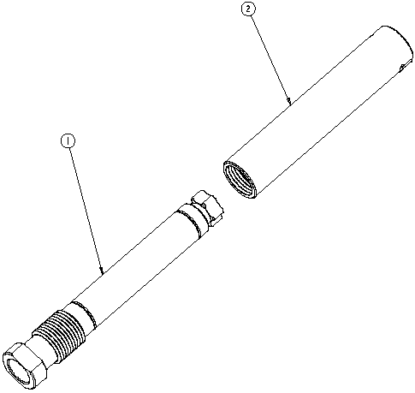
Figure 2 Fixed Adjustor 'Pre Load' unit--from LBL Dwg 25o051--note: bushing replaces spring in item 1.
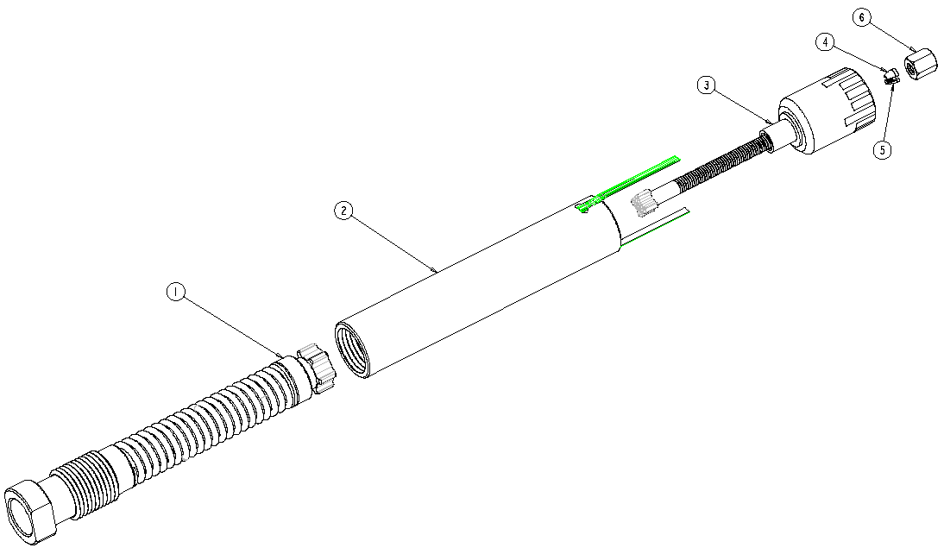
Figure 3 Tension Limiter assembly LBL Drawing Number 25o040 sheet 1
Assembly 25o084 ‘Adjuster Assembly,’ Figure 4 below, is pre-assembled with the correct thread engagements to position the adjustable parts in the middle of the adjustment range—see Figure 5. The pre-assembled distance compensates for travel during initial preload, and allows for some cable slack to be taken up by adjustor travel—this is more fully covered in ATL-IP-ER-0009. Part of the assembly process is aimed at removing slack—see section 2.2.4, so the portion of the travel budget allotted to slack adds conservatism to the adjustment range.

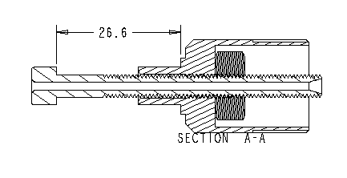
Figure 4 Section of assembly 25o084 showing proper engagement length

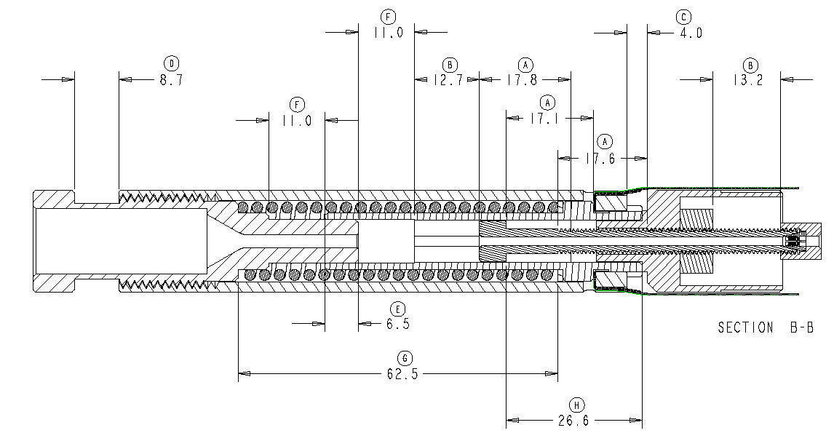

Figure 5 Assembly Gaps in properly assembled Tension Limiter LBL DWG No 25o040 sht2—cable shown in red.

Adjuster Assembly Installed
Assembly 25o084, the “Adjuster Assembly” (Figure 4) is slid over the protruding cable, to dead height (see section view in Figure 5), and the collet grips and cap (ref LBL DWG No’s: 25o049, 25o050—items 4,5 & 6 in Figure 3) are installed over the protruding length of cable.

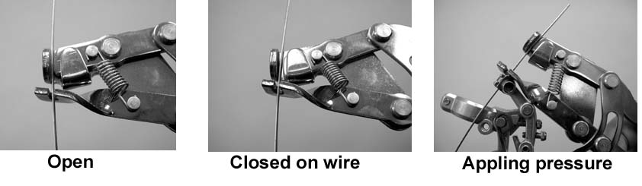
Figure 6 Fourth Hand Tool cable tensioner shown engaging cable--image courtesy http://www.parktool.com
Cable slack is removed with ‘fourth hand’ cable tensioner bearing on the collet cap (25o050), pulling on the protruding cable. The cable is pulled through the collet cap until some tension develops in the cable. The Collet Cap is then tightened to grip the cable.

Initial Tension Procedure
The Yoke support is still carrying the entire Beam Pipe load. The adjustors are installed in pairs, one rigid; the other packed with a tension limiting preloaded spring. These load limiting adjustors are at –X, and –Y, on both sides. They are set to trip at slightly above the nominal tension of the support wires—(See ATL-IP-ES-0068). Using the Yoke support to react the tension, these limiters are tensioned until the electrical signal is broken, then backed off ½ turn of the adjustor nut and locked down.
The opposite adjustors—the ‘Fixed’ adjustors on +X, and +Y are adjusted up until the yoke is unloaded. This can be sensed in many low-tech ways such as a trapped piece of paper or with dial test indicators.
After this procedure, the beam pipe should be fully supported by the cables, and on center. This should also leave the central yoke supports (near the wires) completely unloaded.

ITT cradles lowered within length of BPSS
After the central yokes are unloaded the beam pipe is being supported by the BPSS at the wire end. The yoke supports at this end can clearly be lowered. The yoke supports in the middle of the BPSS are nominally only there for purposes of sliding the Pixel Detector around on the ITT. They also can be lowered if they are not already.

Service Integration Overview
Service integration is extremely complex. This phase of the assembly will take significant manpower and time as a lot of testing is required at every step of this process. The Beam Pipe technical personnel should not be required during this period as Pixel personnel, and their work dominate it.

Service Quarter Panels Introduced
For the purposes of this document, a Service Quarter panel is a unit which covers the outside of the BPSS with services, electrical and cooling for the Pixel detector, and carries with it, the structural elements of PP1. This unit is installed onto the BPSS and mechanically fastened along its length. A lot of pre-assembly has been done within this unit to minimize time required to hook it in, but for every connection made, functional tests must be completed. Failure of any significant portions of the detector at this stage may require partial or total disassembly of the Package. This procedure continues assuming good test results here.
On the ITT, it is possible to install only two Quarter Service panels at a time without rotating the package.

Termination of BPSS to PP1
Nominally this termination will occur right after the Service Quarter panel is installed. It is brought out here to describe the function and procedure, as this forms a part of the support chain, if only temporarily, of the Beam Pipe.
After a pair of quarter panels is assembled on the BPSS, they can be joined at their shared seam at PP1, making for a half plate of PP1. Within each panel there are provisions for two BPSS pass throughs, one for the Adjustor, which must also affect a seal, the other to mechanically attach the PP1 Panel to the BPSS. After the quarter PP1 panels are fastened to each other, they are locked to the mechanical attachment point of the BPSS. This attachment allows for PP1 to support the Beam Pipe off of its inner radius, as the outer radius is supported by the BPSS directly

Assembly of Bellows Flange on PP1
As mentioned earlier, the Bellows unit should already be in the installed position at this point. This unit is intended to seal off the gas volume of the PST, while allowing for Beam Pipe bake out expansion, and the allowed radial adjustment range. This unit, during the assembly, will have a protective can around it, which supports (and centers) the bellows radially. This can, after the bellows flange is coupled to the PP1 inner radius, is the temporary radial support.
Note, at this stage, only ½ of PP1 is there, so the Bellows PP1 Flange will only be coupled to that half.

Transfer of Load from ITT to Temporary Forward Support
This stage may require a brief interaction with the Beam Pipe Technical Personnel, as it is a change of support condition of the Beam Pipe. It is a fairly minor change but should be monitored if only for information.
After the Flange unit is attached to PP1 half, the support yoke at the end of the ITT is no longer needed. At this stage this final support from the ITT is removed, and not used again (assuming successful completion of the Package assembly (i.e. no maintenance requirements…)

Final Service Panel Work
As mentioned earlier, the service panels can only be assembled on the top half of the ITT. To assemble the lower two panels, the ITT must be rotated 90 degrees to either side giving access to these lower panel positions. This work as with the prior panel installation, may take a significant amount of time

ITT is rotated to allow for additional service panel installation
During rotation, the support condition of the beam pipe should not be changing as it is supported by the BPSS entirely at this stage.

Bellows Flange coupled to remaining service panels
This is exactly the same process as the prior, with the exception of the load transfer, which is already affected. Again, may require interaction with Beam Pipe technical personnel.

Adjustment of BPSS Wires
The adjustment of the wires is an issue larger than the scope of this document. It is inherently tied with survey of the beam pipe. It is obvious that the system provided in this design can move the beam pipe in increments as low as 0.25mm likely lower—a discussion of resolution is available in ATL-IP-ER-0009. Survey Sigma is on order of 1.2mm, so a nominal adjustment increment of 1mm is reasonable. The Screw Pitch on the adjustor unit is 1mm, so barring significant changes in nominal tension, adjusting opposing adjustors by one turn moves the beam pipe 1mm. The actual tension changes for a given displacement are covered in ATL-IP-ER-0009, but nominally one should move the beam pipe in directions to increase wire tension.

Procedure to adjust beam pipe from ‘known’ position to target position

Tension verified
The nominal tension of the system is set to be above 7kg, but limited to under 10kg. The preload device opens at 10kgf, and a quarter turn reduces this load by 2.5kgf—these numbers to be verified with prototypes. However the principle is to adjust load limiter up to where it separates (indicating it is at 10kgf), and reduce the load to a known value. This process yields a repeatable elastic condition, and it is in this state that the beam pipe is in a stable, repeatable position. In this condition, it is surveyed.

Adjustment made
Survey data indicates beam pipe should move to new position, ΔX, ΔY. The Adjustor on the side of the direction of required beam pipe travel (if moving in +X the adjustor on the +X side) is adjusted by the appropriate number of turns (1 turn per mm) to a resolution of ~0.250mm). For adjustments over the entire range, this should be limited in force by the tension limiter, to well under the required load limit (spring stiffness is << than wire stiffness—See ATL-IP-ER-0009 for load calculations) While the tension is limited to the value required, it is different than nominal (higher), so the elastic position of the beam pipe is different than simply the number of turns the adjustor barrel would indicate. This can be fixed by using the procedure outlined above—to bring the tension back to nominal

Tension verified
By now turning the opposite adjustor an equal number of turns, the load should be brought close to nominal. This procedure should follow the above outline—as the tension is brought back down, the acceptable load light should ignite, indicating the load limit was reached—the adjustor should be turned ¼ turn past this to achieve nominal load. Note it is important to adjust the second adjustor (regardless whether it is the ‘fixed’ or ‘load limiting’ adjustor) to achieve this to maximize the resolution of the system.

Survey of position
The beam pipe should be in a stable position as at the beginning of this procedure. The survey should verify that the appropriate distance was moved.

Repeat procedure
If the distance moved was incorrect, or the survey indicates further motion is required, the procedure can be repeated. However, care should be taken to ascertain the resolution of the survey, as compared to the resolution/repeatability of the adjustment system, which should be much higher.

References
- ATL-IP-QA-0007
- ATL-IP-ED-0160
- ATL-IP-ER-0009
- ATL-IP-ES-0068
- Park Tool Website—http://www.parktool.com

