Development of a Compact Fast CCD Camera and Resonant Soft X-ray Scattering Endstation for time-resolved Pump-Probe experiments

D. Doering^{1*}, Y.-D. Chuang^{2*}, N. Andresen¹, K. Chow¹, D. Contarato¹, C. Cummings¹, E. Domning¹, J. Joseph¹, J.S. Peper¹, B. Smith¹, G. Zizka¹, C. Ford³, W.S. Lee³, M. Weaver³, L. Patthey⁴, J. Weizeorick⁵, Z. Hussain², P. Denes^{1,2}
1 Engineering Division, Lawrence Berkeley National Laboratory, 1 Cyclotron Rd., Berkeley, California 94720, USA
2 Advanced Light Source, Lawrence Berkeley National Laboratory, 1 Cyclotron Rd., Berkeley, California 94720, USA
3 SIMES, SLAC National Accelerator Laboratory and Stanford University, 2575 Sandhill Road, Menlo Park, California, 94025, USA
4 Paul Scherrer Institute, 5232 Villigen PSI, Switzerland
5 Argonne National Laboratory, 9700 S. Cass Ave., Argonne, Illinois 60439, USA
* Correspondence should be addressed to ddoering@lbl.gov and ychuang@lbl.gov

The designs of a compact, fast CCD (cFCCD) camera together with a resonant soft X-ray scattering (RSXS) endstation are presented. The cFCCD camera consists of a highly parallel, custom, thick, high-resistivity CCD, readout by a custom 16-channel ASIC with a readout rate of 200 frames per second. The camera is mounted on a virtual-axis flip stage inside the RSXS chamber. When this flip stage is coupled to a differentially pumped rotary seal, the detector assembly can rotate about 100º/360º in the vertical/horizontal scattering planes. With a six-degrees-of-freedom cryogenic sample goniometer, this endstation has the capability to detect superlattice reflections from electronic orderings showing up in the lower hemisphere. The complete system has been tested at the Advanced Light Source, Lawrence Berkeley National Laboratory, and has been used in multiple experiments at the Linac Coherent Light Source, SLAC National Accelerator Laboratory.

Keywords: Resonant Soft X-ray Scattering, CCD, optical pump and X-ray probe, direct detection, high speed readout.

I Introduction

Strong correlation effects in complex systems can lead to the formation of real space superstructures in different electronic degrees of freedom (charge, spin and orbital) that can compete and/or cooperate with electron itinerancy. Such competition/cooperation behavior has been argued as one of the key ingredients to understand how various emergence phenomena, such as high temperature superconductivity (HTSC) and colossal magnetoresistance (CMR), can arise from different ground states [1-3]. To study the electronic self-assembling effects (called electronic orderings), resonant soft X-ray scattering (RSXS) spectroscopy has been identified as one of the most powerful probes due to its direct coupling to relevant orbitals and sensitivity to long-range spatial coherence [4].
Although quasi-static electronic orderings in correlated systems have been extensively studied with RSXS spectroscopy at third generation synchrotron facilities, their dynamics remains largely unexplored [5-10]. It has been suggested that using the pump-probe technique, i.e. perturb the system with pump beam and probe it with an X-ray beam at later time Δt to explore its temporal evolution, can yield to invaluable insight about the dynamics. However, generating such ultrafast X-ray probe beam has become the major technical challenge that limits the progress in this field. Slicing sources at third generation synchrotron facilities, such as the beamline 6.0 at the Advanced Light Source (ALS), Lawrence Berkeley National Laboratory (LBNL), can produce fast enough X-ray pulses, but their intensity is dramatically reduced by more than six orders of magnitude [11]. On the other hand, the newly commissioned Linac Coherent Light Source (LCLS) at SLAC National Accelerator Laboratory is an X-ray free electron laser (XFEL) capable of delivering ultrafast/ultra-bright X-ray pulses (>10¹¹ photons per pulse with <10fs temporal resolution) [12], thus it is an ideal source for such pump-probe studies. This high temporal resolution, however, can be potentially ruined by fluctuations inherent to the FEL process such as time jitter and energy fluctuation, which become intensity fluctuation after the monochromator.
To correct these fluctuations, the data acquisition has to be carried out in shot-by-shot mode. The acquired images can then be individually normalized by the incident photon flux and reassigned a new time stamp to eliminate intensity fluctuation and temporal jitter. This can only be achieved if the imaging detector is capable of reading out a full image between two pulses. Besides the high-speed full-frame readout requirement, the detector also needs to (i) be compact enough to fit inside a reasonable size vacuum chamber, (ii) have sufficient cooling to reduce thermal noise and (iii) have single-photon sensitivity in soft X-ray regime (from 0.5 to 1.5keV).
In the following sections, we will present the designs of the cFCCD camera that meets the aforementioned requirements and the RSXS endstation used to carry out time-resolved pump-probe RSXS experiments. We will also show data taken at ALS and LCLS to demonstrate the capability of this new instrument.

II System design

A. Compact Fast CCD

The block diagram of the cFCCD camera system is shown in Fig. 1. The primary components of this camera include: the camera head with all in-vacuum modules, a vacuum-to-air interface, the backend readout electronics, a host processor unit (typically a personal computer) and auxiliary components like temperature controller, chiller and power supply.

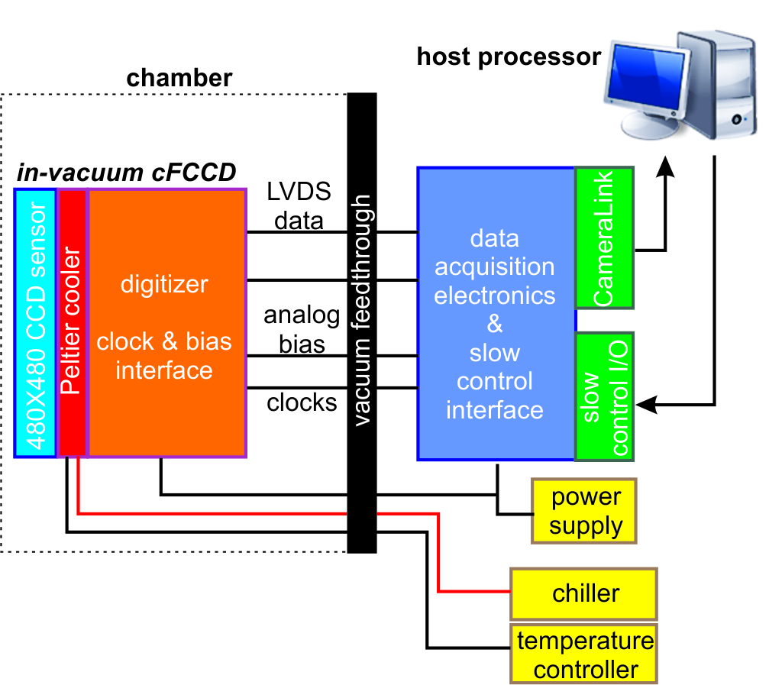
Figure 1 – Block diagram showing the cFCCD camera system. The camera head with all in-vacuum modules (left) is separated from other components (backend electronics, control I/O, host processor and auxiliary components) by the vacuum-to-air feedthroughs.
The cFCCD camera head is based on a custom, thick, fully-depleted direct detection CCD designed at LBNL [13, 14]. This CCD has an array of 480 x 480 30 μm square pixels and can be back–illuminated for direct soft X-ray detection. The device is thick (200 μm) and has high detection efficiency for X-rays with energies lower than 8keV. It is fully depleted to collect all of the charge and minimize diffusion, thus greatly improving the spatial resolution. This CCD has an “almost column parallel” architecture in which every 10 columns have an individual output stage [14]. Reading out both top and bottom halves of the CCD leads to a total number of 96 output ports. The CCD is read out by a custom 16-channel ACD and signal processing ASIC called Fast CCD Readout IC (FCRIC). Each channel consists of a preamplifier, multi-gain integrator and correlated double sampler, followed by a 13-bit pipelined ADC. With gains of 1, 2 and 8, a 15-bit range can be spanned (an additional bit is used to control offsets).
The large number of outputs on the CCD enables 200 frames per second (fps) operation. Each output has a static dissipation of about 12 mW, so the total heat generated at the periphery of the CCD is approximately 1.2 W. This heat load plus the limited cooling capacity from commercial Peltier coolers and the requirement of being compact (the entire camera head has to fit inside a 3.5” cube) led us to redistribute electronic circuitries into three sets of circuit boards: top, digitizer and clock feed-through boards. Figure 2 shows the construction of the top board and the arrangement of various boards in flat and folded-up geometries.
The top board assembly holds the CCD sensor and provides the cooling path for it. The backbone of this assembly is an AlN substrate with a cutout hole for exposing the back side of CCD to incident X-rays (figure 2(a)). A Kapton board implementing the electrical circuit for the assembly with slightly larger openings is placed on top of the AlN substrate on the CCD front side. This board is glued to the substrate by an adhesive film with the same dimensions as the Kapton board. The unmasked region on the AlN substrate is then used to glue the CCD to the substrate. To complete the assembly, four connectors are used: two from the CCD to the digitizer boards and two to the clock feed-through boards. These five boards are arranged in the way shown in figure 2 (figure 2(b) and 2(c)). The top board assembly is attached to the Peltier cooler with four clamp-on copper fingers. During operation, the CCD is cooled to -25⁰C to reduce dark current.
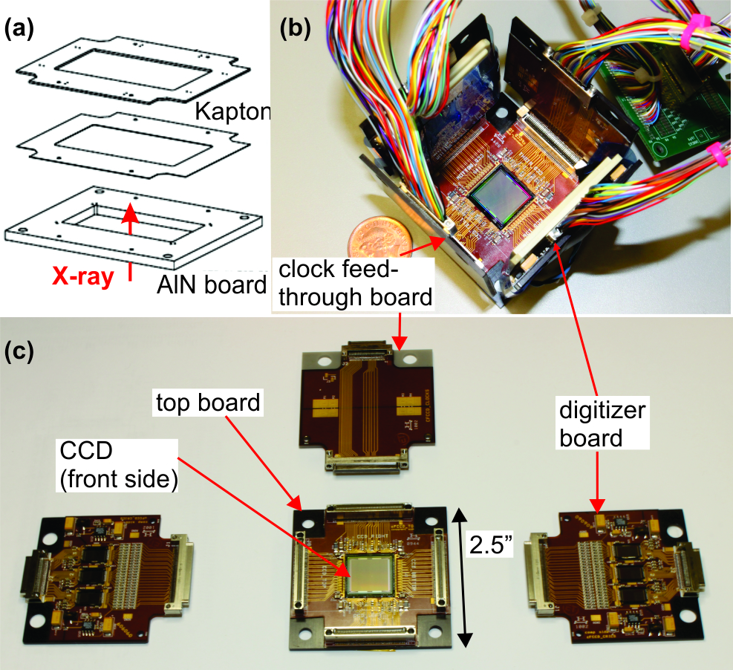
Figure 2– (a) Schematic plot showing the construction of the cFCCD top board. (b) and (c) Arrangement of various boards (top, digitizer and clock feed-through) in folded-up and flat geometries.

Each digitizer board contains 3 FCRIC ASICs. Each ASIC has 16 inputs that are AC coupled to the CCD (48 inputs per digitizer board and two boards to handle 96 outputs from CCD). The outputs of groups of four ADCs are multiplexed into one LVDS output. Before the AC coupling, there are bias resistors that provide load current to the CCD source-follower outputs. These resistors are mounted on this digitizer board to minimize the heat load on the top board assembly. The digitizer boards are mechanically secured to the copper cooling block as well.
Digital data is collected by an FPGA-based system designed at Argonne National Laboratory (ANL) [13]. At the ALS, this ANL readout system is used in a stand-alone mode, storing data on a local host processor. At the LCLS, the ANL system has been interfaced to the LCLS experimental data acquisition system.
The clock feed-through boards, which are also mounted on the copper cooling block, transmit the analog clocks and bias voltages generated in the air side by the backend electronics to the CCD. But the long pathway (over 1.2m in the current system) inevitably leads to higher noise pickup and line inductance. Future designs will move all these functions directly onto the clock feed-through boards and this will greatly reduce the noise.
The cooling mechanism of the cFCCD has sufficient flexibility to accommodate its required complex motion. The CAD model and photograph of the actual camera are shown in Figure 3. The CCD is cooled by a three-stage Peltier cooler through four clamp-on copper fingers. The Peltier cooler is glued onto the top of a copper block with silver-loaded epoxy. There are three sets of water channels in the block (figure 3(a) and 3(b)). When flowing water through these channels, the copper block will reach~15ºC and the front side of the Peltier will reach -25ºC, sufficiently low for dark current reduction in a CCD operated at these high frame rates. This copper block also provides the cooling for the digitizer and clock feed-through boards mounted on four sides. The cooling water is delivered from the chiller to the copper block through Teflon tubing, which is separate from high vacuum by the vacuum guard made out of a long edge-welded bellow (see figure 5(a)).
The cFCCD assembly is fully enclosed in a metal housing for both mechanical protection and holding a visible light blocking filter in front of the CCD sensor (figure 3(c)). Currently, a 250nm thickness, free-standing Al window (with 15mm square opening) is mounted on the metal housing to block the scattered 800nm laser beams during pump-probe experiments at LCLS. The backend of the cFCCD assembly has three anchoring holes for mounting onto the support bracket on the detector flip stage. Four 50-pin electronic connectors can be accessed through slots on the base plate, which are taped off after connections are made to minimize light-leakage (figure 3(b)).

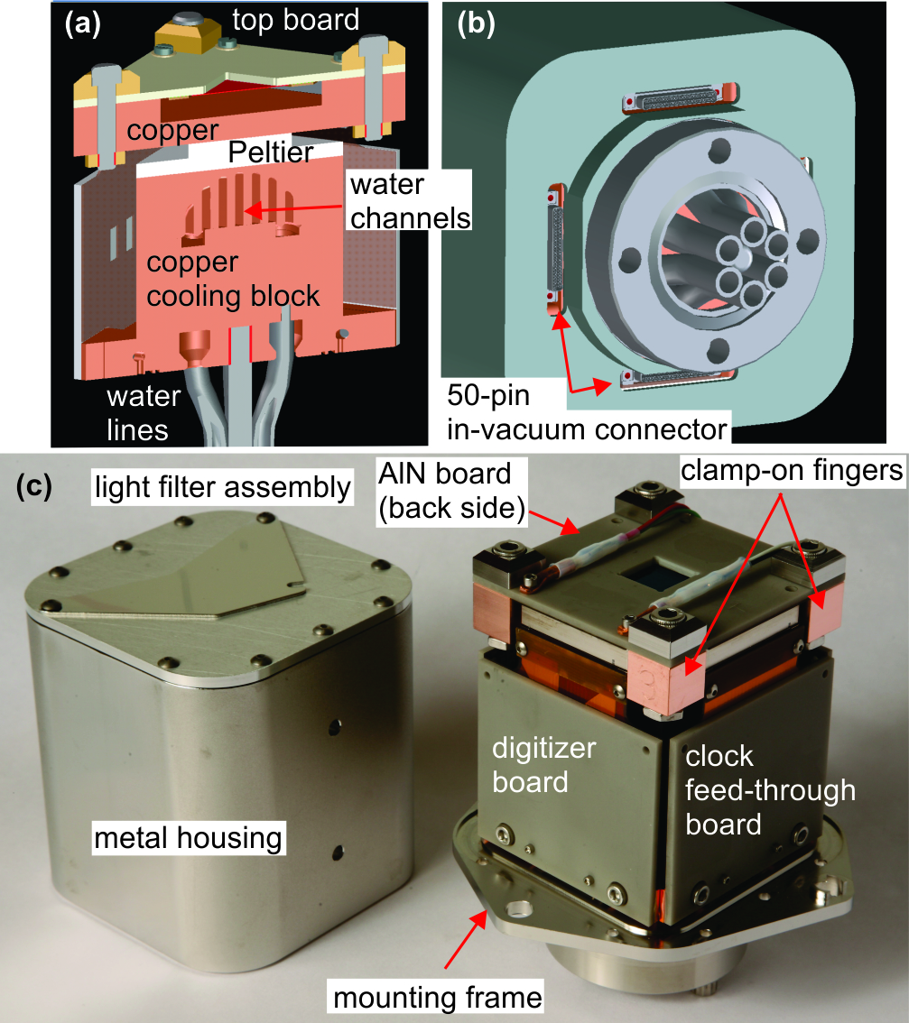
Figure 3 – (a) Cross-section view of the cFCCD camera showing the design of the copper cooling block and water channels. (b) Bottom view of the cFCCD showing electronic and water connections. (c) Photographs of the actual cFCCD camera with the mechanical housing removed to reveal its internal construction.

B. RSXS chamber

The RSXS endstation is constructed to house the cFCCD (see figure 4 for CAD model). It has the following components: (i) a sample cryostat with XYZ manipulator (figure 4(b)), (ii) two differentially pumped rotary seals for sample and detector stages, (iii) an experimental chamber with a large wire-sealed base flange to support the detector assembly (single-channel and cFCCD detectors), (iv) pumping and vacuum monitoring systems for experimental and load-lock chambers, (v) a sample load-lock assembly for quick sample switching and (vi) a motorized alignment system for in-situ alignment.
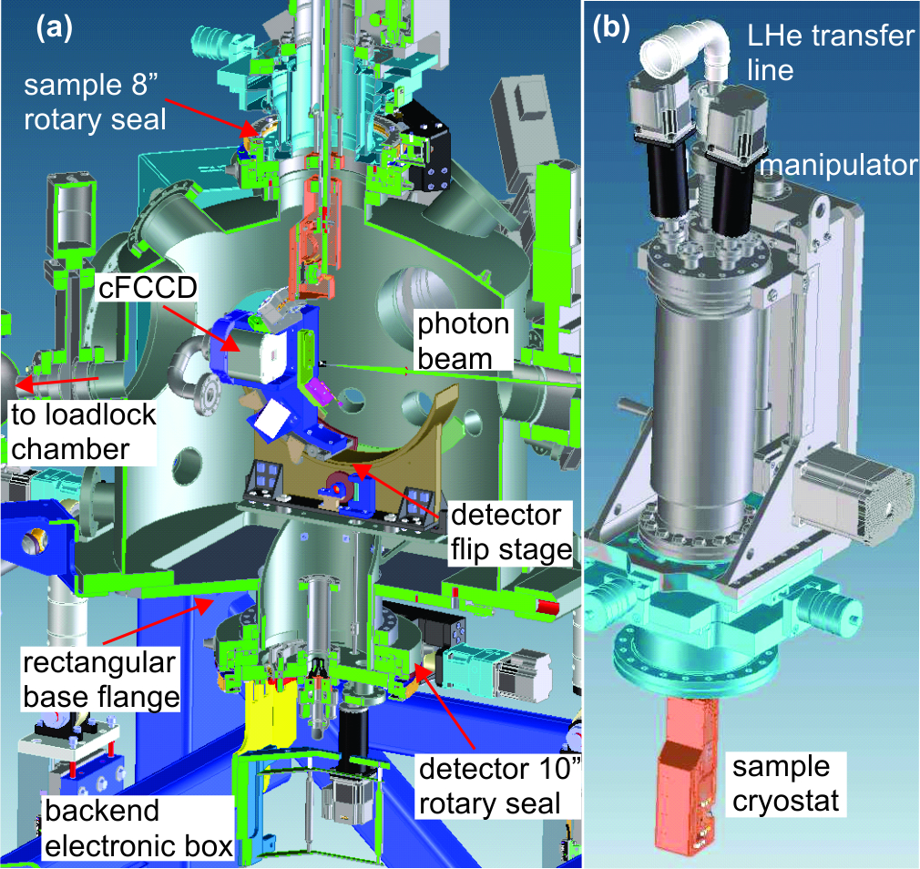
Figure 4–(a) CAD model showing major components of the RSXS chamber. (b) CAD model showing the sample manipulator and cryostat.
The cFCCD camera, together with other single-channel detectors such as avalanche photodiodes (APDs) and thermopile detectors, are mounted on a virtual axis flip stage. This flip stage allows them to be rotated by ~100º in the vertical scattering plane (see Figure 5(a)) and the relative angle can be read from an attached in-vacuum tilt sensor with 0.1ºangular resolution. When coupled to the scanning pinhole/knife-edge tool mounted underneath the sample cryostat, these single-channel detectors can be used to measure the photon beam profile (X-ray, 800nm and mid-IR) to determine the pump and probe beam fluence. They are also used to achieve spatial overlap between pump and probe beams. The flip stage is attached to a 10” base flange, which is then mounted onto the bottom 10” differentially pumped rotary seal. This rotary seal rotates the detector assembly by 360º in the horizontal scattering plane. The combined rotational motion enables the detection of superlattice reflections from electronic orderings in the lower hemisphere. It also gives the opportunity to perform RSXS measurements in either σ or π scattering geometry. To have a quick turn-around time should detectors get damaged and need to be replaced, the assembly is mounted on a rectangular wire-sealed base flange for modular installation.
The open-cycle sample cryostat has built-in heaters for temperature control from ~15K to ~450K. The sample goniometer is isolated from ground to allow total electron yield (TEY) measurement. This goniometer has two rotational degrees of freedom: it can rotate the sample about its surface normal (azimuth rotation) by >270º and flip in the vertical plane by >90º (figure 5(b)). The cryostat is mounted on top of the XYZ manipulator, providing three translational degrees of freedom. The manipulator is placed on top of an 8” differentially pumped rotary seal, which rotates the sample goniometer in the horizontal plane (figure 5(a)). These combined motions give a total of six degrees of freedom for sample manipulation.
The endstation has fiducials on the chamber and differentially pumped rotary seals to properly set the rotational centers for sample (three rotational axes) and detector (two rotational axes). Since the horizontal scattering geometry is the most precise one (and most commonly used) for this endstation, the critical rotational axes are defined by sample and detector differentially pumped rotary seals. These two axes are first determined by using the coordinate measurement machine (CMM) to tie to the fiducials on them and then adjusted to be co-center within 500μm at nominal measurement location. The chamber has a nominal outer diameter (OD) of 26” with several large OD ports (up to 12”) for pumps and view ports. These ports can also be used to install instruments such as time-zero antenna tool, FEL beam stop or in-coupling mirrors. The chamber sits on top of a six-strut system. Each strut is attached to a motorized linear translational stage for (remote) in-situ alignment.
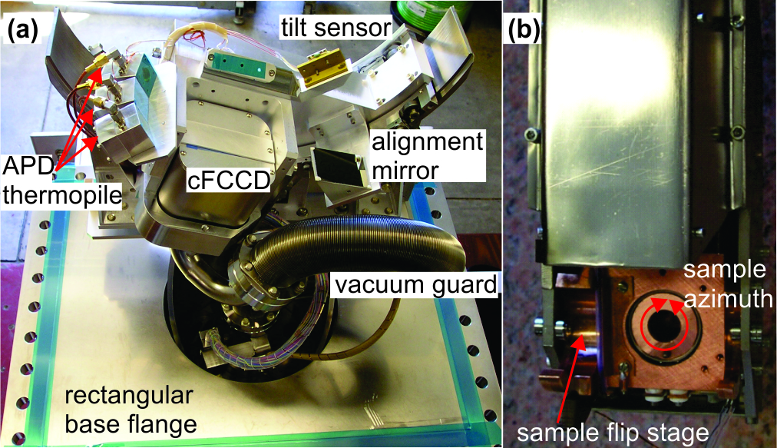
Figure 5 (a) Photograph of the detector assembly mounted on the rectangular base flange. (b) Photograph of the sample cryostat.

III Experiments

Commissioning of the RSXS endstation and the cFCCD camera was carried out at beamline 8.0.2 at the ALS at LBNL. Nickelate samples (La_{2-x}Sr_{x}NiO₄) with two different doping levels (25% and 33%) were measured during the commissioning run. At low temperature, doped holes and spins can form long range orderings with patterns illustrated in figure 6(a). To first order, the excessive holes at Ni³⁺ sites (blue spheres, S=1/2) and spins at Ni²⁺ sites (red arrows, S=1) form one-dimensional stripes extending along the b* axis and alternating between each other along thea* axis (in orthorhombic coordinate), leading to extended unit cells indicated by blue and red dashed rectangles in the figure 6(a). The corresponding charge and spin ordering wave vectors are (2ε,0,1) and (1-ε,0,0) in (2π/a,2π/b,2π/c) units (ε is the incommensurability and is roughly proportional to the doping level) [15].
These ordering vectors have strong doping and temperature dependence, as seen in the phase diagram in figure 6(b). Below the ordering transition temperature T_{CO} (for charge ordering) and T_{N} (for spin ordering), if sample (θ) and detector angles (ϕ) are set properly such that the photon momentum transfer and its projection match the ordering vector q (|q|=(4π/λ)*sin(ϕ/2) and (H,0,L)=(q•â*,0,q•ĉ*), see figure 6(c) for experimental geometry), the superlattice reflection peaks from charge and spin stripes are expected to be seen in the CCD sensor when incident photon energy is tuned to the Ni L_{III, II} edge (in this case, L_{III} edge is around 854eV) [10,15]. In Figure 6(d), we show the data taken from a 25% doped nickelate sample at ~60K (below T_{N}), 854eV at ALS. The cFCCD was set with 1.0s exposure time and a bump-like feature can be clearly seen in un-normalized image. The large exposure time is needed because the cross-section of photon-in/photon-out process (X-ray fluorescence) is much smaller than the photon-in/electron-out process (Auger), and in this case, the scattered light from charge/spin stripes is more than 6 orders of magnitude smaller than incident photon flux. In figure 6(e), we show data taken at LCLS Soft X-ray (SXR) beamline. With the pulse source, the acquisition was set to the shot-by-shot mode with 8ms exposure time. This exposure time is short enough to ensure that the cFCCD can readout a full image between pulses (16.67ms separation). The image in figure 6(e) is a sum of 15 single-shot images and this hump-like feature, although much weaker, has comparable shape and width (detector flip and rotary angles are slightly different). This is very interesting because the X-ray fluence per shot at LCLS is 2-3 orders of magnitude higher than what was used at ALS. Such high fluence is able to produce a statistically meaningful image while still preserving the pristine electronic structure during the probe time span (<10fs). The consistent results also indicate that this cFCCD camera is capable of running at such high full-frame readout speed without degradation in data quality. Some offline tests at 120 fps were also carried out at the ALS and the LCLS using independent trigger signals to test the camera and its readout system performance at this rate. These independent tests also confirm that no degradation in performance is observed with respect to different readout rates.
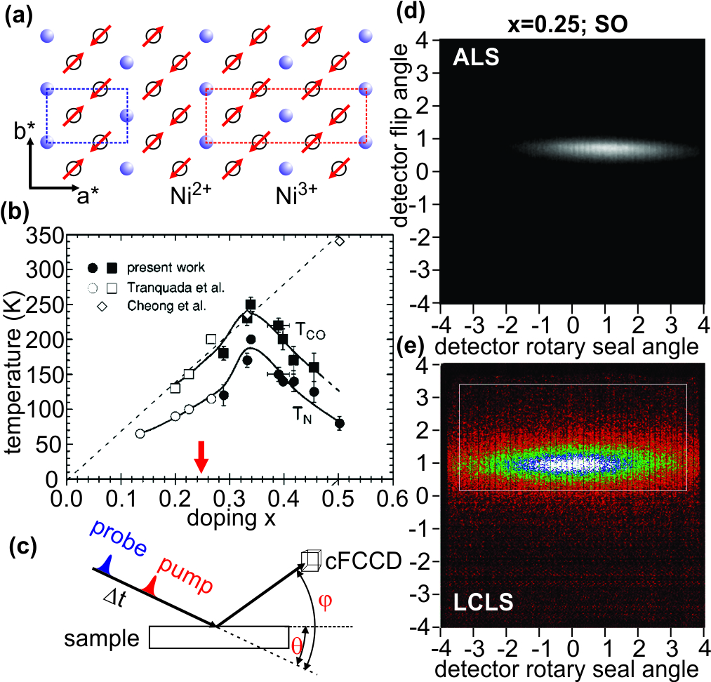
Figure 6- (a) Schematic plot showing the spin and charge orderings in 33% doped (La,Sr)₂NiO₄. The blue and red dashed rectangles represent the unit cell for charge (hole) and spin orderings respectively. (b) Phase diagram of (La,Sr)₂NiO₄ showing the charge (T_{CO}) and spin (T_{N}) ordering transition temperatures with hole concentration. The red arrow indicates the sample doping level for data shown in panel (d) and (e) (figure taken from [15]). (c) Schematic plot illustrating the experimental geometry. (d) The spin ordering peak recorded at ALS. The incident photon energy was set at Ni L₃ edge (854eV). The exposure time was 1.0s. (e) The spin ordering peak recorded at LCLS. The image is the sum of 15 (8ms exposure time) single-shot images.

IV Conclusions

A high speed compact, fast CCD camera (cFCCD) and a new resonant soft X-ray scattering (RSXS) chamber have been designed and constructed. The cFCCD camera is based on two custom ICs (FCCD and FCRIC) designed at LBNL. This new camera together with the new RSXS chamber have been designed to perform laser pump X-ray probe experiments to investigate strong correlation effects in complex systems as explained earlier in this paper. The cFCCD has been used at the LCLS rate (60Hz) for several experiments, and higher speeds at the ALS. Sample images of the data collected at both facilities have been shown demonstrating the capability and performance of the system while executing the pump-probe experiments.
Future improvements to this system consist in a new camera, currently under development, with a 1Megapixel frame store detector running at similar speeds.

Acknowledgments

Lawrence Berkeley National Laboratory is supported by the Director, Office of Science, Office of Basic Energy Sciences, of the U.S. Department of Energy under Contract No. DE-AC02-05CH11231

References
[1] “Handbook of High Temperature Superconductivity: Theory and Experiments” by J.R. Schrieffer, Springer 2007.
[2] “Nanoscale Phase Separation and Colossal Magnetoresistance: The Physics of Manganites and Related Compounds” by E. Dagotto, Springer 2003.
[3] Y. Tokura, Rep. Prog. Phys. 69, 797 (2006).
[4] S. Ishihara, S. Maekawa, Rep. Prog. Phys. 65, 561 (2002).
[5] P. Abbamonte, G. Blumberg, A. Rusydi, A. Gozar, P.G. Evans, T. Siegrist, L. Venema, H. Eisaki, E.D. Isaacs & G.A. Sawatzky, Nature 431, 1078 (2004).
[6] P. Abbamonte, A. Rusydi, S. Smadici, G.D. Gu, G.A. Sawatzky and D.L. Feng, Nat. Phys. 1, 155 (2005).
[7] S.B. Wilkins, P.D. Spencer, P.D. Hatton, S.P. Collins, M.D. Roper, D. Prabhakaran and A.T. Boothroyd, Phys. Rev. Lett. 91, 167205 (2003).
[8] K.J. Thomas, J.P. Hill, S. Grenier, P. Abbamonte, L. Venema, A. Rusydi, Y. Tomioka, Y. Tokura, D.F. McMorrow, G. Sawatzky and M. van Veenendaal, Phys. Rev. Lett. 92, 237204 (2004).
[9] S.S. Dhesi, A. Mirone, C. De Nadai, P. Ohresser, P. Bencok, N.B. Brookes, P. Reutler, A. Revcolevschi, A. Tagliaferri, O. Toulemonde and G. van der Laan, Phys. Rev. Lett. 92, 056403 (2004).
[10] C. Schubler-Langehenie, J. Schlappa, A. Tanaka, Z. Hu, C.F. Chang, E. Schierle, M. Benomar, H. Ott, E. Weschke, G. Kaindl, O. Friedt, G.A. Sawatzky, H.-J. Lin, C.T. Chen, M. Branden and L.H. Tjeng, Phys. Rev. Lett. 95, 156402 (2005).
[11] R.W. Schoenlein, S. Chattopadhyay, H.H.W. Chong, T.E. Glover, P.A. Heimann, C.V. Shank, A.A. Zholents, M.S. Zolotorev, Science 287, 2237 (2000).
[12] SLAC-R-521 “Linac Coherent Light Source (LCLS) Design Study Report”, see link in http://www.slac.stanford.edu/pubs/slacreports/slac-r-521.html
[13] P. Denes, D. Doering, H. A. Padmore, J.-P. Walder, and J. Weizeorick, A fast, direct x-ray detection charge-coupled device, REVIEW OF SCIENTIFIC INSTRUMENTS 80, 083302 (2009). [DOI: 10.1063/1.3187222]
[14] S. E. Holland, D. E. Groom, N. P. Palaio, R. J. Stover, and M. Wei, IEEE Trans. Electron Devices 50, 225 200
[15] H. Yoshizawa, T. Kakeshita, R. Kajimoto, T. Tanabe, T. Katsufuji and Y. Tokura, Phys. Rev. B 61, R854 (2001).

