WorkManager Error:

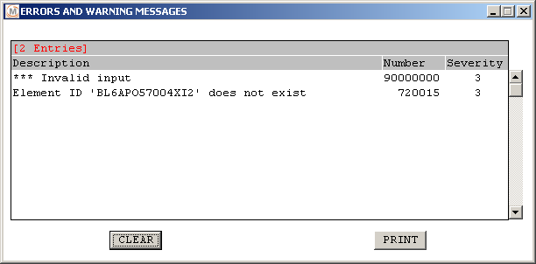

Why this occurs…

Typically this occurs when checking a drawing into WM.

In this case the drawing has already been checked into WM but was then deleted from WM.

The element ID is a system ID that the user rarely sees but every drawing and model has a system ID.

In this case Annotation knows that this Element ID has been checked into WorkManager at one time

