ALS Beamline Coordinate Systems for the design and installation of hardware

1. Definition of the Coordinate Systems

  - All coordinate systems are "right handed". The naming convention uses alphabetical order to relate between systems, such that the axis labeled "X" in the "X,Y,Z" system will be the "R" axis in the "R,S,T" system or the "U" axis in the "U,V,W" system.

1.2 ALS Global Coordinate System (X=15xx, Y=35xx, Z=25xx) [meters]

    - This coordinate system is the basis for all survey and alignment field activities involving components that must be installed and aligned at the ALS. The ALS global coordinate system is the master coordinate system and is used to define all other local beamline coordinate systems (Figure 1). The storage ring is in a plane parallel to the X, Z Plane at a Y value of 3500 m. The offset of the origin (center of the storage ring) to 1500, 3500, 2500 was originally done to eliminate confusion as to which value was being used (X, Y, or Z) and to eliminate negative values.

1.3 Beamline Coordinate System (R, S, T)

    - Each beamline will have a unique coordinate system with its Origin, and Direction defined in terms of ALS Global coordinates. The beamline coordinate system is defined by giving the origin (first point) and a second point on the beam centerline in ALS coordinates. Individual components shall be installed and aligned using the beamline R, S, T coordinate system. The R, S, T coordinate system is oriented such that the positive R direction is horizontal to the left when facing downstream along the beamline, the S axis is oriented vertically upward, and the T axis is along the beam direction (Figure 1).

1.4 Fiducial Coordinate System (U,V,W)

    - Individual components that are fiducialized and aligned using tooling balls also contain their own local U, V, W coordinate system that is used to define the location of the tooling balls with respect to the important feature or features of the component.

1.5 ALS CAD Coordinate System

    - ALS CAD Coordinates are a local version of ALS Global Coordinates where for convenience the origin is moved to the center of the storage ring (Figure 1).
    - This coordinate system is typically used in CAD systems to relate one beamline to the others or for laying out the storage ring or building components. The values relate to the ALS Global Coordinate system as follows:

ALS CAD ALS GLOBAL

X = X - 1500 m
Y = Y - 3500 m
Z = Z - 2500 m

When working in the X, Y plane in a 2D CAD system the values are:

ALS 2D CAD ALS GLOBAL

X = Z - 2500 m
Y = X - 1500 m

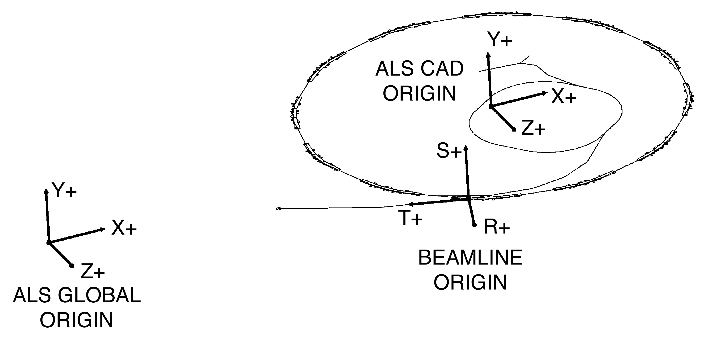

FIGURE 1

2. Defining Beamline Coordinate Systems

  - The beamline coordinate system should be defined as early as possible in the design process. The coordinate system needs to be documented by means of a critical points drawing that defines the location of the origin and a second point on the beamline in the ALS global coordinate system. Only 2 points are used to define the R,S,T coordinate system and only 1 coordinate system is defined per beamline. There are some cases where more than one local coordinate system might be used but these cases are rare and should be avoided whenever possible. The critical points drawing is also used to define the locations of all other critical points on the beamline in the local R,S,T coordinate system such as mirrors, monochromators, apertures, the focus and any other location that needs to be documented and communicated to the rest of the design team. Note that only the first 2 points are represented in ALS global coordinates and the rest of the points are only represented in beamline coordinates. Some examples of beamline critical point drawings are 25D2686, 24M5196 (Attached). Once the beamline coordinate system is defined, the drawing is given to the survey crew and this drawing number is referenced on any future installation drawing.

  - Defining Source points:

    - Bend magnet source points are defined using the method created by Roderick Keller based on magnet measurement data. This method has been turned into a "C" program that is currently available on the UNIX system by typing in the command "alsbsp". The program takes 3 arguments separated by spaces: "sector number" "port number" and "angle in milliradians" (the angle is from the nominal port centerline). The output is in the form of an X, Y coordinate given in meters and located in 2D ALS CAD coordinates system. This point is the source of the beamline, the second output is an angle in degrees which gives the direction of the line around the storage ring. If you use this program without any arguments it will return the instructions for use. Currently the output is used to place the centerline in the ALS sector layout drawings that have been generated in ME10 and are numbered 23J2016-23J2126 where the numbers 01 - 12 correspond to the sector of interest. The ALS global coordinates can easily be measured at this point using a macro in ME10. The macro is located SYMBOLS -> MENU 2 -> SPECIAL -> ALS COORD.

    - Insertion device source points are typically defined at the center of the insertion device along the electron beam. While this is sufficient for the definition of the local coordinate system be aware that the source is distributed along the entire length of the magnetic structure of the insertion device with the most extreme rays of the photon beam given by the two ends of the insertion device.

    - Super bend source points are defined by CAD based on the theoretical electron beam trajectory. The electron beam path and directions for finding the sources are given in drawing number 25D6786 and 25D8285 (Attached).

All of these coordinates are related to the ALS Global coordinate system by using the sector layout drawings 23J201 - 23J212 (Attached).

- Documentation Required for Installation:

  - The critical points drawing is required for the survey crew to locate the beamline in the ALS Global coordinate system.

  - An installation drawing is required for each component to be installed and aligned in the ALS. This drawing gives the location of each component in the local R,S,T beamline coordinate system and it should contain a reference to the critical points drawing that was used to define the R,S,T coordinate system used. Some examples of installation drawings for fiducialized components such as mirrors, vessels etc. are given in drawing 24L5984 for fiducialization, 24M3886 for installation, and examples for non-fiducialized components stands, spools etc. are given in 25F5796 . Components should always be installed in local R,S,T coordinates and the locations should not be given in any other coordinate systems. Installation drawings should also include the location of nearby survey monuments that will be required in planning the setup of survey equipment. The monument locations are defined on drawing number 24M2636 (all reference drawings attached).

  - Fiducialization drawings are required for components that have critical alignment requirements (better that ± 1 mm). This drawing must have the written instructions of how the U,V,W coordinate system is defined relative to the important features. There should also be a table for recording the tooling ball coordinates. Once the item has been fiducialized the drawing must be revised with the addition of the coordinate data. Some examples of fiducialization drawings are 25H9936, 24M3946, and 24B8576. The labeling convention for tooling balls in a fiducial drawing is shown in figure 2. The tooling balls are labeled A, B, C, D, … in a clockwise direction (looking down) starting to the right of the incoming beam.

    - The fiducial origin should be a point that can be easily measured and is an actual critical point to the design. Some examples are: in the case of an aperture it should be a point on the actual aperture opening, or in the case of a mirror it should be the center or the leading edge of the optical surface.

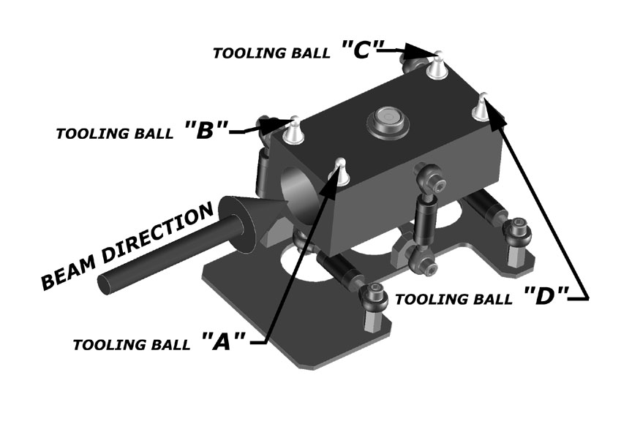
FIGURE 2
Do's and Don'ts of Installation.

    - All components should be installed in the local R,S,T coordinate system with no redundant coordinates in other coordinate systems.

    - It is important to note that the installation drawings for fiducialized components should give the location of the component's U,V,W origin and direction (given as a second point), not the actual tooling ball locations. While it can be easy to determine the tooling ball locations in a CAD system, it often leads to errors that can be difficult to trace. The survey crew has the ability to convert coordinates from any coordinate system to any other coordinate system; this should not be done by the designer.

4 The use of 3D CAD for beamline design. The coordinate system used in a CAD model should be the same coordinate system used for installation. The designer should be able to directly measure the R,S,T coordinate of components in the CAD model. To do this in SolidDesigner the beam origin is at (0,0,0), the “Z” direction is along the beam axis, and the “Y” direction is up (X,Y,Z => R,S,T). All installation information given on survey drawings should be directly measurable on the model.

  - In some cases, where multiple beamlines are designed at the same time it doesn’t make sense to keep each beamline at the global origin while interrelated components are designed. In these cases, one beamline coordinate system is used as the origin in the CAD system and the others are located relative to it (examples include 8.2.1, 8.2.2 and 8.3.1 or 5.3.1, 5.3.2). When this is done it often leads to confusion, so the designer is responsible for keeping track of relative locations. When installation drawings are created the individual beamlines must be moved so their beamline coordinate system origins are at the CAD system origin and oriented correctly (see section 4) then filed this way so coordinates can be measured directly from the model. The designer must keep adequate records to avoid installation errors or to be able trace any problems should they arise. When beamlines and components need to be moved from one coordinate system to the other (such as in the case mentioned above) it should be done by the use of a macro that can consistently move between coordinate systems without rounding errors. This macro can be easily written on a case by case basis until a global transformation macro is written.

There is additional information available on survey and alignment located in APPENDIX C of the ALS beamline design guide. This document is currently available at http://www-als.lbl.gov/als/bdguide/index.html.

